Great Gardeners

Remote learning curriculum pack Upper Key Stage 2 (Years 5 and 6) Pack 9

HIAS REMOTE LEARNING CURRICULUM PACK

HIAS Teaching and Learning Team

Summer 2021

Final version

© Hampshire County Council
HIAS Remote Learning Curriculum Pack
Using the Remote Learning Materials
Dear Parents and carers,

Your school is sending you this pack of remote learning activities to help you to support your child at home. Your school may also have given you English and mathematics resources, and this pack of activities can supplement and work alongside these.
These activities are designed to help your child continue with learning across the wider curriculum, which is linked to the National Curriculum and will build on their existing skills, help them learn new ones, and allow for suitable independence.

How to use the pack and support your child:
- Learning at home is distinctive and different to school but try to establish a routine with your child. These activities are practical and creative and can be used to work alongside the other remote learning activities.
- Encourage your child to choose the activities that most interest them. Some will build on knowledge that they already have, and some will be newer learning; but all are designed to be practical and fun.
- Activities may need reading with your child and explaining, and you may need to help them find resources. All the activities can be adapted where needed to make them work for you.
- The activities have been designed to enable a good amount of independence. Let your child work at their own pace, encourage them and celebrate their achievements frequently.
- These activities could take approximately 2 to 3 hours to complete (approximately half a day) but can be spread across a few days if necessary. There is no time limit to the activities, they may take more or less than the suggested time.

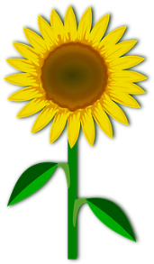
Great Gardeners

Key theme:

This theme is linked to the science curriculum for Upper Key Stage 2.

Pupils in Year 5 should be taught to:

- describe the differences in the life cycles of a mammal, an amphibian, an insect and a bird.
- describe the life process of reproduction in some plants and animals.

Pupils in Year 6 should be taught to:

- describe how living things are classified into broad groups according to common observable characteristics and based on similarities and differences, including microorganisms, plants and animals.
- give reasons for classifying plants and animals based on specific characteristics.

Evolution and inheritance - identify how animals and plants are adapted to suit their environment in different ways and that adaptation may lead to evolution.

Upper Key Stage 2
The big idea
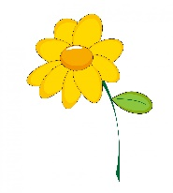
Invent a new plant suitable for a habitat

Key learning
Science:
- describe how living things are classified into broad groups according to common observable characteristics and based on similarities and differences, including microorganisms, plants and animals.
- use relevant scientific language and illustrations to discuss, communicate and justify their scientific ideas.
- identify how animals and plants are adapted to suit their environment in different ways.
English:
- Retrieve, record and present information from non-fiction.

How to do it
Plants can be easily sorted according to their common features and characteristics. Plants fall into four categories: With seeds: flowering plants and conifers and without seeds e.g., ferns and mosses.
There are some good reminders of the learning by visiting:
https://www.bbc.co.uk/teach/class-clips-video/science-ks1-ks2-ivys-plant-workshop-classifying-and-grouping-plants/zh9jvk7
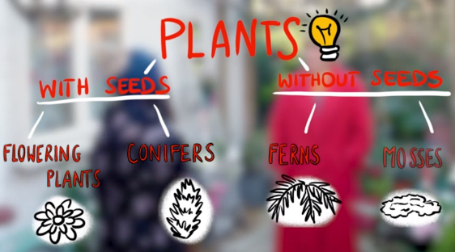

This activity is about inventing a plant. This needs to fall into one of these categories, and then consider what adaptations it will need in order to survive in the chosen habitat.

Think about:
- Where is the plant going to live (habitat)? Is it in a garden, forest, desert? What are the growing conditions like? Weather and amount of water or light have a big impact on how plants grow and develop. These need to be written down in order to consider what the new plant would need to be like. For example, if it is cold and dark, a flowering plant would not grow well so the plant might need to be a fern or moss.
- Think about the main parts of the plant: roots, stem, leaves and flower (if it has them). What will they need to be like in order to survive in the habitat?
- How is the plant going to create seeds? How will they be dispersed (move away from the parent plant). This happens in one of four ways: wind, water, movement (animals or humans) and explosion. The size and type of seeds links to the way they are dispersed.
- Decide on the size of the plant. Is it going to be small like a daisy or large like an oak tree (yes these are flowering plants too!)
- A good idea is to start with a known plant, and then make some changes to create the design of the ‘made up’ plant.

Completing the activity:
- Draw a picture of the plant and label the parts. Try to add as much detail as possible. Explain which type of plant it is (think about the 4 different categories).
- Describe (in words or pictures) what kind of habitat it lives in and how it had adapted to live there.
- Give the plant a good scientific name.
Useful questions
- Which of the four categories does the plant fall into?
- Will the adaptations help it to live in the habitat that has been chosen?
- Has all the information possible been included?
Useful websites and resources:
https://www.bbc.co.uk/teach/class-clips-video/science-ks1-ks2-ivys-plant-workshop-classifying-and-grouping-plants/zh9jvk7
https://www.plantlife.org.uk/uk/discover-wild-plants-nature/habitats
https://kids.nationalgeographic.com/explore/nature/habitats/

Upper Key Stage 2
The big idea
Be a leaf detective

Key learning
Science:
- describe how living things are classified into broad groups according to common observable characteristics and based on similarities and differences.
- using classification systems and keys to identify some animals and plants in the immediate environment.
- build on their learning about grouping living things by looking at the classification system in more detail.
- use relevant scientific language and illustrations.
How to do it
Every plant and tree has leaves that are individual to them. It is imporant to look closely at a leaf and its different features in order to tell which plant or tree it comes from. This will also provide an opportunity to develop appropriate vocabulary in trying to describe the leaves. This task will help in being aware of differences between leaves as well as features that are common to a range of leaves.
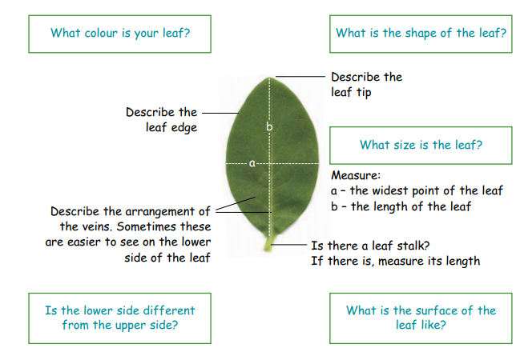
Most people when asked to describe leaves would probably say that leaves are green and know that they have different shapes. To be a leaf detective there needs to be close observation of a selection of leaves observable features, using correct scientific language to describe them.

Think about:

- How to describe a leaf accurately. Consider the following:
• colour • shape • size • veins • leaf edge • surface • leaf tip
• leaf stalk • comparison of upper and lower sides of leaf.

- The correct vocabulary that will need to be used. Sometimes the first word would not always be clear to other people.

- Colour – green, brown, olive, dark, light
- Leaf edge – smooth, toothed, wavy, prickly
- Leaf surface – smooth, rough, wrinkly, dull, glossy, hairy, furry
- Leaf tip – pointed, round, sharp
- Leaf stalk – present, absent
- Veins – one main vein with branches; several veins starting from the bottom and coming together again at the tip; several main veins spreading out from the bottom of the leaf

Completing the activity:
- Collect some leaves while out on daily exercise or from the garden. Pictures of leaves can also be used from the internet if they cannot be collected. The pictures included here can also be used: (from Science and Plants for schools’ pack)
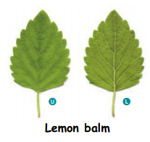
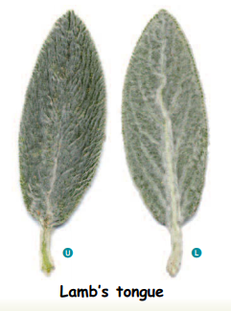
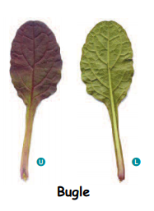
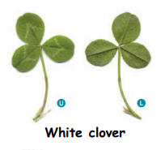

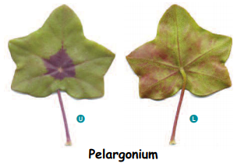
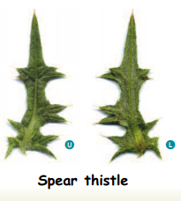
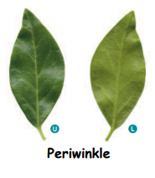

- Write a description of each leaf, remembering to be accurate. Remember that the correct scientific vocabulary needs to be used.
- This could be turned into a game by cutting the descriptions and the leaves out (or use the actual leaf if they were collected) and then making this up as a pairs game.

Useful questions
- Are the descriptions of the leaves clear and accurate?
- Are the descriptions of the leaves accurate?

Useful websites and resources:
https://www.saps.org.uk/primary/teaching-resources
https://www.woodlandtrust.org.uk/trees-woods-and-wildlife/british-trees/how-to-identify-trees/
https://www.woodlandtrust.org.uk/blog/2020/03/tree-id-kids/

Upper Key Stage 2
The big idea
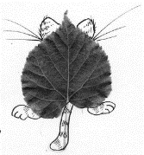
Design some leaf animals using classification groups

Key learning
Science:
- describe how living things are classified into broad groups according to common observable characteristics and based on similarities and differences, including microorganisms, plants and animals.
- give reasons for classifying plants and animals based on specific characteristics.

Art:
- produce creative work, exploring their ideas and recording their experiences

How to do it
There are two main groups within the animal kingdom: the invertebrates (without a backbone) and the vertebrates (with a backbone).
Invertebrates - important groups include the molluscs, insects and arachnids
Vertebrates - important groups include fish, amphibians, reptiles, birds and mammals

The knowledge from the leaves that were studied, in the previous activity, are going to be turned into animals from some of the groups above.

Think about:

- The characteristics that define each of the groups above:

Mollusc - they have a soft unsegmented body and live in aquatic or damp habitats, and most kinds have an external shell.
Insect - a small arthropod animal that has six legs and generally one or two pairs of wings.
Arachnids - is a class of joint-legged invertebrate animals.
Fish - is a scaly skinned vertebrate, that swims in water and breathes using gills.
Amphibian – they are cold blooded vertebrates that spend part of their time on land and in water. They usually have smooth moist skin.
Reptile - they are vertebrates that have a dry scaly skin and typically laying soft-shelled eggs on land.
Birds – they are vertebrates with wings and feathers. Their bodies are covered with a light, tough layer of feathers and they have very light skeletons. Instead of teeth, they have horn-like beaks, or bills.
Mammals - a warm-blooded vertebrate animal that have hair or fur, females that make milk to feed young, and (typically) give birth to live young.

- The shapes of some of the leaves that were studied before, and what kinds of animals that could be truned into.

Completing the activity:
- Stick the leaf onto the paper – or draw the leaf shape. Make sure that the shape is represented accurately when it is being drawn.
- Add features to creature an animal that is from one of the above animal kingdom groups.
- Write down the features and characteristics that the creature has.
- Can it be given a name that links to the type of leaf?
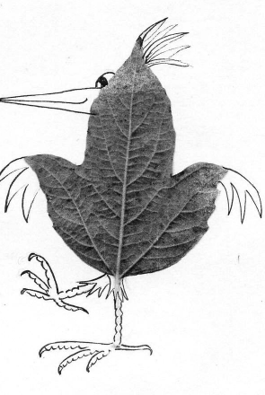
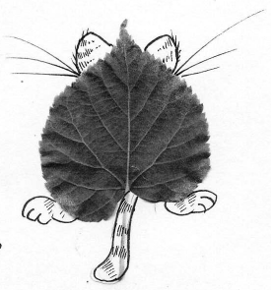
Some examples:

Useful questions
- Are the characteristics of the animal clear in the drawing?
- Has the leaf shape been drawn carefully so that it is obvious which leaf it is?
Useful websites and resources:
https://www.bbc.co.uk/bitesize/topics/zn22pv4/articles/z3nbcwx

Upper Key Stage 2
The big idea
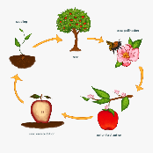
Make a collage or model of life cycles in plants and label

Key learning
Science:
- describe the life process of reproduction in some plants and animals.
- observing and comparing the life cycles of plants.

Art:
- to improve their mastery of art and design techniques, including drawing, painting and sculpture with a range of materials.

How to do it
The life cycles of flowering and non-flowering plants are quite similar in lots of ways. They also have common features with animals – they produce off spring which grow and in turn reproduce.

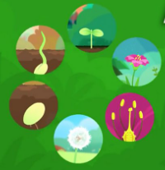 Life cycles of plants can be explored by following this link: https://www.bbc.co.uk/bitesize/topics/zgssgk7/articles/zyv3jty

Think about:
- what are the stages of the life cycle of a flowering plant?
- life starts as a seed. A seed contains a tiny plant, which will start to emerge once the conditions are right - a process that is called germination.
- germination ends when the plant emerges from the soil and shows above ground: it is now called a shoot. Once the shoot is exposed to sunlight, leaves will begin to grow and it is able to start producing its own food through photosynthesis. As well as growing up, the plant will have been growing down. Roots develop and grow deep into the soil, absorbing the water and minerals.
- once the shoot and roots are grown, the plant will begin to flower. This is a key part of the life cycle, as it allows the plant to reproduce by making seeds of its own. The flowers produce pollen. To develop seeds, this pollen must then be transferred to another plant of the same species. This is achieved with a little help either from the wind or insects or other animals.
- once pollinated, the plant is able to produce seeds.

Also think about how the 3D model can be made. This could be with materials like cardboard packets and tubes or clay, play dough or papier mache could be used.

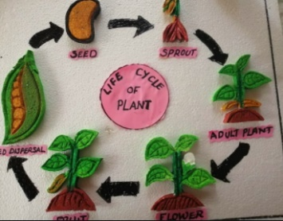
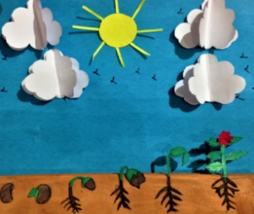
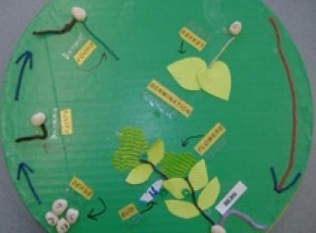
A picture of the plant could also be created at different stages in the life cycle and collage with different coloured paper or materials to show the different parts of the plant.

Completing the activity:
- Begin by planning the way that is going to show the stages if the life cycle. Scrap paper could be used to do this. This will help to think about what is needed. It is sometimes a good idea to layout everything out before they are stuck down.
- Design and make the 3D model or the collage. Remember that the stages need to be shown with the correct scientific vocabulary: germination, sprouting, pollination, seed dispersal are just some of the words that will be needed.
- Including arrows in the model or picture is very helpful to show the order of the stages.

Useful questions
- Are all the life cycle stages shown with the correct vocabulary?
- Are the stages clear with all the detail needed?

Useful websites and resources:
https://www.woodlandtrust.org.uk/blog/2017/11/life-cycle-of-a-plant-seeds-shoots-and-roots/
https://www.youtube.com/watch?v=KyKIs0NO848

HIAS Teaching and Learning Team

The HIAS Teaching and Learning Team give practical and supportive advice through coaching and mentoring teachers to improve outcomes for all pupils. They use a ‘plan, do, review’ approach to teaching and learning which broadly includes observation of teaching, personal target setting with areas given to improve, planning, demonstration of lessons and team teaching. The team focus their work on impact within the classroom.

They also work with Senior and Middle Leaders to develop the coaching model in their schools.

For further details referring to Primary Teaching and Learning support, please contact Sarah Sedgwick, Teaching and Learning Adviser: sarah.sedgwick@hants.gov.uk

For further details on the full range of services available please contact us using the following details:

Tel: 01962 874820 or email: hias.enquiries@hants.gov.uk.

