Our Amazing World

Remote learning curriculum pack Upper Key Stage 2 (Years 5 and 6) Pack

HIAS REMOTE LEARNING CURRICULUM PACK

HIAS Teaching and Learning Team

Spring 2021

Final version

© Hampshire County Council
HIAS Remote Learning Curriculum Pack
Using the Remote Learning Materials
Dear Parents and carers,

Your school is sending you this pack of remote learning activities to help you to support your child at home. Your school may also have given you English and mathematics resources, and this pack of activities can supplement and work alongside these.
These activities are designed to help your child continue with learning across the wider curriculum, which is linked to the National Curriculum and will build on their existing skills, help them learn new ones, and allow for suitable independence.

How to use the pack and support your child:
- Learning at home is distinctive and different to school but try to establish a routine with your child. These activities are practical and creative and can be used to work alongside the other remote learning activities.
- Encourage your child to choose the activities that most interest them. Some will build on knowledge that they already have, and some will be newer learning; but all are designed to be practical and fun.
- Activities may need reading with your child and explaining, and you may need to help them find resources. All the activities can be adapted where needed to make them work for you.
- The activities have been designed to enable a good amount of independence. Let your child work at their own pace, encourage them and celebrate their achievements frequently.
- These activities could take approximately 2 to 3 hours to complete (approximately half a day) but can be spread across a few days if necessary. There is no time limit to the activities, they may take more or less than the suggested time.

Our Amazing World

Key theme:

This theme is based on thinking about our world - the natural spaces; places both close to us and far away and about how much we are interconnected. The activities are based around, in part, to some of the geography curriculum (see below).

Key Stage 2
When extending their knowledge of the wider world, pupils should be taught to:

Locational Knowledge
- Locate the world’s countries, concentrating on their key physical features.
- Name and locate countries and cities of the United Kingdom, identifying their key topographical features (including hills, mountains, coasts, and rivers).
Place Knowledge
- Understand geographical similarities and differences through a study of physical geography of a region within North or South America or Europe.
Human and Physical Geography
- Describe and understand the key aspects of biomes, rivers and mountains.
- Describe and understand the key aspects of land use and economic activity.

The activities will also link to the English and art curriculum.

Upper Key Stage 2
The big idea
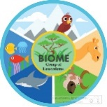
Comparing Biomes – temperate rainforest and deserts

Key learning
English:
- plan their writing by noting and developing initial ideas, drawing on research where necessary.
- use further organisational and presentational devices to structure text and to guide the reader (headings, bullet points, underlining).
- Retrieve, record and present information from non-fiction texts.
Geography:
- to describe and understand the key aspects of biomes.

Useful questions
- Can you write down five key facts that you have found out?
- What skills will you need to complete your task?
- What do you want the reader to think when they have looked at your work?
How to do it
A biome is a large ecosystem. The Earth has many different biomes, with each one containing many different living organisms that have adapted to the environment. This activity is about comparing mountain and desert biomes. The information can then be presented in an interesting way.

Think about:
- doing some research to collect information and make notes.
- looking at the main features of the 2 biomes.

Main features are:

Desert
Deserts make up the hottest biome but can also get cold temperatures in winter. Such temperature swings make this an extreme environment, where many animals must burrow underground to find more stable temperatures in order to survive. Plants and animals that live here must be able to withstand long periods without water.

Temperate Rainforest
This is the kind of forest where there are four relatively distinct seasons. Many of the trees shed their leaves in the autumn and become inactive through the cold winter. In these forests, you may find deer, woodpeckers, and bears, some of which hibernate through the winter.
- Use a map to find an example of each.
- Use a temperate rainforest in the UK and a desert from the wider world. For example, Atlantic Woodlands (which is in Scotland) and the Sahara Desert in Africa.
- Research what each of the areas are like: the climate; plants and animals; human population etc.
- Choose a way to present the findings. Be as creative as you like. This could be:
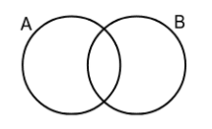
- A poster
- An information page
- A Venn diagram
Venn Diagram – used to
compare and contrast
- A 3D model
- A PowerPoint presentation

Completing the activity:

- Write up the research – remember to start with an introduction about what biomes are.
- Add detail focusing on the 2 chosen areas.
- Use pictures, diagrams and maps to help explain the ideas.
- Share the outcome with your adult/s at home.

Useful websites and resources:
https://www.ducksters.com/science/ecosystems/world_biomes.php
https://www.woodlandtrust.org.uk/blog/2020/07/rainforests-in-the-uk-and-where-to-find-them/
https://www.bbc.co.uk/bitesize/articles/zrx28hv

Upper Key Stage 2
The big idea
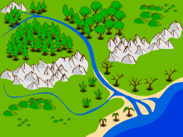
Creating a river

Key learning
Geography:
- Name and locate countries and cities of the United Kingdom, identifying their key topographical features (including hills, mountains, coasts and rivers).
- Describe and understand the key aspects of biomes, rivers and mountains.
Useful questions
- What different features make up the parts of a river?
- How will you make the learning clear?
How to do it
There are lots of important rivers around the world, but have you ever wondered how rivers work? A river is a moving body of water that flows from its source on high ground, across land, and then into another body of water, which could be a lake, the sea, an ocean or even another river. A river flows along a channel with banks on both sides and a bed at the bottom. If there is lots of rainfall, or snow or ice melting, rivers often rise over the top of their banks and begin to flow onto the floodplains at either side.
This activity is about creating a picture or a model of a river, labelling all the important sections.
Think about:
How a river is made and what all the different parts are. The following information will help but extra research may add more detail.

Glossary:
Course: The path that the river follows.
Delta: These form where the sea cannot take up the minerals from the river as quickly as the river deposits it.
Floodplain: Wherever a river floods, it deposits nutrients and forms a flood plain which can be very useful for farming. This is part of the lower course.
Meander: Where the sides of the river have eroded to make the river wider, then form horseshoe shaped bends. This is the main feature of the middle course.
Mouth: Where the river meets the sea.
Oxbow Lake: After a lot of erosion, a section of the meander becomes separated from the river to form a curved lake. Oxbow lakes are usually close to the river they formed from.
Source: The source of the river is where the river begins, at the top of a mountain or hill after rain or snow collects.
Tributary: A small stream.
Valley: A valley is where two mountains meet at the bottom, where a river can run through.

- Find a clear picture of a river to help with this task and then do some research using books or the internet. This website has some good ideas: https://canalrivertrust.org.uk/explorers/resources
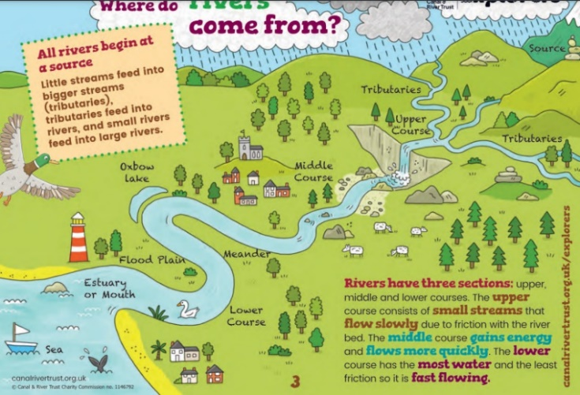
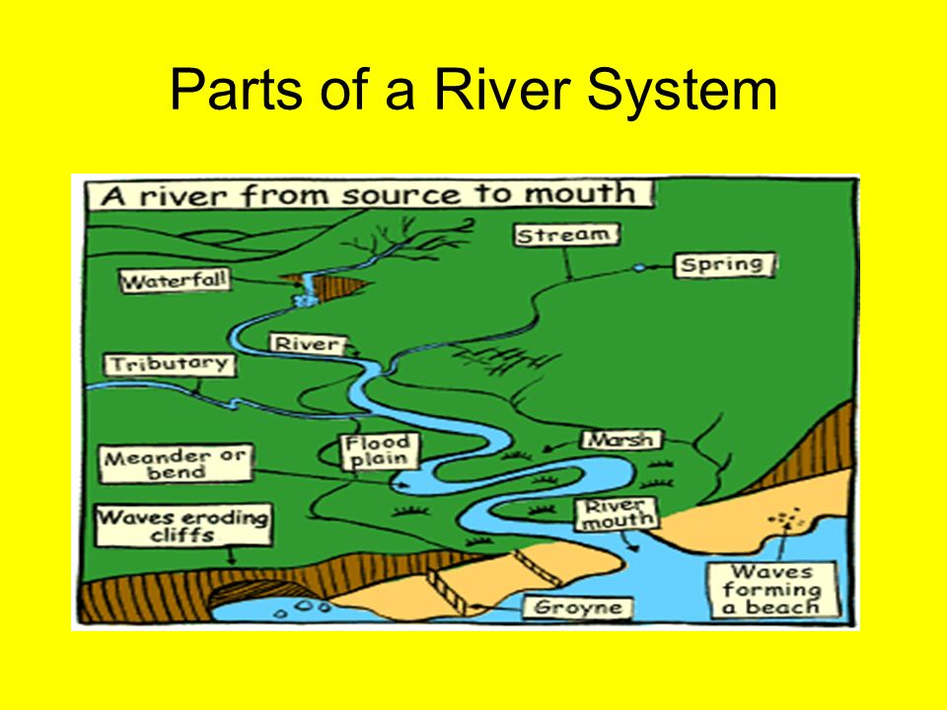

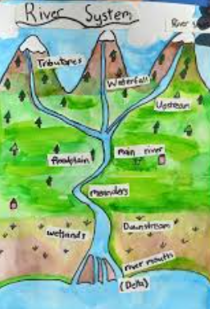

Completing the activity:
- Decide whether the river is going to be painted, drawn or made.
- Gather the relevant materials to complete the activity.

Draw or paint:
- Use a large piece of white paper or card as the background.
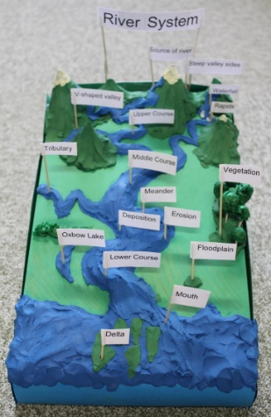
- Draw the outline of the river lightly with pencil with the main parts drawn clearly.
- Mix the paints or use coloured pens to make the colour.
- Label the key parts of the river with small boxes for simple explanations.

Make:

This could be made using a shoe or cereal box as the base. Paper, plasticine
or play dough could be used to build up the features of a river. Add labels to show what each part is called.

Useful websites and resources:
https://www.bbc.co.uk/bitesize/topics/z849q6f/articles/z7w8pg8
https://www.theschoolrun.com/homework-help/rivers
https://www.thegeographeronline.net/rivers.html

Upper Key Stage 2
The big idea
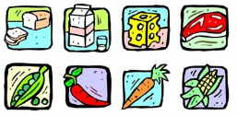
How many miles has my food travelled?

Key learning
Geography:
- Name and locate countries around the world.
- Understand the key aspects of human geography – including trade links and natural resources including food.
English:
- Identify the audience for and the purpose of the writing.
- Select the appropriate form and using other similar writing as models for their own.
Useful questions
- Was it a surprise where the food came from?
- Are there common countries where a lot of the food came from?
- Is there anything useful that could be done with the results?
How to do it
Food miles is the distance food is transported from the time of its making until it reaches the consumer (that is you!) In a time when we are all trying to help the environment and cut down on pollution, the fewer the miles the better.
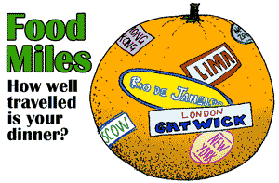
This activity is all about finding out how many miles the food we eat comes from. The results may be very surprising!

Think about:
- making a list of the food that is eaten during the day. The packets and boxes show the country of origin. This is where the food starts from.
- finding a map of the countries and plotting the foods on.
- finding out how far it is from your country to the country of origin – use a food miles calculator: https://www.foodmiles.com/
- how to record and present the information that is found.
Completing the activity:
- Next to each item that is eaten in a day, write down how many miles it has travelled. At the end of the day the total can be calculated to find the overall the total by adding them all. A calculator might be useful to help!
- Create a poster to show the information that is found. The food and the miles could be in a table:

Food type | Miles travelled and country
apple | South Africa = 9023km
cereal | USA = 5898km

- A world map could be drawn with lines to show how many different countries the food has come from.
- Make it clear how many miles in total!
- Think about how the amount of miles could be reduced – make a list of ideas or add them on as an extra box.

Useful websites and resources:
https://www.foodmiles.com/
https://www.bbc.co.uk/bitesize/topics/zjr8mp3/articles/zjnxwnb
https://www.bbcgoodfood.com/howto/guide/facts-about-food-miles

Upper Key Stage 2
The big idea
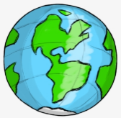
Where in the world – creating a travel guide

Key learning
Geography:
- Understand geographical similarities and differences through a study of physical geography of a region within North or South America or Europe.
English:
- Use expanded noun phrases to convey complicated information concisely.
- Selecting the appropriate form and using other similar writing as models for their own.
Useful questions
- What persuasive language has been used?
- Are all the facts about the location included?
How to do it
Where have you travelled to outside of Great Britain? If you haven’t left your country yet, think about where you would really like to go to. You are going to create travel guide to a place in Europe, or North or South America. This will help other children to get as excited as you are about the country of your choice.

A guide book or travel guide is ‘a book of information about a place designed for the use of visitors or tourists’. It will usually include information about sights, accommodation, restaurants, transportation, and activities. Maps of varying detail and historical and cultural information are often included.

Think about:
- which country have you visited or would really like to visit – it should be in Europe, North America or South America.
- what did you find so good about it or why do you really want to visit it?
- how to write the guide including how to set it out and the persuasive language that can be used.
8 Tips for writing a travel guide:
- Pick a country that is interesting and that you want to write about.
- Choose how you will make the travel guide.
- Research the key facts about the country.
- Include – place to visit and things to do.
- Include – pictures.
- Include – maps.
- Include – weather.
- Include – food.
- Also include – fun and weird facts, history and famous people.

Completing the activity:
- Plan the leaflet first – think about whether it is going to be a poster, a folder leaflet, or a PowerPoint presentation.
- Think about the language that is needed to make the country sound interesting and exciting to visit. This will need to be language to persuade people to go there.
- Use text, pictures, and fact boxes to present all the information needed.
Useful websites and resources:
https://www.funkidslive.com/learn/penguin-explorers/make-travel-brochure/#
https://www.natgeokids.com/uk/discover/geography/general-geography/five-reasons-to-travel-to-finnish-lapland/

HIAS Teaching and Learning Team

The HIAS Teaching and Learning Team give practical and supportive advice through coaching and mentoring teachers to improve outcomes for all pupils. They use a ‘plan, do, review’ approach to teaching and learning which broadly includes observation of teaching, personal target setting with areas given to improve, planning, demonstration of lessons and team teaching. The team focus their work on impact within the classroom.

They also work with Senior and Middle Leaders to develop the coaching model in their schools.

For further details referring to Primary Teaching and Learning support, please contact Sarah Sedgwick, Teaching and Learning Adviser: sarah.sedgwick@hants.gov.uk

For further details on the full range of services available please contact us using the following details:

Tel: 01962 874820 or email: hias.enquiries@hants.gov.uk.

