Our amazing world

Remote learning curriculum pack Lower Key Stage 2 (Years 3 and 4) Pack

HIAS REMOTE LEARNING CURRICULUM PACK

HIAS Teaching and Learning Team

Spring 2021

Final version

© Hampshire County Council
HIAS Remote Learning Curriculum Pack
Using the Remote Learning Materials
Dear Parents and carers,

Your school is sending you this pack of remote learning activities to help you to support your child at home. Your school may also have given you English and mathematics resources, and this pack of activities can supplement and work alongside these.
These activities are designed to help your child continue with learning across the wider curriculum, which is linked to the National Curriculum and will build on their existing skills, help them learn new ones, and allow for suitable independence.

How to use the pack and support your child:
- Learning at home is distinctive and different to school but try to establish a routine with your child. These activities are practical and creative and can be used to work alongside the other remote learning activities.
- Encourage your child to choose the activities that most interest them. Some will build on knowledge that they already have, and some will be newer learning; but all are designed to be practical and fun.
- Activities may need reading with your child and explaining, and you may need to help them find resources. All the activities can be adapted where needed to make them work for you.
- The activities have been designed to enable a good amount of independence. Let your child work at their own pace, encourage them and celebrate their achievements frequently.
- These activities could take approximately 2 to 3 hours to complete (approximately half a day) but can be spread across a few days if necessary. There is no time limit to the activities, they may take more or less than the suggested time.

Our Amazing World
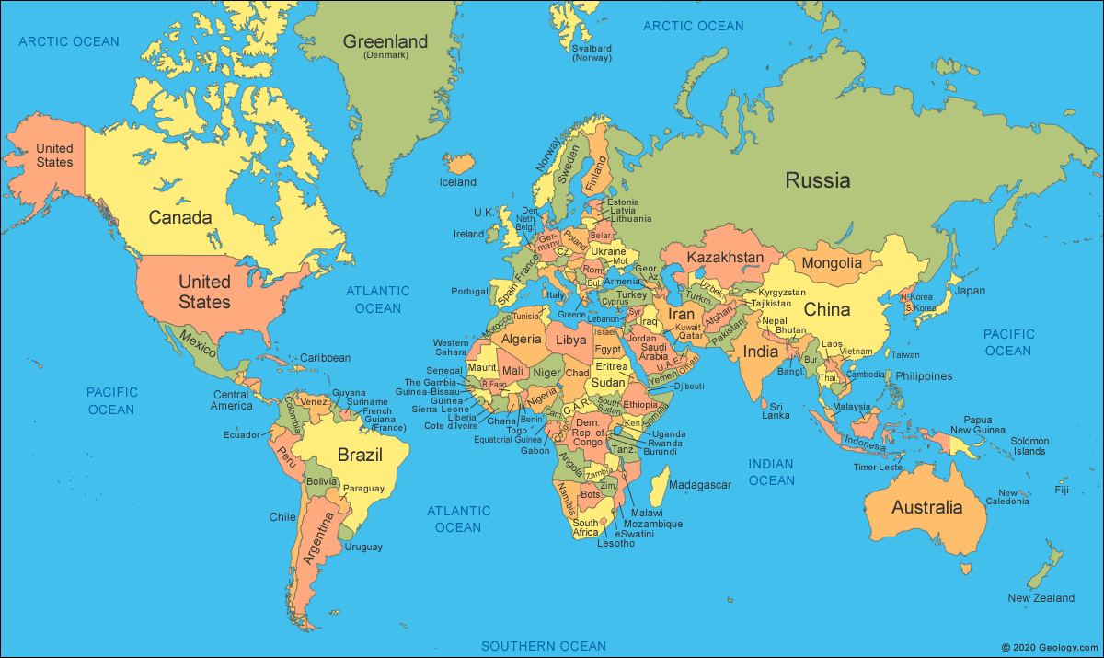

Key theme:

This theme is based on thinking about our world - the natural spaces; places both close to us and far away and about how much we are interconnected. The activities are based around, in part, to some of the geography curriculum (see below).

Key Stage 2
Pupils should be taught to:

Locational Knowledge
- Locate the world’s countries, concentrating on their key physical features.
- Name and locate countries and cities of the United Kingdom, identifying their key topographical features (including hills, mountains, coasts, and rivers).
Place Knowledge
- Understand geographical similarities and differences through a study of physical geography of a region within North or South America or Europe.
Human and Physical Geography
- Describe and understand the key aspects of biomes, (a large naturally occurring community of flora and fauna occupying a major habitat, e.g. forest or tundra) rivers, and mountains.
- Describe and understand the key aspects of land use and economic activity.

The activities will also link to the English and art curriculum.

Lower Key Stage 2
The big idea
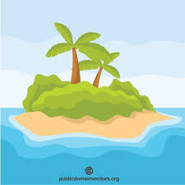
My favourite place in the world
Make a definition card game

Key learning
Geography:
- Locate the world’s countries, concentrating on their key physical features.
- Name and locate countries and cities of the United Kingdom, identifying their key *topographical features (including hills, mountains, coasts, and rivers.

*topographical – the arrangement or representation of the physical features of an area
Useful questions
- What countries are of interest and why?
- How can the main geographical features of the countries be shown in the game?
How to do it
This activity is about learning to describe the world’s countries and their main features using geographical vocabulary. Children can make a game of their choice to test out their knowledge and the knowledge of others.

The game could be a card game that is based around some popular games like ‘Snap’, ‘Happy Families’ or ‘Top Trumps’. These can be researched online, or someone can share the rules of a well- known game.

Think about:
- how the knowledge of countries can be shown in the game. Will it be around local physical features or human elements?
- whether the game can be played alone or with a small team of people.
- the rules of the game. These may need to be written down and practiced first before the game is played.
- the materials that are available to make the game.

How to make the game:
- Start by researching different countries of interest and what makes them unique. This key information is needed before the game is made.
- Card could be used to make the cards for the game. When the objects are being drawn, a rectangle on the card would be useful with the pictures inside each card. Draw the pictures before cutting them up to make it easier to draw accurately.
- Consider using dice or other objects to play the game and make it more interesting.
- Consider writing definitions for one card and then the pictures for the other. These could be drawn on one set of cards with the definitions written on the other set. The game could then be played by matching the two cards.
- Finally make up the rules of the game. These might need to be written down and altered as the game is played.

Lower Key Stage 2
The big idea
Take a city…
Describe using pictures
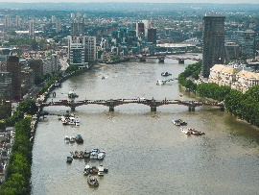

Key learning
Geography:
- Name and locate cities of the United Kingdom, identifying their key topographical features (including hills, mountains, coasts and rivers)
Useful questions
- What are the key features of the chosen city?
- What landmark could be used as an outline to give the best effect for the picture?
How to do it
This activity is about describing a city in the United Kingdom using pictures showing the main geographical features. Children can select any city that they are interested in finding out more about and use this as a basis for their drawing.

Completing the activity:
- Use a map of the United Kingdom and decide on the city that is to be studied. This could be local to the child or somewhere that has been visited.
- Research the key features of the city using books or the internet.
- Cut out photos or pictures of the main features (get permission before cutting out any pictures).
- Draw an outline that the pictures could fit into – this could be a particular place of interest in the city.
- Fit the pictures inside the outline.
- Extra detail could be given by adding labels to describe the features.

Useful websites and resources:
www.bbc.bitesize

Lower Key Stage 2
The big idea
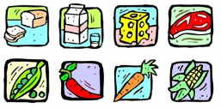
How many miles has my food travelled?

Key learning
Geography:
- Name and locte countries around the world.
- Understand the key aspects of human geography – including trade links and natural resources, including food.
English:
- Identifying the audience for and the purpose of the writing.
- Selecting the appropriate form and using other similar writing as models for their own.
Useful questions
- Were you surprised about where the food came from and why?
- Are there common countries where a lot of the food came from?
- Will you do anything about the results?
How to do it
Food miles is the distance food is transported from the time of its making until it reaches the consumer (that is you!) In a time when we are all trying to help the environment and cut down on pollution, the fewer the miles the better.
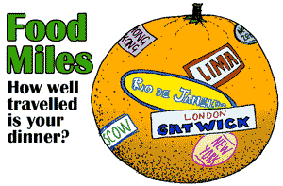

This activity is about finding out about the food miles for the food that has been eaten in one day. This might cause a BIG surprise!
Think about:
- making a list of the food that is eaten during the day – try to keep the packets or boxes. Food packaging often shows the country of origin – that means where it has come from. If this isn’t obvious, then the food could be researched to find out the different places in the world that it could come from.
- using research to find all the countries that the food might come from. Find a map and plot them on.
- finding out how far it is from your country to the country of origin – use a food miles calculator: https://www.foodmiles.com/
- how to record and present the information that is found.

Completing the activity:
- Next to each item that is eaten in a day, write down how many miles it has travelled. At the end of the day the total can be calculated by adding them all together. This might involve using calculator!
- Create a poster to show the information that is found. The food and the miles could be shown in a table like the one below:

Food type | Miles travelled and country
apple | South Africa = 9023km
cereal | USA = 5898km

- A world map could be used, and lines could be drawn to show how many different countries the food has come from.
- Make it clear how many miles in total!
- It could be interesting to think about how the number of miles could be reduced– make a list of ideas or add them on as an extra box.

Useful websites and resources:
https://www.foodmiles.com/

Lower Key Stage 2
The big idea
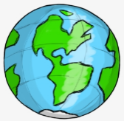
Where in the world – creating a travel guide

Key learning
Geography:
- Understand geographical similarities and differences through a study of physical geography of a region within North or South America or Europe.
English:
- Use expanded noun phrases to convey complicated information concisely.
- Select the appropriate form and using other similar writing as models for their own.
Useful questions
- Are the main ideas clearly shown?
- Is the writing interesting in a way that will engage the reader?
How to do it
Before starting this activity, get the child to discuss and think about where they have travelled to outside of Great Britain. If they haven’t left Great Britain yet, think about a destination that they would really like to travel to. This will help get the child excited about writing or drawing the travel guide.
The travel guide will be based on a place in Europe, or North or South America.

A guidebook or travel guide is "a book of information about a place designed for the use of visitors or tourists". It will usually include information about sights, accommodation, restaurants, transportation, and activities. Maps of varying detail and historical and cultural information are often included.

Think about:
- which country has been visited or would like to be visited - it should be in Europe, North America or South America.
- what was good about it and why was it chosen as a place to visit.
- how to write the guide.
8 Tips for writing a travel guide:
- Pick a country to focus on.
- Choose how the travel guide will be made.
- Research what will be written about.
- Include – places to visit and things to do.
- Include – pictures.
- Include – maps.
- Include – weather.
- Include – food.
- Also include – fun and weird facts, history, and famous people.

Completing the activity:
- Plan the leaflet first – think about whether it is going to be a poster, a folder leaflet, or a PowerPoint presentation.
- Think about the language that will be needed to make the country sound amazing and a place that the reader would really like to visit. Complete some persuasive phrases to engage the reader.
- Use text, pictures, and fact boxes to present all the information that is needed.
Useful websites and resources:
https://www.funkidslive.com/learn/penguin-explorers/make-travel-brochure/#

HIAS Teaching and Learning Team

The HIAS Teaching and Learning Team give practical and supportive advice through coaching and mentoring teachers to improve outcomes for all pupils. They use a ‘plan, do, review’ approach to teaching and learning which broadly includes observation of teaching, personal target setting with areas given to improve, planning, demonstration of lessons and team teaching. The team focus their work on impact within the classroom.

They also work with Senior and Middle Leaders to develop the coaching model in their schools.

For further details referring to Primary Teaching and Learning support, please contact Sarah Sedgwick, Teaching and Learning Adviser: sarah.sedgwick@hants.gov.uk

For further details on the full range of services available please contact us using the following details:

Tel: 01962 874820 or email: hias.enquiries@hants.gov.uk.

