Our amazing world

Remote learning curriculum pack Key stage 1 (Years 1 and 2)

Pack 7

HIAS REMOTE LEARNING CURRICULUM PACK

HIAS Teaching and Learning Team

Spring 2021

Final version

© Hampshire County Council
HIAS Remote Learning Curriculum Pack
Using the Remote Learning Materials

Dear Parents and carers,

Your school is sending you this pack of remote learning activities to help you to support your child at home. Your school may also have given you English and mathematics resources, and this pack of activities can supplement and work alongside these.
These activities are designed to help your child continue with learning across the wider curriculum, which is linked to the National Curriculum and will build on their existing skills, help them learn new ones, and allow for suitable independence.

How to use the pack and support your child:
- Learning at home is distinctive and different to school but try to establish a routine with your child. These activities are practical and creative and can be used to work alongside the other remote learning activities.
- Encourage your child to choose the activities that most interest them. Some will build on knowledge that they already have, and some will be newer learning; but all are designed to be practical and fun.
- Activities may need reading with your child and explaining, and you may need to help them find resources. All the activities can be adapted where needed to make them work for you.
- The activities have been designed to enable a good amount of independence. Let your child work at their own pace, encourage them and celebrate their achievements frequently.
- These activities could take approximately 2 to 3 hours to complete (approximately half a day) but can be spread across a few days if necessary. There is no time limit to the activities, they may take more or less than the suggested time.
Our amazing world
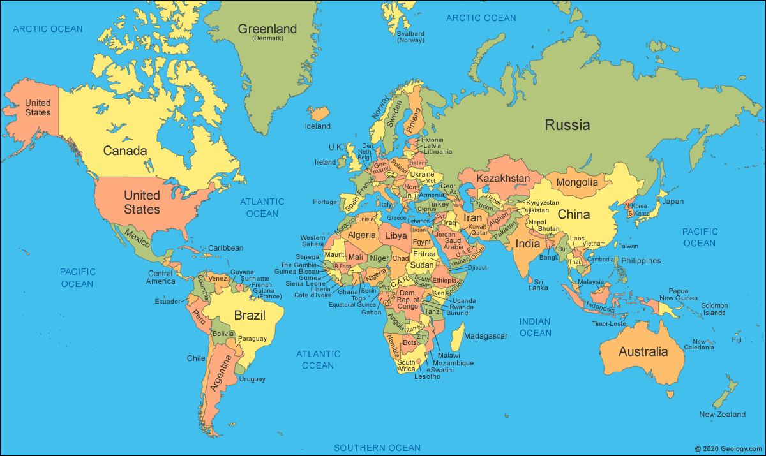

Key theme:

This theme is linked to the geography curriculum where children can explore their locality and different weather patterns.

Geography:
- Understand geographical similarities and differences through studying the human and physical geography of a small area of the United Kingdom.
- Identify seasonal and daily weather patterns in the United Kingdom and the location of hot and cold areas of the world in relation to the Equator and the North and South Poles.
- Use basic geographical vocabulary to refer to:
*Key physical features, including beach, cliff, coast, forest, hill, mountain, sea, ocean, river, soil, valley, vegetation, season, and weather.
*Key human features, including city, town, village, factory, farm, house, office, port, harbour and shop.
- Use simple compass directions (North, South, East and West) and locational and directional language [for example, near and far; left and right], to describe the location of features and routes on a map.

Key Stage 1
The big idea
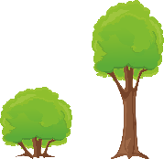
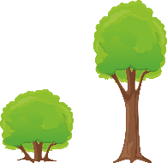
Local places
Make a game of definitions

Key learning
Geography:
- To understand geographical similarities and differences through studying the human and physical geography of a small area of the United
Kingdom.
Useful questions
- What part of the local area will be studied?
- What is the important geographical vocabulary that will need to be shared in the game?
How to do it
This activity is all about describing the local area using geographical vocabulary. Children can make a game of their choice to test out their knowledge and the knowledge of others.
The game could be a card game that is based around some popular games like ‘Snap’, ‘Happy Families’ or ‘Top Trumps’. These can be researched online, or someone can share the rules of a well- known game to base the game on. Alternatively, children can make up a game of their choice that could be played in the home or outside.

Think about:
- how the local knowledge can be shown in the game. Will it be around local physical features or human elements?
- whether the game can be played alone or with a small team of people.
- the rules of the game. These may need to be written down and practiced first before the game is played.
- the materials that are available to make the game.

The vocabulary needed:
The geographical vocabulary needed to play this game may include words such as:
Beach/ cliff/ coast/ harbour/ ocean/ river/ sea
Soil/ forest/ wood/ mountain/ vegetation/ season/ weather
Town/ village/ farm/ factory/ house/ port/ shop
How to make the game:
- Start by researching the local area and what makes it special. This key information is needed before the game is made.
- Thin card could be used to make the cards for the game. When the objects are being drawn, a rectangle on the card could be useful with the pictures inside. Draw the picture before the card is cut to make the drawing easier to complete.
- Consider using dice or other objects to play the game and make it more interesting.
- Consider writing definitions for one card and then the pictures for the other. These could be drawn on one set of cards with the definitions written on the other set. The game could then be played by matching the two cards.
- Finally make up the rules of the game. These might need to be written down and altered as the game is played.

Key Stage 1
The big idea
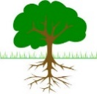
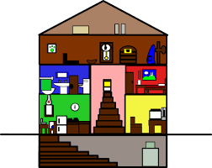
Create an imaginary route, describing the
local area

Key learning
Geography
- Use simple compass directions (North, South, East and West) and locational and directional language (for example, near and far; left and
right) to describe the location of features and routes on a map.
- Use basic geographical vocabulary to refer to:
*Key physical features, including beach, cliff, coast, forest, hill, mountain, sea, ocean, river, soil, valley, vegetation, season, and weather.
*Key human features, including city, town, village, factory, farm, house, office, port, harbour, and shop.
Useful questions
- What part of the local area will show the most interesting geographical features?
- How can the different features be shown on the map?
- Can the different directions be shown using a compass?
How to do it
A route is a path that people can follow. This activity is all about designing a route around the local area which describes both the human and physical features of where the child lives.
N.B: it is not necessary to go outside to complete this activity.

Completing the activity
- Decide where the route is going to take place to take in as much geographical features as possible. Discuss geographical vocabulary to describe the area such as: hill, field, type of soil, coast etc.
- Then plan out the route on a piece of paper using a map or the internet to help identify the different features.
- Now draw a map of the local area following the plan. Compass directions or simple instructions such as ‘right’, ‘left’ and ‘straight on’ could be used to teach directions.
- Label or draw the different objects or features seen on the route.
- Now give the map to someone and get them to imagine following the route and identifying the different objects seen.

Key Stage 1
The big idea
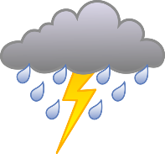
Paint the different seasons

Key learning
Geography:
- Identify seasonal and daily weather patterns in the United Kingdom.
Useful questions
- What is the child’s favourite season and why?
- What are the different weather patterns at different times of the year?
- How will the weather and the seasons be depicted in the painting?
How to do it
Many artists take inspiration from nature and this activity is all about considering the different weather patterns and how the seasonal changes affect what we do and how we live. Children can then take inspiration from this to create their own paintings.

Getting started:
- Look around outside and talk about the current season and what the weather is like. Remember to talk to children about how weather patterns are different across the world.
- Research the different seasons and the weather patterns using books or the internet.
- Gather up the materials that will be needed to complete the painting.

Materials that you could use:
These are some of the materials that will be needed to create the painting:
- Some white paper or a sketchbook
- A range of paints (coloured pencils can also be used)
- A pencil to draw the outline
- Some pictures of photos for inspiration
When using the paper, try to work as large as possible from the beginning to fill all parts of the paper.

Completing the activity:
Once all the materials are gathered then start the painting:

- Use the pictures as stimulus in front of the children.
- Draw the outline of the main objects lightly on the paper.
- Mix the paints to create the different colours. It may be an idea to paint the background lightly and let that dry first before adding the detail.
- Extra detail can be added by making small labels with the key vocabulary on and adding these to the finished painting.

Key Stage 1
The big idea
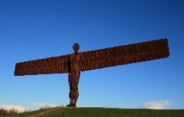
Pick a landmark in three different cities and write or draw about them

Key learning
Geography:
- Understand geographical similarities and differences through studying the human and physical geography of a small area of the United
Kingdom.
Useful questions
- What are the main cities and their landmarks in the United Kingdom?
- What interests the child about the different landmarks?
- How will the landmarks be shown and described?
How to do it
This activity is all about imagining flying over all the famous landmarks in the United Kingdom! Children can then either draw or write about them.
N.B. A landmark means a recognisable feature that stands out in its environment. In this case it also means a structure that is a local or national symbol.

Completing the activity:
- Start with a large piece of paper to record the findings.
- Either draw an outline of the United Kingdom using a map or an atlas to guide or use a completed map from an atlas or the internet.
- Decide on the starting point for the tour of the United Kingdom. This may the place that the child lives or one that the child would like to visit. Then talk about the different cities and landmarks and how a ‘stop’ could be made at each of them.
- When the ‘stop’ is made, research a famous landmark, draw the landmark, and write a label to go with it.
- Alternatively, a non-fiction booklet could be made of the facts that are found.

Features of a non-chronological booklet:
- An eye-catching heading in large font with pictures added in.
- An introductory paragraph – this could tell the reader all about the tour and the different landmarks that will be seen.
- Usually written in the present tense.
- Use of pictures and diagrams to make the booklet more interesting.
- Conjunctions could also be used to make the text more interesting. For example: and, but, because
Drawing the landmarks:
When drawing the landmarks consider:
- Drawing the detail in carefully
- Using the correct colours for each part
- Writing labels to explain each part of the label and where they are

HIAS Teaching and Learning Team

The HIAS Teaching and Learning Team give practical and supportive advice through coaching and mentoring teachers to improve outcomes for all pupils. They use a ‘plan, do, review’ approach to teaching and learning which broadly includes observation of teaching, personal target setting with areas given to improve, planning, demonstration of lessons and team teaching. The team focus their work on impact within the classroom.

They also work with Senior and Middle Leaders to develop the coaching model in their schools.

For further details referring to Primary Teaching and Learning support, please contact Sarah Sedgwick, Teaching and Learning Adviser: sarah.sedgwick@hants.gov.uk

For further details on the full range of services available please contact us using the following details:

Tel: 01962 874820 or email: hias.enquiries@hants.gov.uk.

