Let’s make it!

Remote learning curriculum pack Key stage 1 (Years 1 and 2)

Pack 5

HIAS REMOTE LEARNING CURRICULUM PACK

HIAS Teaching and Learning Team

Spring 2021

Final version

© Hampshire County Council
HIAS Remote Learning Curriculum Pack
Using the Remote Learning Materials

Dear Parents and carers,
Your school is sending you this pack of remote learning activities to help you to support your child at home during the first few days of this isolation period. Your school may also have given you initial English and mathematics resources for the next few days, and this pack of activities can supplement and work alongside these. The school is finalising its plans to deliver your child’s current curriculum remotely to your child, with your support, during the remainder of the isolation period. These plans will be with you shortly and will maintain progress during this short interruption of education at school.
In the meantime, these activities are designed to help your child continue with learning across the wider curriculum, which is linked to the National Curriculum and will build on their existing skills and allow for suitable independence.

How to use the pack and support your child:
- Learning at home is distinctive and different to school but try to establish a routine with your child. These activities are practical and creative and can be used to work alongside the other remote learning activities.
- Encourage your child to choose the activities that most interest them. Some will build on knowledge that they already have, and some will be newer learning; but all are designed to be practical and fun.
- Activities may need reading with your child and explaining, and you may need to help them find resources. All the activities can be adapted where needed to make them work for you.
- The activities have been designed to enable a good amount of independence. Let your child work at their own pace, encourage them and celebrate their achievements frequently.
- These activities could take approximately 2 to 3 hours to complete (approximately half a day) but can be spread across a few days if necessary. There is no time limit to the activities, they may take more or less than the suggested time.
Let’s make it!
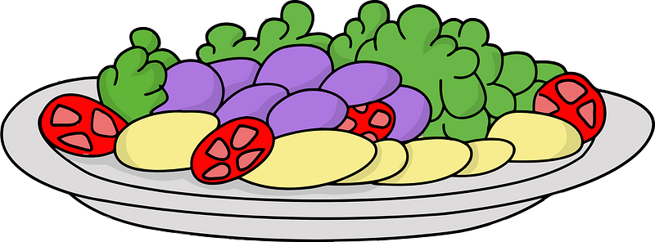
Key theme:

This theme is linked to the design technology curriculum and will involve children designing and making various objects. They can also make some healthy meals as part of the ‘nutrition’ programme in the National Curriculum.

When designing and making, pupils should be taught to:
Design
- design purposeful, functional, appealing products for themselves and other users based on design criteria
- generate, develop, model and communicate their ideas through talking, drawing, templates, mock-ups and, where appropriate, information and communication technology
Make
- select from and use a range of tools and equipment to perform practical tasks [for example, cutting, shaping, joining and finishing] select from and use a wide range of materials and components, including construction materials, textiles and ingredients, according to their characteristics
Evaluate
- explore and evaluate a range of existing products
- evaluate their ideas and products against design criteria
Technical knowledge
- build structures, exploring how they can be made stronger, stiffer and more stable
Cooking and nutrition
Pupils should be taught to:
- use the basic principles of a healthy and varied diet to prepare dishes

Key Stage 1
The big idea
Design a safety poster for the kitchen

Key learning
DT:
In the DT curriculum pupils need to use creativity and imagination to design and make products that solve real and relevant problems within a variety of contexts, considering their own and others’ needs, wants and values. They need to select from and use a range of tools and equipment to perform practical tasks. This activity is therefore all about knowing the safety aspects involved in this.
How to do it
This activity is all about designing and making a safety poster for use in the kitchen. It is important that children know the safety aspects when they are cooking within this space of the home or school.

Completing the activity:
First research the safety aspects needed to work in the kitchen. These could be around the different equipment used, such as the cooker and kitchen utensils and around the general workspace, such as ensuring the floor isn’t slippery etc. Children could write a simple list of areas to help them before completing the poster.

Posters need to be bright and interesting so that they make people look at them. Consider the following when completing this activity:
- Think about having the main objects drawn first with labels around them.
- Ensure that the main design is drafted using pencil and then fill in using bright colours.
- Label the key safety aspects around the objects.
- Give the poster a slogan. That is a striking phrase that people can remember. This will make the poster stand out from all the others.
- Consider drawing a border around the poster to make it more interesting.
- Use some key words with the pictures so that people can remember what to do and the rules to follow.
Key questions:
- What are the main safety aspects and rules that are needed to follow in the kitchen?
- Can children write some persuasive phases to aid safety?
Key Stage 1
The big idea
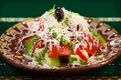
Create a recipe using seasonal products

Key learning
DT- cooking and nutrition:
Pupils should be taught to:
- Use the basic principles of a healthy and varied diet to prepare dishes.
How to do it
This activity is all making something tasty to eat that is based on foods that are in season. This means foods that are usually grown naturally at this time of year. It is important that children also think about the healthy content of food to ensure that the food gives them the energy and vitamins to stay healthy within a balanced diet.
This activity is a good opportunity to make something tasty and healthy. This can be a sweet or savoury dish or one foodstuff with ingredients that the child like to eat.

Different ideas:
- Decide on the type of food that you would like to make. A current meal or a type of food that is already enjoyed could also be adapted.
- Use books, magazines, or the internet to get some extra ideas.
- Talk about what makes meals healthy and how different foodstuffs can give us a balanced diet.
- Check that the ingredients are available or that someone can go shopping to buy them.
- Write down a shopping list of the ingredients that will be needed.
- Ensure that the child can be supervised when cooking and preparing, particularly if it involves using heat or cutting up the ingredients.
- Once the food has been created, someone in the home could taste it and give their opinion on what was great about it and how it could be improved in the future.
- The food could also be photographed with a recipe card as a reminder of how to make it.
- Remember to evaluate what was good about it and what might need to be altered in the future, both with the ingredients and the process.
Key questions:
- What makes a healthy meal?
- How can the ingredients in the food cupboard be adapted to make something new?
- How could the dish be improved next time?
Useful websites and resources:
www.bbcgoodfood.com
www.kids-cooking-activities.com

Key Stage 1
The big idea
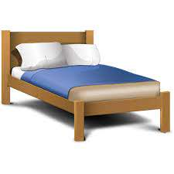
Design a pattern for a child’s bedcover

Key learning
Art:
Pupils should be taught:
- to use drawing, painting, and sculpture to develop and share their ideas, experiences, and imagination
- to develop a wide range of art and design techniques in using colour, pattern, texture, line, shape, form, and space
How to do it
This activity involves designing a material to be used for the cover of a child’s bed.

Getting started:
It might be useful to walk around the home before drawing any ideas to look at the different materials that you can be seen in lots of household objects such as blinds, curtains, bedspreads, and sofa fabrics. This will give the child an idea of the type of pattern to draw. Magazines and books will also help with the research.

Think about:
- how colour is used effectively.
- how repeating patterns are used to give different effects.
- whether the bed cover will have a theme such as a sports theme, or a floral or geometric pattern in the design.
- what colours the child might like.
- the colour scheme of the room as this will affect the choice of colours.

Completing the activity:
Once the type of pattern has been decided then it can be designed in various ways.
- Plan the design first by jotting down some ideas on paper.
- Then draw the design on paper using a pencil outline.
- Use either coloured pencils, pens, or paints to colour in the outline carefully.
- Coloured paper or paper from magazines could also be used to make the design (once people have finished with them!). These could be stuck on to create a collage effect.
Key questions:
- What types of designs does current bedlinen have?
- Can the child use repeating patterns accurately to complete the design?

Key Stage 1
The big idea
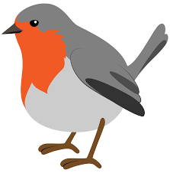
Make a winter-themed puppet

Key learning
DT:
- design purposeful, functional, appealing products for themselves and other users based on a design criteria
- to select from and use a range of tools and equipment to perform practical tasks, selecting from a wide range of materials, including ingredients
How to do it
This activity is all about making a winter themed puppet using different methods. Children can decide on the figure that they choose to make, but it is advised to keep this simple!

Completing the activity:
- Decide on the type of figure that could be made into a puppet. For example, this could be a winter-themed bird or animal.
- Make a template out of thin card by drawing an outline of the figure in pencil. This can then form a guide for either a card puppet or one made of material.
Make the puppet by either:
using a lolly stick and card:
- Use a lolly stick to form the base or ‘stick’ of the puppet and then cut out two pieces of thin card in the shape of the figure (these must be the same size).
- Join the two pieces of card together using tape around the edge with a ‘gap’ at the base to push the lolly stick into. Or alternatively use one piece of card and attach it to the stick.
- Push the lolly stick between the pieces of card and attach them with tape so that they don’t slip.
Or
Use felt and sewing:
Make sure that supervision can be given to the child to help with the stitching and cutting.
- Make a template of the figure, making sure that the shape will fit the hand.
- Put the template on two pieces of felt (to make the front and the back) and cut around it (supervision must be given with the cutting).
- Carefully stitch around the outside of the two pieces of felt to attach them together.
- Decorate the puppet using other pieces of felt to make the eyes, nose etc and attach these using fabric glue (supervision).
Key questions:
- What method will be used to make the puppet?
- How successful was the final puppet against the design?
Useful websites and resources:
www.redtedart.com http://kidscraftroom.com

Key Stage 1
The big idea
Design the contents of a healthy lunchbox to take to school

Key learning
DT- cooking and nutrition:
Pupils should be taught to:
Use the basic principles of a healthy and varied diet to prepare dishes
How to do it
This is an activity based on creating a healthy lunchbox to take to school.

Think about:
- what makes a healthy lunch and how the foods in this meal give energy at the mid-point of the day.
- what favourite foods might be in the lunchbox.
- using different recipe books and online recipes to get some good ideas.

Completing the activity:
- Consider both savoury and sweet foods that can be in the lunchbox to give a balanced diet.
- Use pictures from recipe books to get some ideas.
- Draw the outline of the lunchbox so that the pictures of the foods can be placed inside.
- Draw the foods and colouring them in carefully.
- Label the foods clearly.

Key questions:
- What different foods make a healthy lunch?

HIAS Teaching and Learning Team

The HIAS Teaching and Learning Team give practical and supportive advice through coaching and mentoring teachers to improve outcomes for all pupils. They use a ‘plan, do, review’ approach to teaching and learning which broadly includes observation of teaching, personal target setting with areas given to improve, planning, demonstration of lessons and team teaching. The team focus their work on impact within the classroom.

They also work with Senior and Middle Leaders to develop the coaching model in their schools.

For further details referring to Primary Teaching and Learning support, please contact Sarah Sedgwick, Teaching and Learning Adviser: sarah.sedgwick@hants.gov.uk

For further details on the full range of services available please contact us using the following details:

Tel: 01962 874820 or email: hias.enquiries@hants.gov.uk.

