Be healthy!

Remote learning curriculum pack

Upper Key Stage 2 (Years 5 and 6)

Pack 3

HIAS REMOTE LEARNING CURRICULUM PACK

HIAS Teaching and Learning Team

Autumn 2020

Final version

© Hampshire County Council
HIAS Remote Learning Curriculum Pack
Using the Remote Learning Materials

Dear Parents and carers,
Your school is sending you this pack of remote learning activities to help you to support your child at home during the first few days of this isolation period. Your school may also have given you initial English and mathematics resources for the next few days, and this pack of activities can supplement and work alongside these. The school is finalising its plans to deliver your child’s current curriculum remotely to your child, with your support, during the remainder of the isolation period. These plans will be with you shortly and will maintain progress during this short interruption of education at school.
In the meantime, these activities are designed to help your child continue with learning across the wider curriculum, which is linked to the National Curriculum and will build on their existing skills and allow for suitable independence.

How to use the pack and support your child:
- Learning at home is distinctive and different to school but try to establish a routine with your child. These activities are practical and creative and can be used to work alongside the other remote learning activities.
- Encourage your child to choose the activities that most interest them. Some will build on knowledge that they already have, and some will be newer learning; but all are designed to be practical and fun.
- Activities may need reading with your child and explaining, and you may need to help them find resources. All the activities can be adapted where needed to make them work for you.
- The activities have been designed to enable a good amount of independence. Let your child work at their own pace, encourage them and celebrate their achievements frequently.
- These activities could take approximately 2 to 3 hours to complete (approximately half a day) but can be spread across a few days if necessary. There is no time limit to the activities, they may take more or less than the suggested time.

Be healthy

Key theme:

This theme is based on the design and technology curriculum and cooking and nutrition. It will help children to recognise what they eat and how they keep healthy. They will design and make healthy food, and investigate other ways to have a healthy lifestyle.

DT
Cooking and nutrition
As part of their work with food, pupils should be taught how to cook and apply the principles of nutrition and healthy eating. Instilling a love of cooking in pupils will also open a door to one of the great expressions of human creativity. Learning how to cook is a crucial life skill that enables pupils to feed themselves and others affordably and well, now and in later life.
Pupils should be taught to:

- understand and apply the principles of a healthy and varied diet
- prepare and cook a variety of predominantly savoury dishes using a range of cooking techniques
- understand seasonality, and know where and how a variety of ingredients are grown, reared, caught and processed
Science
- recognise the impact of diet, exercise, and lifestyle on the way their bodies function

The activities will also make links to the English, maths, and science curriculum.

Upper Key Stage 2
The big idea
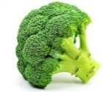
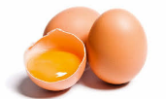
Create an ‘Eatwell’ plate

Key learning
DT
Pupils should be taught to:
- understand and apply the principles of a healthy and varied diet
- prepare and cook a variety of predominantly savoury dishes using a range of cooking techniques
- understand seasonality, and know where and how a variety of ingredients are grown, reared, caught, and processed

How to do it
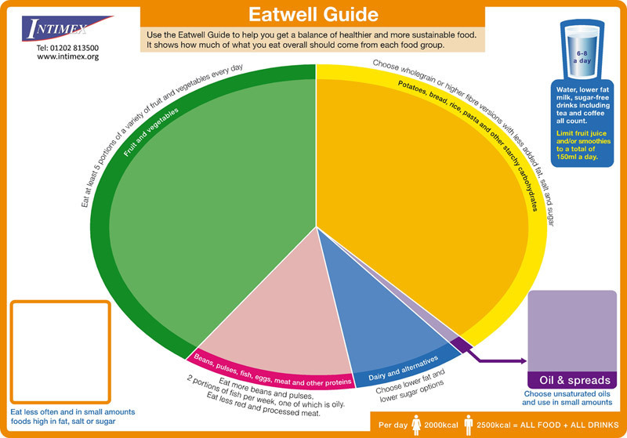

The ‘Eatwell’ guide helps everyone get a balance of healthier and more sustainable food and can aid the understanding of the different food groups to help people make the right decisions when eating and drinking. The plate is available on the NHS website.
This activity is all about using the ‘plate’ format to create a healthy plate of food. Children can then write about each food; describe the food group it is in and why it will aid healthy eating.

Completing the activity:
- Research the different food groups with the foods that belong in each one.
- Use the ‘plate’ format to understand the proportions of food needed in each food group.
- Draw around a real plate on white paper to give an outline of a plate or use a paper plate to create the plate.
- Draw or write the foods needed for one meal that would give a balanced diet (this might need to be the main meal).
- Write a piece to go with the plate about why the foods have been chosen, their food group and how this makes a delicious, balanced meal.

Key questions:
- What are the food groups and what foods belong in each group?
- How can the plate be created to the best effect to make a balanced meal and why?
Useful websites and resources:
www.nhs.uk

Upper Key Stage 2
The big idea
Get active!
Make an active diary and measure the impact
*Year 6*

Key learning
Science:
Pupils should be taught to:
- recognise the impact of diet, exercise, and lifestyle on the way their bodies function

How to do it
This activity is all about recognising what makes us healthy in terms of keeping active. Children can consider what physical exercise they enjoy doing and create a daily diary, making notes of the impact that the exercise had.

Completing the activity:
- Make a note of all the different ways to exercise and discuss how effective these are.
- Decide on the exercise that is enjoyed the most and is accessible. Remember that not all exercise has to be done outside or with equipment.
- Design a diary format (see below) to record the exercises.
- Consider ways to measure the impact of the exercise. This could be through measuring the pulse rate or how the exercise changes the way the child feels afterwards.
- Complete the diary each time exercise takes place and how this makes them feel.
- It might also be possible to create a sense of competition e.g. how can I increase the number of times I do ‘X’?

 | What activities did you do? | Minutes | Impact?
Monday
Tuesday
Wednesday
Thursday
Friday
Saturday
Sunday

Key questions:
- What exercises are cardiovascular? (relating to the heart and blood vessels)
- What exercises help build bones?
Useful websites and resources:
www.nhs.uk

Lower Key Stage 2
The big idea
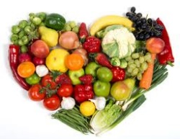
5 a day!

Create ‘5 a day’ for mealtimes

Key learning
DT:
Pupils should be taught to:
- understand and apply the principles of a healthy and varied diet
- prepare and cook a variety of predominantly savoury dishes using a range of cooking techniques
- understand seasonality, and know where and how a variety of ingredients are grown, reared, caught, and processed
How to do it
Fruit and vegetables provide important vitamins and minerals to help keep people healthy. Fruit and vegetables also provide fibre for a healthy digestive system. People should eat at least 5 portions of fruit and vegetables every day. Fresh, frozen, canned, dried, and juiced all count but people should aim to have a variety in their diet. A rough guide to a portion is the amount that fits in the palm of the hand.
This activity is all about understanding what makes up a healthy, balanced diet and making this up into a food diary for the week.
Completing the activity:
- Research what makes a healthy diet using the main food groups. These are starchy carbohydrates, protein, dairy, fruit and vegetables, protein, and fats (not too much!).
- Decide which foods could be eaten throughout the day and divide them up into the appropriate meal.
- Make up a format like the one below that could be used to draw or write each meal. The first row could be writing about each meal and the second row could be illustrations.
- To improve this activity even more, some of the meals and drinks could be made.
- Children could also evaluate the taste and ‘healthiness’ of each option after the diary is complete.

Breakfast | Lunch | Evening meal | Snacks | Drinks

Key questions:
- What are the main food groups?
- How could these foods be combined to make the tastiest and healthiest foods and drinks?
- What is the preferred combination?
Useful websites and resources:
www.cookingwithkids.org www.bbcgoodfood.com

Upper Key Stage 2
The big idea
Invent a game to keep a person fit
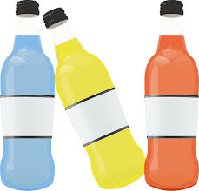

Key learning
Science
Pupils should be taught to:
- recognise the impact of diet, exercise, and lifestyle on the way their bodies function

How to do it
It is always important to get up and get moving to keep ourselves fit and healthy and this activity is all about inventing a game to help us do just that!

Getting started:
- Decide whether the game is one that is going to be played outside or inside. Take care that the garden or outside area is safe before the game is played.
- Think about whether the game is for one person or can be played with others in a team.
- Consider what materials there are already to help make the game. Recycled objects could be useful.
- Consider whether to give the game a theme. It could be based around a football team or something else that is enjoyed.

Designing the game – think about:
- The materials that are available. Balls, bats, cones (or something similar) could be used if the game is outside.
- Chalk may be useful to mark out areas but get permission before anything is marked outside in the garden.
- Plastic bottles could be used to create markers.
- If the game is to be played inside, then it might not need extra materials. The game could be created using timers to compete against e.g. complete several jumps against the clock.
- Consider making a scorecard for the game. This would work whether it is competition against the child or with others.
Key questions:
- What types of games increase the heartbeat the most?

HIAS Teaching and Learning Team

The HIAS Teaching and Learning Team give practical and supportive advice through coaching and mentoring teachers to improve outcomes for all pupils. They use a ‘plan, do, review’ approach to teaching and learning which broadly includes observation of teaching, personal target setting with areas given to improve, planning, demonstration of lessons and team teaching. The team focus their work on impact within the classroom.

They also work with Senior and Middle Leaders to develop the coaching model in their schools.

For further details referring to Primary Teaching and Learning support, please contact Sarah Sedgwick, Teaching and Learning Adviser: sarah.sedgwick@hants.gov.uk

For further details on the full range of services available please contact us using the following details:

Tel: 01962 874820 or email: hias.enquiries@hants.gov.uk.

This activity pack was put together with the support of Sarah Pook – DT Inspector sarah.pook@hants.gov.uk.

