Five a day!

Remote learning curriculum pack

Lower Key Stage 2 (Years 3 and 4)

Pack 3

HIAS REMOTE LEARNING CURRICULUM PACK

HIAS Teaching and Learning Team

Autumn 2020

Final version

© Hampshire County Council
HIAS Remote Learning Curriculum Pack
Using the Remote Learning Materials
Dear Parents and carers,
Your school is sending you this pack of remote learning activities to help you to support your child at home during the first few days of this isolation period. Your school may also have given you initial English and mathematics resources for the next few days, and this pack of activities can supplement and work alongside these. The school is finalising its plans to deliver your child’s current curriculum remotely to your child, with your support, during the remainder of the isolation period. These plans will be with you shortly and will maintain progress during this short interruption of education at school.
In the meantime, these activities are designed to help your child continue with learning across the wider curriculum, which is linked to the National Curriculum and will build on their existing skills and allow for suitable independence.

How to use the pack and support your child:
- Learning at home is distinctive and different to school but try to establish a routine with your child. These activities are practical and creative and can be used to work alongside the other remote learning activities.
- Encourage your child to choose the activities that most interest them. Some will build on knowledge that they already have, and some will be newer learning; but all are designed to be practical and fun.
- Activities may need reading with your child and explaining, and you may need to help them find resources. All the activities can be adapted where needed to make them work for you.
- The activities have been designed to enable a good amount of independence. Let your child work at their own pace, encourage them and celebrate their achievements frequently.
- These activities could take approximately 2 to 3 hours to complete (approximately half a day) but can be spread across a few days if necessary. There is no time limit to the activities, they may take more or less than the suggested time.

Five a day!
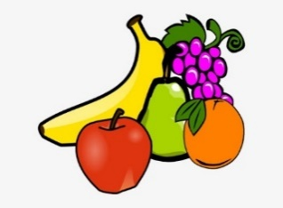

Key theme:

This theme is based on the design and technology curriculum and the activities will help children learn more about how to keep healthy.

Cooking and nutrition
As part of their work with food, pupils should be taught how to cook and apply the principles of nutrition and healthy eating. Instilling a love of cooking in pupils will also open a door to one of the great expressions of human creativity. Learning how to cook is a crucial life skill that enables pupils to feed themselves and others affordably and well, now and in later life.
Pupils should be taught to:

- understand and apply the principles of a healthy and varied diet
- prepare and cook a variety of predominantly savoury dishes using a range of cooking techniques
- understand seasonality, and know where and how a variety of ingredients are grown, reared, caught, and processed

The activities will also link to the English, maths, and art curriculum.

Lower Key Stage 2
The big idea
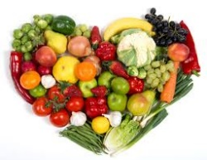
5 a day!

Create ‘5 a day’ for mealtimes

Key learning
DT:
Pupils should be taught to:
- understand and apply the principles of a healthy and varied diet
- prepare and cook a variety of predominantly savoury dishes using a range of cooking techniques
- understand seasonality, and know where and how a variety of ingredients are grown, reared, caught, and processed
How to do it
Fruit and vegetables provide important vitamins and minerals to help keep people healthy. Fruit and vegetables also provide fibre for a healthy digestive system. People should eat at least 5 portions of fruit and vegetables every day. Fresh, frozen, canned, dried, and juiced all count but people should aim to have a variety in their diet. A rough guide to a portion is the amount that fits in the palm of the hand.
This activity is all about helping children understand what makes up a healthy, balanced diet and making this up into a food diary for the week.
Completing the activity:
- Research what makes a healthy diet using the main food groups. These are starchy carbohydrates, protein, dairy, fruit and vegetables, protein, and fats (not too much!).
- Decide which foods could be eaten throughout the day and divide them up into the appropriate meal.
- Make up a format like the one below that could be used to draw or write each meal. The first row could be writing about each meal and the second row could be illustrations.
- To improve this activity even more, some of the meals and drinks could be made and tested.
- Children could also evaluate the taste and ‘healthiness’ of each option after the diary is complete.

Breakfast | Lunch | Evening meal | Snacks | Drinks

Key questions:
- What are the main food groups?
- How could these foods be combined to make the tastiest and healthiest foods and drinks?
- What is the preferred combination?
Useful websites and resources:
www.cookingwithkids.org www.bbcgoodfood.com

Lower Key Stage 2
The big idea
Create a breakfast diary using ideas from across the world
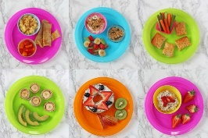

Key learning
DT
Pupils should be taught to:
- understand and apply the principles of a healthy and varied diet
- prepare and cook a variety of predominantly savoury dishes using a range of cooking techniques
- understand seasonality, and know where and how a variety of ingredients are grown, reared, caught, and processed

How to do it
It is important to have breakfast every day as it sets us up by providing the correct nutrients for work and school.
This activity is an ongoing one that is all about creating a healthy breakfast for each day of the week. Children can use the information that they researched in the previous activity to help them with this one.

Completing the activity:
- Research the different kinds of breakfasts that people enjoy across the world. These can change according to the country and the culture.
- Decide on the favourite breakfasts that are currently enjoyed but beware of the sugar content of some of the foods.
- Plan out some ideal recipes that can be used across the week. Take note of the time needed to create some of these foods as time in the early morning can be precious.
- Use the format below, or a similar one, to record the foods eaten for breakfast each day.
- Evaluate how healthy and tasty these breakfasts were at the end of the week.

Day | Food | Drink | Taste?
Monday
Tuesday
Wednesday
Thursday
Friday
Saturday
Sunday

Key questions:
- What are the healthiest foods for breakfast?
- How could these foods be combined to create the best tastes?
Useful websites and resources:
www.cookingwithkids.org www.bbcgoodfood.com

Lower Key Stage 2
The big idea
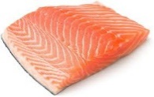
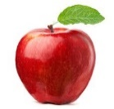
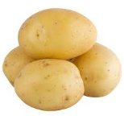
Make a balanced diet game

Key learning
DT:
- understand and apply the principles of a healthy and varied diet
- prepare and cook a variety of predominantly savoury dishes using a range of cooking techniques

How to do it
This activity is based around healthy eating and how to have a balanced diet. The game can be created game around some popular games like ‘Snap’, ‘Happy Families’ or ‘Top Trumps’. These games can be researched online or by showing children the rules of some well-known games.

Think about:
- Whether the game will be based on one type of food or different foods within food groups.
- Whether the game can be played alone or with a small team of people.
- The rules of the game. These might have to be written down and practiced first before the game is played.
- The materials that are available to make the game.

How to make your game:
- Start by researching the foods before the game is made as key information needs to be understood first.
- Card could be used to make the cards for the game. When the objects are being drawn, a rectangle could be drawn on the paper with the pictures completed first before they are cut out.
- Consider using dice or other objects to play the game and make it more interesting.
- Consider writing and drawing foods on one card and then a food group or nutrient on the other set.
- Now make up the rules of the game. These could be written down and altered as the game is played.

Key questions:
- What foods belong to different food groups?
- What could the rules of the game be?

Lower Key Stage 2
The big idea
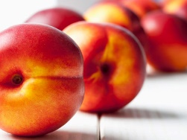
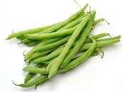
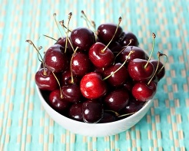
Make up a recipe based on seasonal foods

Key learning
DT
- understand seasonality, and know where and how a variety of ingredients are grown, reared, caught, and processed

How to do it
This activity is all about understanding that certain foods are grown at different times of the year and how this affects what we eat throughout the year. Children can then create a recipe based on these seasonal foods.
Completing the activity:
- Discuss and research a variety of foods that are grown at different times of the year and why this is. If possible, take a look at supermarket recipes that are often freely available.
- Decide on the time of the year that the recipe will be based on and then what foods would be available. It would be useful to discuss with children that different foods are grown in a variety of countries, depending on the climate.
- Look at recipe books, magazines, and online recipes to get an idea of the recipe that could be designed.
- Cut out pictures and photos of the different foods to make the recipe look more interesting.
- Check that the ingredients are available or there is someone that can go shopping to buy them.
- Write down a shopping list of the ingredients that will be needed.
- When the activity is completed, make sure that someone can help the child with the cooking and preparing, particularly if it involves using heat or cutting the ingredients.
- Once the food is created, someone in the home could taste it and give their opinion on what was great about it and how it could be improved in the future.
- The food could also be photographed, and a recipe card could be made as a reminder of how to make it in the future.
- Evaluate what was good about it and what might need to be altered in terms of both the ingredients and the process.

Key questions:
- What does seasonal mean?
- How does it affect the way that we eat?
- What recipe could be made that is seasonal to a particular time of the year?
Useful websites and resources: www.cookingwithkids.org www.bbcgoodfood.com

HIAS Teaching and Learning Team

The HIAS Teaching and Learning Team give practical and supportive advice through coaching and mentoring teachers to improve outcomes for all pupils. They use a ‘plan, do, review’ approach to teaching and learning which broadly includes observation of teaching, personal target setting with areas given to improve, planning, demonstration of lessons and team teaching. The team focus their work on impact within the classroom.

They also work with Senior and Middle Leaders to develop the coaching model in their schools.

For further details referring to Primary Teaching and Learning support, please contact Sarah Sedgwick, Teaching and Learning Adviser: sarah.sedgwick@hants.gov.uk.

For further details on the full range of services available please contact us using the following details:

Tel: 01962 874820 or email: hias.enquiries@hants.gov.uk.

This activity pack was put together with the support of Sarah Pook – DT Inspector sarah.pook@hants.gov.uk.

