Let’s create – the Zoo

Remote learning curriculum pack

Key stage 1 (Years 1 and 2)

Pack 3

HIAS REMOTE LEARNING CURRICULUM PACK

HIAS Teaching and Learning Team

Autumn 2020

Final version

© Hampshire County Council
HIAS Remote Learning Curriculum Pack
Using the Remote Learning Materials

Dear Parents and carers,
Your school is sending you this pack of remote learning activities to help you to support your child at home during the first few days of this isolation period. Your school may also have given you initial English and mathematics resources for the next few days, and this pack of activities can supplement and work alongside these. The school is finalising its plans to deliver your child’s current curriculum remotely to your child, with your support, during the remainder of the isolation period. These plans will be with you shortly and will maintain progress during this short interruption of education at school.
In the meantime, these activities are designed to help your child continue with learning across the wider curriculum, which is linked to the National Curriculum and will build on their existing skills and allow for suitable independence.

How to use the pack and support your child:
- Learning at home is distinctive and different to school but try to establish a routine with your child. These activities are practical and creative and can be used to work alongside the other remote learning activities.
- Encourage your child to choose the activities that most interest them. Some will build on knowledge that they already have, and some will be newer learning; but all are designed to be practical and fun.
- Activities may need reading with your child and explaining, and you may need to help them find resources. All the activities can be adapted where needed to make them work for you.
- The activities have been designed to enable a good amount of independence. Let your child work at their own pace, encourage them and celebrate their achievements frequently.
- These activities could take approximately 2 to 3 hours to complete (approximately half a day) but can be spread across a few days if necessary. There is no time limit to the activities, they may take more or less than the suggested time.

Let’s create – the Zoo
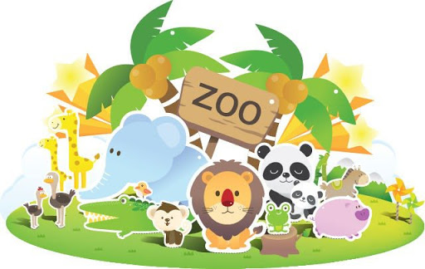
What is a zoo?
- A zoo is a park that looks after many animals that live on the planet.
- Most people enjoy zoos because they can learn about other parts of the world where different animals live in the wild.
- There are lots of reasons why animals live in a zoo. They may have been hurt and cannot live without help from people.
- Some come from families that have always had people to take care of them.
- A zoo is a safe place for these animals to live.

Key theme: This theme is linked to the design technology curriculum and will involve children designing and making various objects around the theme of zoos and how they work hard to keep certain animals safe.

When designing and making, pupils should be taught to:
Design
- design purposeful, functional, appealing products for themselves and other users based on design criteria
- generate, develop, model and communicate their ideas through talking, drawing, templates, mock-ups and, where appropriate, information and communication technology
Make
- select from and use a range of tools and equipment to perform practical tasks [for example, cutting, shaping, joining and finishing] select from and use a wide range of materials and components, including construction materials, textiles and ingredients, according to their characteristics
Evaluate
- explore and evaluate a range of existing products
- evaluate their ideas and products against design criteria
Technical knowledge
- build structures, exploring how they can be made stronger, stiffer and more stable
Key Stage 1
The big idea
Design and draw an enclosure for zoo animals
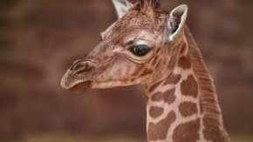

Key learning
DT:
This task is based on the National Curriculum objective for DT that state that children need to design purposeful, functional, appealing products for themselves and other users based on a design criteria.
How to do it
This activity is all about designing and drawing enclosures for zoo animals. It is important to tell children the different places that animals can live and that zoos serve the purpose of conservation and protection.

Completing the activity:
- Start by sharing different pictures of zoo animals and where they might live. If they live in a zoo discuss what sort of enclosure would they need e.g. great height for a giraffe, smaller enclosure for a snake etc.
- Go on a walk and/or look at photographs of the local area to explore structures such as playground equipment, street furniture, walls, towers, and bridges. What are the structures called and what is their purpose? Who might use them? What materials have been used? Why have these been chosen? How have the parts been joined? How have the structures been made strong enough? How have they been made stable?
- Talk to children about how these structures could relate to the zoo enclosures and how they will need to differ depending on the needs of the animal.
- Draw or photograph the structures that have been explored and label with the correct technical vocabulary in relation to the structure, materials used and shapes e.g. wall, tower, framework, base, joint, metal, wood, plastic, brick, triangle, square, rectangle, cuboid, cube.

Key questions:
- Where do different animals come from and where and how do they live in the wild?
- What will the enclosure look like to meet the needs of the animal in the zoo?

Key Stage 1
The big idea
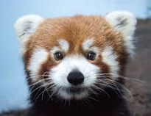
Make an enclosure for a zoo animal

Key learning
DT:
- design purposeful, functional, appealing products for themselves and other users based on a design criteria
- to select from and use a range of tools and equipment to perform practical tasks, selecting from a wide range of materials
How to do it
This activity can follow on from the previous activity where the child can make the zoo enclosure that they have designed. Decide on the enclosure to be made and gather suitable materials to make it.
Getting started:
- Explore a variety of freestanding structures using construction kits, such as wooden blocks, interconnecting plastic bricks and those that make frameworks.
- Discuss how the structure can be made stable and how they can be made to be stronger and stiffer to carry a load. Consider making simple models of the structures seen in school, home and the local area.
- Gather the different materials needed. They could include cardboard boxes or tubes, paper, paints, or plastic bricks.
- Discuss with the children what structure they will be designing, making, and evaluating e.g. Who will your product be for? What will be its purpose? What materials will you use? How will you make it strong and stable?
- Generate some simple design criteria with the child e.g. the structure should stand up on its own, it should be strong enough for the animals to live in.
Completing the activity:
- Demonstrate measuring, marking out, cutting, shaping, joining, and finishing techniques with a range of tools and new and reclaimed materials that could be used to make the structures. Discuss the suitability of materials for their products according to their characteristics.
- Fold paper or card in different ways to make freestanding structures, using masking tape where necessary to make joins. Encourage the child to think about how folding materials can make them stronger, stiffer, stand up and be more stable e.g. Can they support an object on top of their structures without it falling over or breaking?
- Discuss with the child what structure they will be designing, making, and evaluating e.g. Who will your product be for? What will be its purpose? What materials will you use? How will you make it strong and stable?
- Generate some simple design criteria e.g. the structure should stand up on its own and it should be strong enough for the animals to live in.
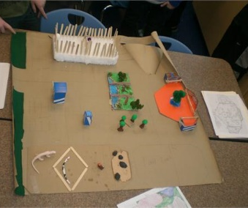
- Encourage the development of ideas through talking, drawing, and making mock-ups of their ideas with construction kits and other materials.
- Finally evaluate the developing ideas and final products against original design criteria

Key questions:
- What materials will make the most effective enclosure for the animal?
- How will the enclosure need to be adapted for the animals?
- What went well and what could be improved?
Useful websites and resources:
www.redtedart.com http://kidscraftroom.com

Key Stage 1
The big idea
Make animals to live in the zoo
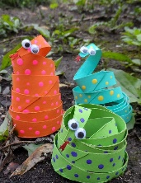
Cardboard cubed coiled snakes

Key learning
DT:
- design purposeful, functional, appealing products for themselves and other users based on a design criteria
- to select from and use a range of tools and equipment to perform practical tasks, selecting from a wide range of materials, including ingredients
How to do it
These cardboard, coiled snakes are ideal animals to live in the zoo!
N.B: Children may need help with cutting and gluing.

Materials to use:
3 cardboard tubes
Tube from wrapping paper or similar tubular item
6 googly eyes (these can be painted if they cannot be bought)
Toothpick
PVA glue
Scissors (children’s safety scissors or help with the cutting)
Craft paint in a choice of colours

Completing the activity:
- Paint the inside and outside of the cardboard tubes. Apply a second coat if needed.
- Using a tube from wrapping paper, or something similar, cut the tubes into coils. Make sure that the cardboard is dry, otherwise it might not hold its shape.
- Wrap the cut cardboard around the tube loosely. Use the handle end of a paintbrush to add polka dots with a contrasting colour of paint. Let dry completely then flip over to the other side and finish the polka dots.
- Remove from the tube and wrap the painted cardboard in coil fashion around a finger.
- Place the coiled cardboard on the table. Paint the end with red and let it dry.
- Meanwhile, glue on googly eyes, adding the glue with a toothpick since they are small or paint them on if ‘googly’ eyes can’t be found.
- When the red paint is dry, use some small scissors to snip the red end into a forked tongue. An easier option, is to cut a forked tongue from red construction paper, snip the end of the cardboard to cut off the point, and glue that paper tongue in place instead.
- Place your snake inside the zoo!

Key questions:
- How could the snake be made to look realistic?
- What other patterns could be used to design the outside of the snake?
- What went well and what could be improved?

Key Stage 1
The big idea
Make animals to live in the zoo
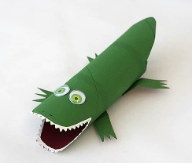
Cardboard tube alligator

Key learning
DT:
- design purposeful, functional, appealing products for themselves and other users based on a design criteria
- to select from and use a range of tools and equipment to perform practical tasks, selecting from a wide range of materials, including ingredients
How to do it
This alligator will look fierce in the zoo! This creature can easily be made from household items. If it isn’t possible to get the ‘googly’ eyes, then these can be painted on instead.
N.B: children may need help with cutting and gluing.

Materials to use:
Paper towel tube
green and white paint
glue dots
paintbrush
scissors
pinking shears
googly eyes
craft glue
black fine point marker

Completing the activity:
- Cut the tube into two sections – 10cms and 17cms.
- Use the pinking shears to cut about 4cms into one end of the tube. Repeat this same cut on the other side. Then cut two more slits from the end of the tube at 45-degree angle, joining them with the ends of the first two slits. This creates the open mouth.
- Using regular scissors at the opposite end of the tube, cut out the tail.
- Take the tail piece that has just been cut from the tube and flatten it. Cut that piece into four equal pieces for the alligator's feet.
- Cut toes from the foot pieces.
- Shape the mouth with the pinking shears. Cut so that both sides are angled and trim the front edges, so they look like teeth.
- Paint the entire tube with green paint.
- Paint the feet green.
- When everything is dry, paint the teeth white.
- Add a glue dot to the flat end of each foot.
- Attach the legs to the alligator's body.
- Add googly eyes and use a fine point marker to add nostrils (or paint them).

The alligator is now ready to go into the zoo!
Key questions:
- How realistic is the made alligator against a picture of a real one?
- What went well and what could be improved next time?

HIAS Teaching and Learning Team

The HIAS Teaching and Learning Team give practical and supportive advice through coaching and mentoring teachers to improve outcomes for all pupils. They use a ‘plan, do, review’ approach to teaching and learning which broadly includes observation of teaching, personal target setting with areas given to improve, planning, demonstration of lessons and team teaching. The team focus their work on impact within the classroom.

They also work with Senior and Middle Leaders to develop the coaching model in their schools.

For further details referring to Primary Teaching and Learning support, please contact Sarah Sedgwick, Teaching and Learning Adviser: sarah.sedgwick@hants.gov.uk

For further details on the full range of services available please contact us using the following details:

Tel: 01962 874820 or email: hias.enquiries@hants.gov.uk.

This activity pack was put together with the support of Sarah Pook – DT Inspector sarah.pook@hants.gov.uk.

