Summer is here!

Remote learning curriculum pack Upper Key Stage 2 (Years 5 and 6)

Pack 11

HIAS REMOTE LEARNING CURRICULUM PACK

HIAS Teaching and Learning Team

Summer 2021

Final version

© Hampshire County Council
HIAS Remote Learning Curriculum Pack
Using the Remote Learning Materials
Dear Parents and carers,

Your school is sending you this pack of remote learning activities to help you to support your child at home. Your school may also have given you English and mathematics resources, and this pack of activities can supplement and work alongside these.
These activities are designed to help your child continue with learning across the wider curriculum, which is linked to the National Curriculum and will build on their existing skills, help them learn new ones, and allow for suitable independence.

How to use the pack and support your child:
- Learning at home is distinctive and different to school but try to establish a routine with your child. These activities are practical and creative and can be used to work alongside the other remote learning activities.
- Encourage your child to choose the activities that most interest them. Some will build on knowledge that they already have, and some will be newer learning; but all are designed to be practical and fun.
- Activities may need reading with your child and explaining, and you may need to help them find resources. All the activities can be adapted where needed to make them work for you.
- The activities have been designed to enable a good amount of independence. Let your child work at their own pace, encourage them and celebrate their achievements frequently.
- These activities could take approximately 2 to 3 hours to complete (approximately half a day) but can be spread across a few days if necessary. There is no time limit to the activities, they may take more or less than the suggested time.

Summer is here!

Key theme:

This theme is linked to all areas of the curriculum and is a chance to explore the theme of summer through many different subjects. Children will be able to create artwork, share their English and maths skills and explore their knowledge of geography, history and science in the following activities.

Upper Key Stage 2
The big idea
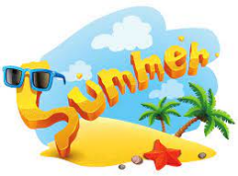

A Summer Work of Art

Key learning
Art:
Pupils should be taught:
- to create sketch books to record their observations and use them to review and revisit ideas.
- to improve their mastery of art and design techniques, including drawing, painting and sculpture with a range of materials (for example, pencil, charcoal, paint, clay).
- about great artists, architects and designers in history.

How to do it
During the school year, there will have been many opportunities to learn new skills in art. This is the chance for you to choose your favourite art techniques to create a summer related work of art!

Think about:

- What style of art is your favourite? There is sketching, painting, 3D sculpture, textiles, collage and printing to name just a few. You will need to think about what materials you have available to use at home.
- What part of summer you are going to create. It could be:
- a landscape of a beautiful summer scene that you might see at the beach or a park
- a portrait of a person in summer clothes or doing a summer activity
- a still life of flowers or summer food
- a print or collage made up of summer images
- an abstract picture or model that reflects summer colours
- Are you going to use the style of an artist that you have studied at school? Here are a few artists that you might like to think about, but there are hundreds of others you might know:
- Vincent Van Gogh – sunflowers, the yellow house, wheat field with crows
- Georgia O’Keefe – red poppy, light iris, shells
- Yvonne Coomber – flower scenes
- Pierre-Auguste Renoir – people and scenes
- Claude Monet – flower gardens
- David Hockney – swimming pools
- What size will your artwork be? You will be limited by what you have available, but you could always tape some sheets of paper together to get a bigger size ‘canvas’.

Completing the activity:

- Collect all the materials that you will need for your work. If you are drawing/painting a still life, then you will need to set up the items in an interesting position:
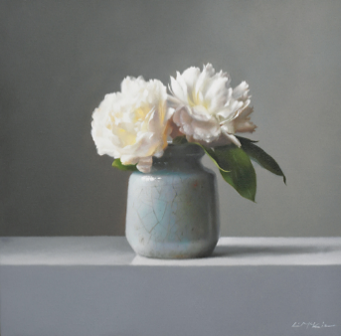
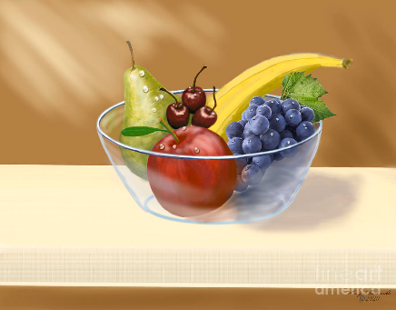
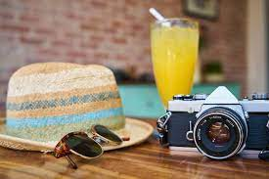

- Find somewhere you can work quietly.
- Enjoy!

Useful questions:
- Do you have all the resources you need for your artwork?
- Do you have a clear idea of the style?

Useful websites and resources:
https://www.yvonnecoomber.com/?UTM_source=GMB_listing&UTM_medium=organic
https://www.tate.org.uk/kids/make/paint-draw/create-art-van-gogh
https://www.tate.org.uk/kids/make
https://www.georgiaokeeffe.net/paintings.jsp
https://www.wikiart.org/en/pierre-auguste-renoir
https://blog.bridgemanimages.com/blog/here-comes-the-sun-famous-paintings-of-summer
https://www.tate.org.uk/art/artists/david-hockney-1293
Upper Key Stage 2
The big idea
A World Traveller

Key learning
Geography:
Pupils should extend their knowledge and understanding beyond the local area to include the United Kingdom and Europe, North and South America. This will include the location and characteristics of a range of the world’s most significant human and physical features. They should develop their use of geographical knowledge, understanding and skills to enhance their locational and place knowledge.
Art:
Pupils should create sketch books to record their observations and use them to review and revisit ideas.

How to do it
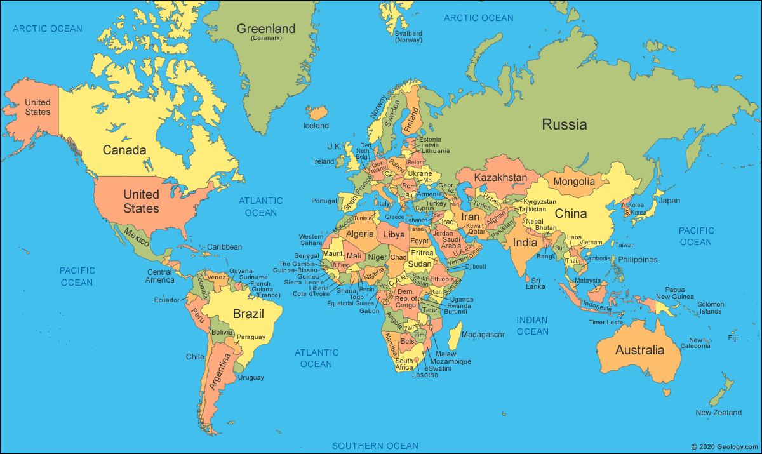
The world is an amazing place filled with beautiful countries, exciting people and breath-taking places to visit. Where in the world would you really like to go?

You are going to create a mood board of future travel destinations!

Think about:

- Where would you really like to travel to when you have the chance? Have you heard about places from programmes; studied places at
school; seen beautiful pictures on the internet? Make a list of the places that really interest you.
- What is a mood board:

A mood board is a type of visual presentation or 'collage' consisting of images, text, and samples of objects in a composition. It can be based
on a set topic or can be any material chosen at random. A mood board can be used to convey a general idea or feeling about a particular
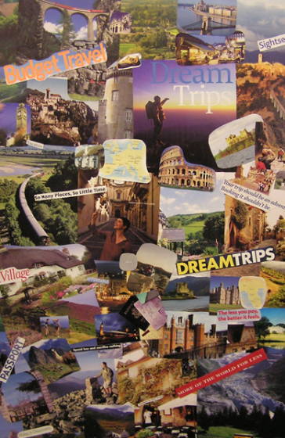
topic.

Completing the activity:

- Choose the countries you are going to include on your travel mood board.
- Collect or draw images that link with each country. This could include a part of a map where it is, a picture of a famous place
or landmark, foods and plants and animals that come from the country and lots more ideas as well.
- Choose some paper or card to create your mood board on. It is up to you what size you choose.
- Cut out and arrange your images so that they create a picture.
- You can fill in spaces with words, colours and pictures of ways to travel like planes and boats.
- As an alternative, you could create your mood board on a computer or tablet. Publisher, PowerPoint or a paint programme would all
work well.
- You could create one together with your family as a way to plan future holidays.

Useful questions
- Have you included a range of images for each country?
- Are there different places in the same country that you could group together?
- Does your board inspire you to go there?

Upper Key Stage 2
The big idea
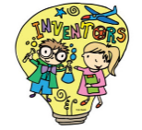
Ready, Set, Invent!

Key learning
Design and Technology:
Design
- use research and develop design criteria to inform the design of innovative, functional, appealing products that are fit for purpose, aimed at particular individuals or groups.
- generate, develop, model and communicate their ideas through discussion, annotated sketches, cross-sectional and exploded diagrams, prototypes, pattern pieces and computer-aided design.

How to do it
The summer is an amazing time to enjoy fun activities in the warm sunshine. However, there are often annoying little things that get in the way – like sand in your sandwiches or ice-cream dripping down your fingers. Wouldn’t it be great if someone invented something to help? Well now is your chance! Ready … Set … Invent!

Think about:

- What are some of the problems that annoy you or your family when you are enjoying your summer fun? Write these down as these will be part of the design process.
- Think about what the main issues are and what really needs to be solved.
- Don’t worry about how strange your idea seems – there really are crazy inventions out there:
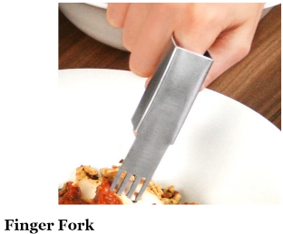
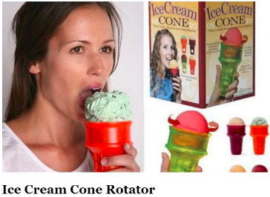
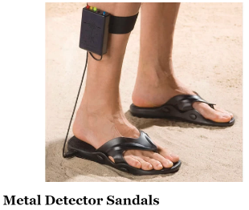

Completing the activity:

- Write down what the problem is that you are trying to solve – this is your design statement.
- Draw a series of clear diagrams of the ideas for your invention. Try to draw them from a range of different views:

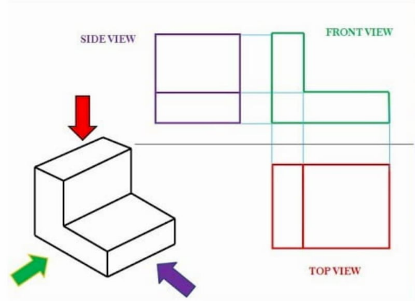
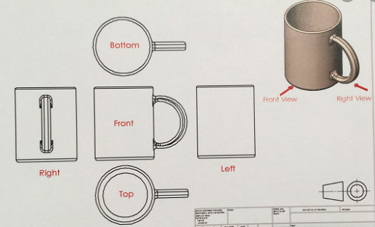

- Make sure you label the parts of your invention – what does each part do? You could try to include an exploded diagram:

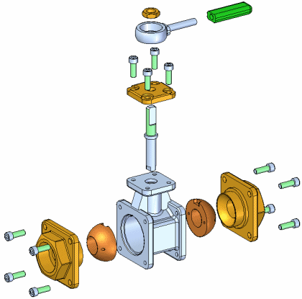

- Finally, write about how things will be better with your design! (Who knows – you might actually create your invention in the years to come).

Useful questions
- Is the problem something you really want to solve?
- Are the diagrams clear and labelled?
- Have you explained how things will be better when using your invention?
Useful websites and resources:
https://www.bbc.co.uk/bitesize/guides/zrx7xfr/revision/6
https://www.boredpanda.com/kids-inventions-turned-into-reality-inventors-project-dominic-wilcox/?utm_source=google&utm_medium=organic&utm_campaign=organic

Upper Key Stage 2
The big idea
Devise a general knowledge quiz about everything you have learnt about this year

Key learning
This activity can focus on any subjects or subjects that the child has enjoyed learning about this year. This could include maths, English, science, art, geography, or history.

How to do it
The starting point for this activity will be to discuss with the child what they have enjoyed about their learning this year. As the year has been a very different one for children this may be some work or project that they have undertaken at home or work that they have completed in their time in school.

Think about:

The subjects that could be covered are:
- Art
- Science
- Geography
- History
- Music
- English
- Maths

Completing the activity:
- Decide on the theme of the quiz and gather the information that you already know about the subject or subjects. There may need to be some time doing further research.
- Gather the materials needed to make the quiz. This could be in the form of white card or thin paper that can be cut into rectangles to make cards. If you have access to technology, then you could create a quiz on Kahoot (an adult would need to sign up for an account).
- Write a question on one side of the card and the answer on the back. This will really test the knowledge of all the family!
- Alternatively, the quiz could take the form of multiple-choice questions that could be written on one piece of paper.
- You can make the quiz more attractive by adding pictures to show the key learning in an attractive way.

Useful questions
- Will the quiz test one area or subject and why has this focus been chosen?
- How will the questions test your knowledge?
Useful websites and resources
https://kahoot.com/
https://www.quiz-maker.com/

HIAS Teaching and Learning Team

The HIAS Teaching and Learning Team give practical and supportive advice through coaching and mentoring teachers to improve outcomes for all pupils. They use a ‘plan, do, review’ approach to teaching and learning which broadly includes observation of teaching, personal target setting with areas given to improve, planning, demonstration of lessons and team teaching. The team focus their work on impact within the classroom.

They also work with Senior and Middle Leaders to develop the coaching model in their schools.

For further details referring to Primary Teaching and Learning support, please contact Sarah Sedgwick, Teaching and Learning Adviser: sarah.sedgwick@hants.gov.uk

For further details on the full range of services available please contact us using the following details:

Tel: 01962 874820 or email: hias.enquiries@hants.gov.uk.

