Over the land, over the sea

Remote learning curriculum pack Upper Key Stage 2 (Years 5 and 6) Pack 10

HIAS REMOTE LEARNING CURRICULUM PACK

HIAS Teaching and Learning Team

Summer 2021

Final version

© Hampshire County Council
HIAS Remote Learning Curriculum Pack
Using the Remote Learning Materials
Dear Parents and carers,

Your school is sending you this pack of remote learning activities to help you to support your child at home. Your school may also have given you English and mathematics resources, and this pack of activities can supplement and work alongside these.
These activities are designed to help your child continue with learning across the wider curriculum, which is linked to the National Curriculum and will build on their existing skills, help them learn new ones, and allow for suitable independence.

How to use the pack and support your child:
- Learning at home is distinctive and different to school but try to establish a routine with your child. These activities are practical and creative and can be used to work alongside the other remote learning activities.
- Encourage your child to choose the activities that most interest them. Some will build on knowledge that they already have, and some will be newer learning; but all are designed to be practical and fun.
- Activities may need reading with your child and explaining, and you may need to help them find resources. All the activities can be adapted where needed to make them work for you.
- The activities have been designed to enable a good amount of independence. Let your child work at their own pace, encourage them and celebrate their achievements frequently.
- These activities could take approximately 2 to 3 hours to complete (approximately half a day) but can be spread across a few days if necessary. There is no time limit to the activities, they may take more or less than the suggested time.

Over the land, over the sea
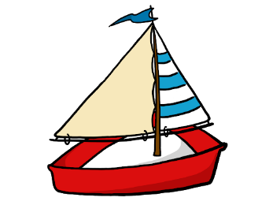

Key theme:

This theme is linked to the geography curriculum for Upper Key Stage 2 and explores the world around us.

Pupils in Key Stage 2 should be taught:
Locational knowledge
- locate the world’s countries, using maps to focus on Europe (including the location of Russia) and North and South America, concentrating on their environmental regions, key physical and human characteristics, countries, and major cities.
- name and locate counties and cities of the United Kingdom, geographical regions and their identifying human and physical characteristics, key topographical features (including hills, mountains, coasts and rivers), and land-use patterns; and understand how some of these aspects have changed over time.
Human and physical geography
describe and understand key aspects of:
- physical geography, including: climate zones, biomes and vegetation belts, rivers, mountains, volcanoes and earthquakes, and the water cycle.
- human geography, including: types of settlement and land use, economic activity including trade links, and the distribution of natural resources including energy, food, minerals and water.
Geographical skills and fieldwork
- use maps, atlases, globes and digital/computer mapping to locate countries and describe features studied.
- use the eight points of a compass, four and six-figure grid references, symbols and key (including the use of Ordnance Survey maps) to build their knowledge of the United Kingdom and the wider world.
- use fieldwork to observe, measure, record and present the human and physical features in the local area using a range of methods, including sketch maps, plans and graphs, and digital technologies.

Upper Key Stage 2
The big idea
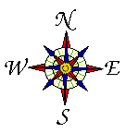
Use a compass and create a trail round your home or garden

Key learning
Geography:
- use the eight points of a compass and symbols and key (including the use of Ordnance Survey maps) to build their knowledge
- use fieldwork to observe, measure, record and present the human and physical features in the local area using a range of methods, including sketch maps, plans and graphs

How to do it
You are going to create a trail around your home or garden using the 8 points of a compass and a map. You could watch this BBC teach video to give you some ideas:
https://www.bbc.co.uk/teach/class-clips-video/maths-ks2-using-compass-and-reading-maps/z77tf4j

Think about:
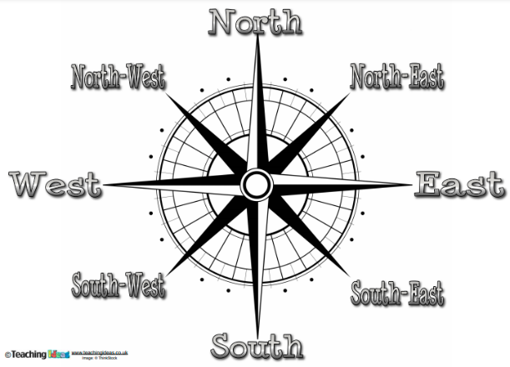
- What the 8 compass points are and how we use them. You are going to have to use a picture version of a compass for your task (unless you actually have a compass at home!) They are designed to help us move around an area using language that everyone would understand.
These are the direction points. You usually have one of these drawn
on your map so that you know which way North is. Then you can
work out the other directions.

- You are going to choose a starting point either inside your home or in your garden. It needs to be something that never moves, like a door or window or gate. You need to decide what measures you are going to give. For example, are you using metres? This is great if you have a tape measure or you could make a measuring stick for yourself. Or you could give your measurements in strides or steps or paces.
- You could also choose some other landmarks or objects that you could include in your instructions to make it easier for the person following them.

Completing the activity:

- Choose your starting point. Write this as your first instruction on your map or list.
- Think about which way you need to face for the first set of moves – give this as an instruction. For example, face east and move 6 paces. Make sure that your map has a clear compass drawn at the top.
- Move around your space, plotting the moves and directions as you go. If you are using other landmarks, then remember to include them. For example, move 5 paces North and you should now be at the kitchen sink!
- Think about where your trail will finish. What might you find there are a prize for following the trail?
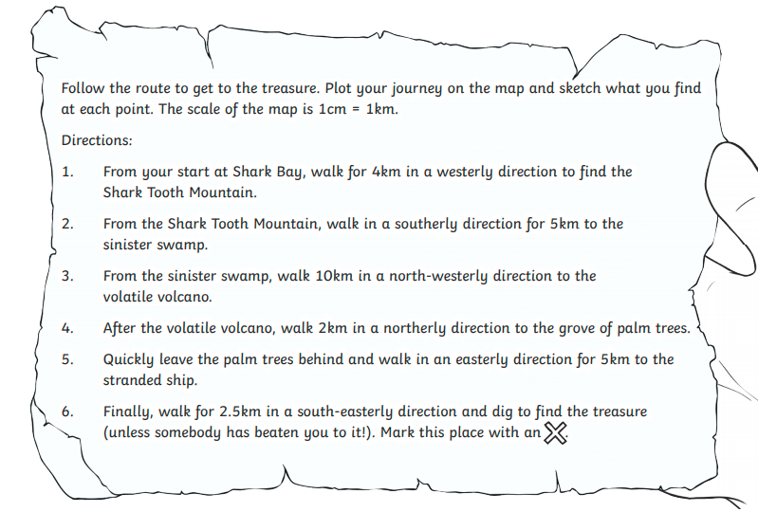
- Draw the map and/or write the set of instructions clearly, so that someone can read them and follow them. It would be a good idea for you to check the instructions!
- Good luck.
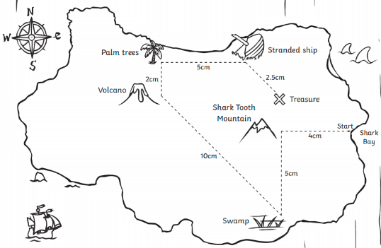

Useful questions
- Have you got a compass, could you make one or will use draw one on your paper?
- Are the instructions really clear to follow.
- Have you used all 8 compass points?

Useful websites and resources:
https://www.bbc.co.uk/teach/class-clips-video/maths-ks2-using-compass-and-reading-maps/z77tf4j

Upper Key Stage 2
The big idea
World Countries – Top Trump cards

Key learning
Geography:
- locate the world’s countries, using maps to focus on Europe (including the location of Russia) and North and South America, concentrating on their environmental regions, key physical and human characteristics, countries, and major cities.
- use maps, atlases, globes and digital/computer mapping to locate countries and describe features studied
English:
- identifying the audience for and purpose of the writing, selecting the appropriate form and using other similar writing as models for their own

How to do it
You are going to create a Top Trumps type game linked to different countries from around the world.

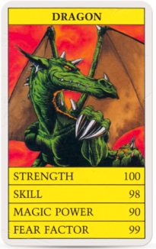
In Top Trump packs, the cards are based on a theme, such as cars, aircraft, books, boats, dinosaurs, or characters from a popular film or television series. In this case, it will be countries. Each card in the pack shows a list of numerical data about the item. For example, in a pack based on mythical creatures (like the example shown) the categories are: strength, skill, magic power and fear factor.

Think about:

- Which countries you will include on your cards? It would be good to have at least one country from each of the seven continents. This might be enough for you to make.

Continents;
- Europe
- Asia
- Africa
- North America
- South America
- Australia/Oceania
- Antarctica

- What will be the 4 or 5 categories that you include on each card? These have to be exactly the same for each one, so you will need to choose categories that you can research for each country. Some ideas could be:

- Population – the number of people
- Size of the country
- Biome area
- Key physical features

- You then have to decide how to give each of your categories a value. For population and country size, you might just use the exact number but for the others you will a value. Think of the range – for example if you are doing climate, 1 could be for the coldest countries up to 10 for the hottest.

Completing the activity:

- Decide on the categories that you will have on your cards. Four or five is usual, but you can decide this for yourself.
- Research and make note for the countries that you choose. Remember to find out the same things for each country.
- Draw or make your Top Trump style cards. You could just draw them onto a piece of paper or you could cut them out of card. Empty cereal boxes would be the right kind of card for this job. Here is a template of what your card should look like:

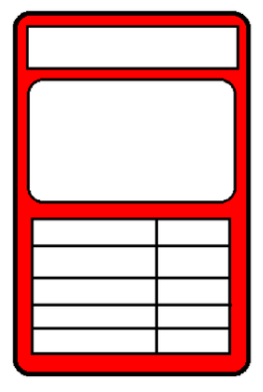

- Fill in the information on each card and draw a picture. This could be the flag of the country or something that the country is well known for, like an animal. Remember to write the name of the country at the top of your card.
- You now might want to write some rules for playing the game so that everyone understands.
- Happy playing!

Useful questions
- Have you thought about using one country from each continent?
- Have you found out the right information for each one?
- Have you presented your work neatly and carefully?
- Are your rules clear?

Useful websites and resources:
https://en.wikipedia.org/wiki/Top_Trumps
https://www.wikihow.com/Play-Top-Trumps

Upper Key Stage 2
The big idea
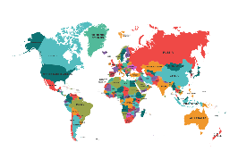
Research a country of interest and present in any format

Key learning
Geography:
- locate the world’s countries, using maps to focus on Europe (including the location of Russia), North, and South America, concentrating on their environmental regions, key physical and human characteristics, countries, and major cities.
- name and locate counties and cities of the United Kingdom, geographical regions and their identifying human and physical characteristics, key topographical features (including hills, mountains, coasts and rivers), and land-use patterns; and understand how some of these aspects have changed over time
English:
- retrieve, record and present information from non-fiction texts
- identify the audience for and purpose of the writing, selecting the appropriate form and using other similar writing as models for their own
- noting and developing initial ideas, drawing on reading and research where necessary

How to do it
There are many countries around the world full of varied landscapes, people, climates, plants and animals. You may have been lucky enough to visit some places outside of England or you may have dreams of visiting far off lands in the future. Well now is your chance to research an exciting foreign country and present what you have discovered. Good luck and happy traveling.
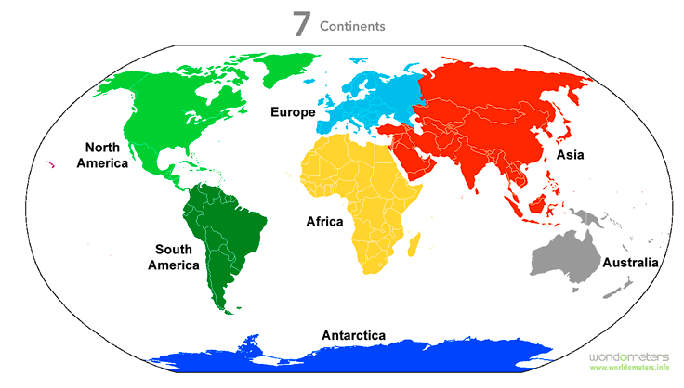
Think about:

- Where in the world is your country? You will need a world map
or find one on the internet. You need to have a clear idea of
which continent your country is in.
https://www.worldometers.info/geography/7-continents/

- Which country are you going to focus on? You need to decide what information you think is the most interesting about your country, but this should include both physical and human characteristics:

- Physical features: Biomes, Rivers, Mountains, Volcanoes, Earthquakes, Waterfalls, Oceans.
- Human characteristics: houses, roads and bridges are things that have been built by people.

- 3) How will your present your research? This could be a travel brochure or leaflet. It could be a poster or model. It could be a
- powerpoint or other presentation on your computer or device.

Completing the activity:

- Research your chosen country and make detailed notes. Make sure you include the information about where in the world it is; about the human population (about food and culture) and about natural and physical features (including plants and animals).
- Present your information in a clear and organised way. You can look in information books to help you decide on a written layout or look at websites if you are choosing a detail media.
- Make sure that you check the spelling, punctuation and grammar of the sentences you are using.

Useful questions
- Have you included physical features of the country?
- Have your included human characteristics of the country?
- Have you edited your work to check and improve it?

Useful websites and resources:
https://www.worldometers.info/geography/7-continents/
https://www.kids-world-travel-guide.com/
https://www.natgeokids.com/uk/category/discover/geography/
https://www.ducksters.com/geography/

Upper Key Stage 2
The big idea
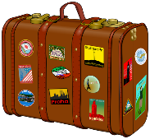
Pack a Biome Travel Bag

Key learning
Geography:
- describe and understand key aspects of: physical geography, including: climate zones, biomes and vegetation belts, rivers, mountains, volcanoes and earthquakes, and the water cycle.
- use maps, atlases, globes and digital/computer mapping to locate countries and describe features studied

How to do it
A biome is a large region of Earth that has a certain climate and certain types of living things. Major biomes include tundra, forests, grasslands, and deserts. The plants and animals of each biome have traits that help them to survive in their particular biome. Each biome has many ecosystems.

You are going to choose one of the world biomes. Then using the characteristics of this chosen biome, decide what items you would need to take in your Biome Travel Bag in order to prepare for its weather and climate, as well as its plants and animals. You will need to explain why you have packed each item, making clear links to the features of the biome.

Think about:

- What the different biomes of the world are. This BBC Bitesize clip gives you some information, but you will probably need to visit some other websites to get more information. Some biomes include rainforest, desert, savannah etc
https://www.bbc.co.uk/bitesize/topics/z849q6f/articles/zvsp92p

- What is the weather and climate like in your chose biome? What clothes will you need to be dressed appropriately?

- What animals and plants will you encounter in your biome? Do you need protecting from them or do you need equipment to help you see or study them?

Completing the activity:

- Decide on the biome that you want to focus on. Make notes on the main features about weather, climate, plants and animals.
- You can then draw your travel bag – this could be a rucksack or suitcase or sports bag.
- Then make a list of all the items you will pack for your visit to the biome. Remember for each item you have to explain why you are taking it. Make sure your reasons link to a feature of the biome.
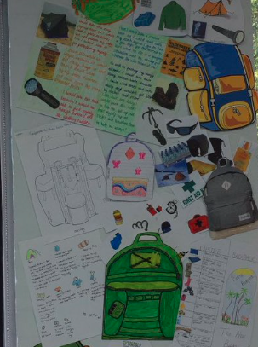
Here are some examples of how children have completed this task:
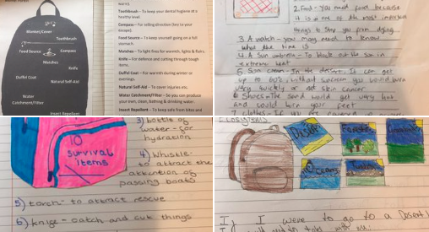

Useful questions
- Which of the world’s biomes will you choose and why?
- Are all the items in your travel bag necessary for you trip there?
- How will each of them be used?

Useful websites and resources:
https://www.bbc.co.uk/bitesize/topics/z849q6f/articles/zvsp92p
https://www.ducksters.com/science/ecosystems/world_biomes.php
https://www.youtube.com/watch?v=_vAOarzqZhg
https://kidsdiscover.com/spotlight/biomes-for-kids/

HIAS Teaching and Learning Team

The HIAS Teaching and Learning Team give practical and supportive advice through coaching and mentoring teachers to improve outcomes for all pupils. They use a ‘plan, do, review’ approach to teaching and learning which broadly includes observation of teaching, personal target setting with areas given to improve, planning, demonstration of lessons and team teaching. The team focus their work on impact within the classroom.

They also work with Senior and Middle Leaders to develop the coaching model in their schools.

For further details referring to Primary Teaching and Learning support, please contact Sarah Sedgwick, Teaching and Learning Adviser: sarah.sedgwick@hants.gov.uk

For further details on the full range of services available please contact us using the following details:

Tel: 01962 874820 or email: hias.enquiries@hants.gov.uk.

