Over the land, over the sea

Remote learning curriculum pack Lower Key Stage 2 (Years 3 and 4) Pack 10

HIAS REMOTE LEARNING CURRICULUM PACK

HIAS Teaching and Learning Team

Summer 2021

Final version

© Hampshire County Council
HIAS Remote Learning Curriculum Pack
Using the Remote Learning Materials
Dear Parents and carers,

Your school is sending you this pack of remote learning activities to help you to support your child at home. Your school may also have given you English and mathematics resources, and this pack of activities can supplement and work alongside these.
These activities are designed to help your child continue with learning across the wider curriculum, which is linked to the National Curriculum and will build on their existing skills, help them learn new ones, and allow for suitable independence.

How to use the pack and support your child:
- Learning at home is distinctive and different to school but try to establish a routine with your child. These activities are practical and creative and can be used to work alongside the other remote learning activities.
- Encourage your child to choose the activities that most interest them. Some will build on knowledge that they already have, and some will be newer learning; but all are designed to be practical and fun.
- Activities may need reading with your child and explaining, and you may need to help them find resources. All the activities can be adapted where needed to make them work for you.
- The activities have been designed to enable a good amount of independence. Let your child work at their own pace, encourage them and celebrate their achievements frequently.
- These activities could take approximately 2 to 3 hours to complete (approximately half a day) but can be spread across a few days if necessary. There is no time limit to the activities, they may take more or less than the suggested time.

Over the land, over the sea
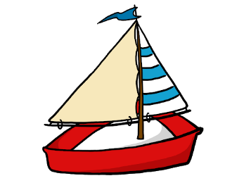

Key theme:

This theme is linked to the geography curriculum for Lower Key Stage 2 and explores the world around us.

Pupils in Key Stage 2 should be taught:
Locational knowledge
- locate the world’s countries, using maps to focus on Europe (including the location of Russia) and North and South America, concentrating on their environmental regions, key physical and human characteristics, countries, and major cities.
- name and locate counties and cities of the United Kingdom, geographical regions and their identifying human and physical characteristics, key topographical features (including hills, mountains, coasts and rivers), and land-use patterns; and understand how some of these aspects have changed over time.
Human and physical geography
describe and understand key aspects of:
- physical geography, including: climate zones, biomes and vegetation belts, rivers, mountains, volcanoes and earthquakes, and the water cycle.
- human geography, including: types of settlement and land use, economic activity including trade links, and the distribution of natural resources including energy, food, minerals and water.
Geographical skills and fieldwork
- use maps, atlases, globes and digital/computer mapping to locate countries and describe features studied.
- use the eight points of a compass, four and six-figure grid references, symbols and key (including the use of Ordnance Survey maps) to build their knowledge of the United Kingdom and the wider world.
- use fieldwork to observe, measure, record and present the human and physical features in the local area using a range of methods, including sketch maps, plans and graphs, and digital technologies.

Lower Key Stage 2
The big idea
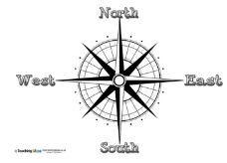
Use a compass and create a trail round your home or garden

Key learning
Geography:
- use the points of a compass and symbols and key (including the use of Ordnance Survey maps) to build their knowledge
- use fieldwork to observe, measure, record and present the human and physical features in the local area using a range of methods, including sketch maps, plans and graphs

How to do it
You are going to create a trail around your home or garden using the 4 points of a compass and a map. You could watch this BBC teach video to give you some ideas:
https://www.bbc.co.uk/teach/class-clips-video/maths-ks2-using-compass-and-reading-maps/z77tf4j

Think about:
- What the 4 compass points are and how we use them. You are going to have to use a picture version of a compass for your task (unless you actually have a compass at home!) They are designed to help us move around an area using language that everyone would understand.
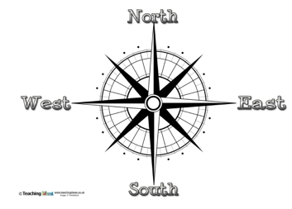
These are the direction points. You usually have one of these drawn
on your map so that you know which way North is. Then you can
work out the other directions.

- You are going to choose a starting point either inside your home or in your garden. It needs to be something that never moves, like a door or window or gate. You need to decide what measures you are going to give. For example, are you using metres? This is great if you have a tape measure or you could make a measuring stick for yourself. Alternatively, you could give your measurements in strides or steps or paces.
- You could also choose some other landmarks or objects that you could include in your instructions to make it easier for the person following them.

Completing the activity:

- Choose your starting point. Write this as your first instruction on your map or list.
- Think about which way you need to face for the first set of moves – give this as an instruction. For example, face east and move 6 paces. Make sure that your map has a clear compass drawn at the top.
- Move around your space, plotting the moves and directions as you go. If you are using other landmarks, then remember to include them. For example, move 5 paces North and you should now be at the kitchen sink!
- Think about where your trail will finish. What might you find there are a prize for following the trail?
- Draw the map and/or write the set of instructions clearly, so that someone can read them and follow them. It would be a good idea for you to check the instructions!
- Good luck
Useful questions
- Have you got a compass, could you make one or will use draw one on your paper?
- Are the instructions clear to follow?
- Have you used all 4 compass points?

Useful websites and resources:
https://www.bbc.co.uk/teach/class-clips-video/maths-ks2-using-compass-and-reading-maps/z77tf4j

Lower Key Stage 2
The big idea
Make a map game – Concentration pairs

Key learning
Geography:
Locational knowledge
- locate the world’s countries, using maps to focus on Europe (including the location of Russia) and North and South America, concentrating on their environmental regions, key physical and human characteristics, countries, and major cities.
How to do it
Concentration, also known as Matching Pairs or simply Pairs, is a card game in which all of the cards are laid face down on a surface and two cards are flipped face up over each turn. The object of the game is to turn over pairs of matching cards.

You are going to create a pairs game with world countries and their capital cities.

Think about:

- Which countries to use in your game. You need to learn about countries from Europe and North and South America, so it would be good to choose some of these. You will need to use an atlas, a world map or the internet to search for the countries you want to use.
- Do you know the capital city? For each country you choose, make sure you have researched the capital city too.
- How many cards will you make? To make the game interesting to play, you will need at least 10 countries and their capital cities – so that will be 20 cards. The more cards you make, the longer the game will take and the trickier it becomes.

Completing the activity:

- Use an atlas or a world map (or internet) to research the countries you will include in your game. If you are making 10 pairs, then maybe have 5 countries from Europe and 5 countries from North/South America (you can include England for a starting point).
- Think about what you will be on each of the cards. You could simply write the country name on one card and then it’s capital city on the other card. You could draw a picture of the shape of the country on one card (or cut it out if you can print out the countries) and then draw something famous from the capital city on the other.

For example:

Choice 1: Choice 2 (harder):
Paris
France

Choice 3: you could do a mixture of both – so names and pictures.

- How are you going to make the cards? You could use paper or thin card. Cereal boxes would be good, but plain paper would work just as well. You need to make sure that all the cards as the same size and shape, so it might be a good idea to create a template to help you.
- Can you see through the cards when you turn them over? If you can, then it would be a good idea to stick something onto the back of each card. This could be wrapping paper; coloured paper or you could create a design of your own.
- You are now ready to play.

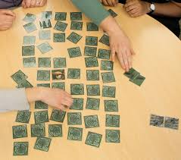
Playing the game:

Each player takes turns flipping two cards face-up — if they match a country with the capital city,
then that player wins the pair and gets another turn. If the cards are not of the same country, they are
turned back facedown and it becomes the next player's turn to pick two cards.

You can play this game as a single player. You could time how long it takes you to find all the pairs.

You could play in a different way and make it a snap game.

Useful questions
- Have you included countries from Europe, North America and South America?
- Do you have pairs – the country and the capital city?
- Have you spelt all the names correctly and used capital letters?

Useful websites and resources:
https://kids.britannica.com/students/article/world-capitals-at-a-glance/624667

Lower Key Stage 2
The big idea
Research an ocean of interest and present in any format

Key learning
Geography:
- name and locate counties and cities of the United Kingdom, geographical regions and their identifying human and physical characteristics, key topographical features (including hills, mountains, coasts and rivers), and land-use patterns; and understand how some of these aspects have changed over time.
English:
- retrieve, record and present information from non-fiction texts.
- identify the audience for and purpose of the writing, selecting the appropriate form and using other similar writing as models for their own.
- noting and developing initial ideas, drawing on reading and research where necessary.

How to do it
Around 70 percent of the Earth is covered in salt water. We call this body of water the Ocean. The ocean divides into 5 major oceans, but they actually all connect together. You are going to research one of these oceans and present your information.

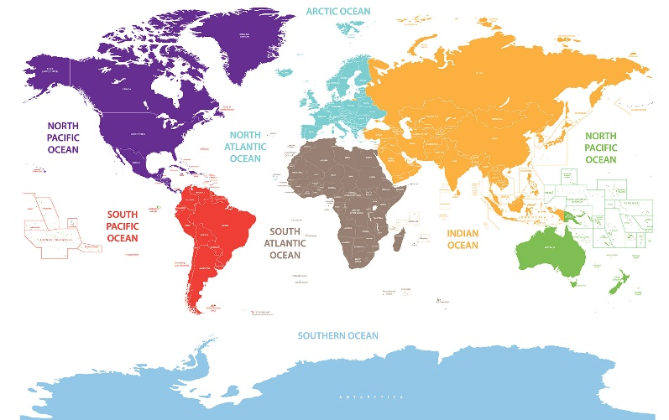
Think about:

- Which ocean are you going to focus on? You need to decide what
information you think is the most interesting about your ocean, and
which countries are surrounded by it.

- What amazing sealife can be found in your ocean? Are there any species that are not found anywhere else? Which physical features can be found under your ocean? Are there known underwater volcanoes or valleys or earthquake fault lines?
- How will your present your research? This could be a travel brochure or leaflet. It could be a poster or model. It could be a powerpoint or other presentation on your computer or device.

Completing the activity:

- Research your chosen ocean and make detailed notes. Make sure you include the information about where in the world it is; about the natural and physical features (including plants and sea life).
- Present your information in a clear and organised way. You can look in information books to help you decide on a written layout or look at websites if you are choosing a detail media.
- Make sure that you check the spelling, punctuation and grammar of the sentences you are using.

Useful questions
- Have you included physical features of the ocean?
- Have your included information on which countries your ocean touches?
- Have you edited your work to check and improve it?

Useful websites and resources:
https://www.ducksters.com/geography/oceans.php
https://www.kids-world-travel-guide.com/ocean-facts-for-kids.html
https://kids.britannica.com/kids/article/ocean/346185
https://www.natgeokids.com/uk/discover/geography/general-geography/ocean-facts/

Lower Key Stage 2
The big idea
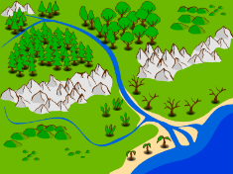
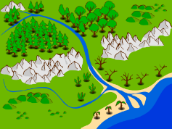

Promote your local area

Key learning
Geography:
- name and locate counties and cities of the United Kingdom, geographical regions and their identifying human and physical characteristics, key topographical features (including hills, mountains, coasts and rivers), and land-use patterns; and understand how some of these aspects have changed over time.
- use fieldwork to observe, measure, record and present the human and physical features in the local area using a range of methods, including sketch maps, plans and graphs, and digital technologies.

English:
- read books that are structured in different ways and reading for a range of purposes.
- retrieve and record information from non-fiction.
- discuss writing similar to that which they are planning to write in order to understand and learn from its structure, vocabulary and grammar.

How to do it
The local area where we live is often full of exciting and interesting places to visit and links with the past. However, we often don’t really take any notice of them because we are just so used to seeing them. Now is your chance to celebrate the local area where you live.

Think about:
- Where in the country do you live? Can you find your village, town or city on a map? If you have an actual paper map, then is it quite interesting to look at all the things that are around in your area. Otherwise, you can use Google maps to help you. The satellite view is particularly useful for showing you clearly what is in your area.
- Now think about what you have found. Consider whether the area is mainly urban (built on) or rural (countryside). Think about what the land is your local area is mainly used for – what are the main features? Features to look for:
- Roads
- Rivers/lakes
- Hills
- Buildings
- Bridges
- Woods/forest
- Shops
- Parking
- What do you think is the best thing about living in your local area? Maybe try to research a little bit about this. You could then draw a picture or collect some pictures. Take your own pictures if an adult can go with you.
- Imagine that some people are coming to your local area to see what it is like. What information might they need to know? Think about whether it is close to major transport links like main roads and railway stations. Are there any dangerous places that you might need to warn them about? If you live by the sea or a large lake it can be great fun, but you need to tell people about the safety elements that need to be thought about. Are there any historical places or facts about your local area that you could tell them about? What interesting places might they want to visit while they are there?
- Once you have collected all your information, you will be ready to complete the guide to your local area.

Completing the activity:

- Think about how you want to present your guide to your local area. Is it going to be a poster, a leaflet, a powerpoint etc?
- Collect all the information your have and plan where things will go on your presentation.
- Write your sections or paragraphs carefully – make sure that each one has a clear theme.
- Draw pictures, diagrams and maps to help your work to be more interesting and eyecatching.

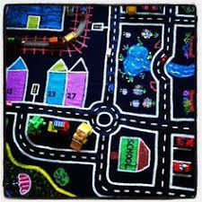
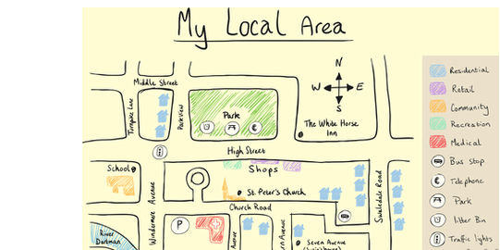
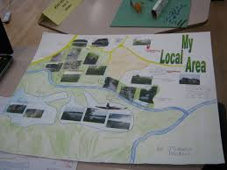

Useful questions
- Have you collected interesting facts about your local area?
- Have your thought about the best way to present your information?
- Have you checked and edited your writing?
Useful websites and resources:
https://www.bbc.co.uk/teach/class-clips-video/geography-ks1--ks2-cities-towns-villages/zjn492p

HIAS Teaching and Learning Team

The HIAS Teaching and Learning Team give practical and supportive advice through coaching and mentoring teachers to improve outcomes for all pupils. They use a ‘plan, do, review’ approach to teaching and learning which broadly includes observation of teaching, personal target setting with areas given to improve, planning, demonstration of lessons and team teaching. The team focus their work on impact within the classroom.

They also work with Senior and Middle Leaders to develop the coaching model in their schools.

For further details referring to Primary Teaching and Learning support, please contact Sarah Sedgwick, Teaching and Learning Adviser: sarah.sedgwick@hants.gov.uk

For further details on the full range of services available please contact us using the following details:

Tel: 01962 874820 or email: hias.enquiries@hants.gov.uk.

