Over the land, over the sea

Remote learning curriculum pack Key Stage 1 (Years 1 and 2)

Pack 10

HIAS REMOTE LEARNING CURRICULUM PACK

HIAS Teaching and Learning Team

Summer 2021

Final version

© Hampshire County Council
HIAS Remote Learning Curriculum Pack
Using the Remote Learning Materials
Dear Parents and carers,

Your school is sending you this pack of remote learning activities to help you to support your child at home. Your school may also have given you English and mathematics resources, and this pack of activities can supplement and work alongside these.
These activities are designed to help your child continue with learning across the wider curriculum, which is linked to the National Curriculum and will build on their existing skills, help them learn new ones, and allow for suitable independence.

How to use the pack and support your child:
- Learning at home is distinctive and different to school but try to establish a routine with your child. These activities are practical and creative and can be used to work alongside the other remote learning activities.
- Encourage your child to choose the activities that most interest them. Some will build on knowledge that they already have, and some will be newer learning; but all are designed to be practical and fun.
- Activities may need reading with your child and explaining, and you may need to help them find resources. All the activities can be adapted where needed to make them work for you.
- The activities have been designed to enable a good amount of independence. Let your child work at their own pace, encourage them and celebrate their achievements frequently.
- These activities could take approximately 2 to 3 hours to complete (approximately half a day) but can be spread across a few days if necessary. There is no time limit to the activities, they may take more or less than the suggested time.

Over the land, over the sea
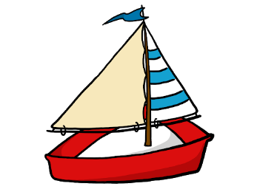

Key theme:

This theme is linked to the geography curriculum for Key Stage 1 and explores the world around us.

Geography:
- Understand geographical similarities and differences through studying the human and physical geography of a small area of the United Kingdom.
- Identify seasonal and daily weather patterns in the United Kingdom and the location of hot and cold areas of the world in relation to the Equator and the North and South Poles.
- Use basic geographical vocabulary to refer to:
*Key physical features, including beach, cliff, coast, forest, hill, mountain, sea, ocean, river, soil, valley, vegetation, season, and weather.
*Key human features, including city, town, village, factory, farm, house, office, port, harbour and shop.
- Use simple compass directions (North, South, East and West) and locational and directional language [for example, near and far; left and right], to describe the location of features and routes on a map.

Key Stage 1
The big idea
Create a poster for the local area
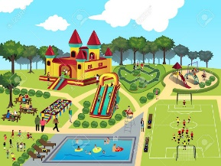

Key learning
Geography:
Use basic geographical vocabulary to refer to:
- key physical features, including beach, cliff, coast, forest, hill, mountain, sea, ocean, river, soil, valley, vegetation, season,
and weather.
- key human features, including city, town, village, factory, farm, house, office, port, harbour and shop.
Useful questions:
- What great features does the local area have?
- How can the poster show these positive areas?
- What geographical vocabulary can be used on the poster?
How to do it
This activity is all about looking at the positive features of where the child lives and putting these into a poster to advertise the area.

Completing the activity

Think about:
- the main message of the poster- this needs to be all about the local area and what it gives to the people who live there.
- giving the poster a slogan. That is a striking phrase that people can remember. This will make the poster stand out from all the others.
- drawing a border around the poster to make it more interesting.
- using some key words with the pictures so that people can see what it is like to live there and why they might want to visit.
- drawing and writing the physical features (land, sea, soil, vegetation etc) and the human features (shops, restaurants, churches etc) that might persuade people to visit.
- making sure the poster is colourful and eye- catching!

Key Stage 1
The big idea
Make a cities board game
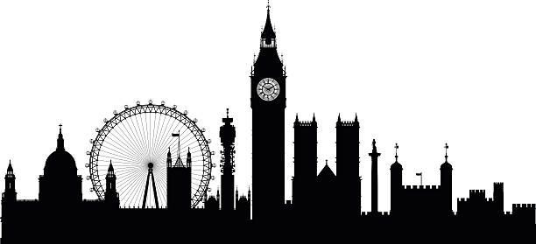

Key learning
Geography:
- Understand geographical similarities and differences through studying the human and physical geography of a small area
of the United Kingdom.
- Use basic geographical vocabulary to refer to:
*Key physical features, including beach, cliff, coast, forest, hill, mountain, sea, ocean, river, soil, valley, vegetation, season, and weather.
*Key human features, including city, town, village, factory, farm, house, office, port, harbour and shop.
Useful questions:
- What cities have interesting landmarks?
- Can the child name some cities in the United Kingdom?
- How will the game test the knowledge of cities?
How to do it
This activity is about creating a game based on cities around the United Kingdom. It is probably best to make this an indoor game and can be based on any of the cities of interest to the child.

Focus of the game:
The game could be based around the following but must test geographical knowledge such as:
- Where people live in the city.
- The main physical features such as rivers, vegetation and weather.
- The main human features such as land use, factories and housing.
- Special features of the cities.

Make the game based on the following:
- Board games like bingo, snakes and ladders or a game using cards.
- Games that involve moving around indoors. These could be based on: ‘Hide and Seek’, ‘What’s the time Mr. Wolf?’, ‘Follow my Leader’ or an indoor obstacle course.

Getting started:
- First research the facts to be included in the game. A question could be generated with a related answer.
- Find some card or cardboard to make the base if it is a board game.
- Then look for other objects, such as dice or markers, so that turns can be taken and moved around the board.

Making the game (board game):
- Plan the game, thinking about the design and how the objects will be used. Think about the rules of the game and how people are going to ‘score’ points.
- Cut out the base of the board. If card is being used, then the child may need some support with this.
- Mark out the shapes on the board using a pencil to start with and then fill in with pen or colour.
- Draw rectangles on white card for the questions and answers.
- Write and draw the questions and answers on the board and cards.

Now play the game once through with a friend or family member, making notes of how the game can be altered if needed.

Key Stage 1
The big idea
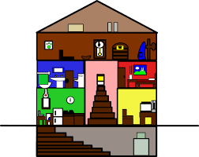
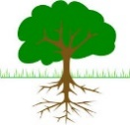
Make a trail around the local area

Key learning
Geography
- Use simple compass directions (North, South, East and West) and locational and directional language [for example, near and far;
(left and right), to describe the location of features and routes on a map.
- Use basic geographical vocabulary to refer to:
*Key physical features, including beach, cliff, coast, forest, hill, mountain, sea, ocean, river, soil, valley, vegetation, season, and
and weather.
- *Key human features, including city, town, village, factory, farm, house, office, port, harbour, and shop.
Useful questions
- Where will the trail show the best features of the area around the home?
- Can the child use compass directions to see where they are facing?
How to do it
A trail is a path or track where objects are laid out for people to follow. This activity is about designing and making a trail around the home or garden or both if it is possible to get outside and to use compass points to see what direction they are facing.

Getting started:
- First decide where the trail is going to take place.
- Then decide on the objects that will direct people around the trail. Take care to think about safety and whether the objects are waterproof if the trail is going to be outside.

Completing the activity:
- Once it has been decided where the trail is going to be, the route needs to be planned out. This could be planned first on a piece of paper.
- Now create or collect the objects that will mark out the route. Material could be cut up (with permission!) or use card or paper and make them into flags or arrows. Small stones or sticks could also form the route. Numbers could be added onto the objects so that people will follow the route in the correct order.
- Now draw the map carefully, following the plan. Compass directions could be used or simple instructions such as ‘right’, ‘left’ and ‘straight on’.
- Now place the objects along the route and follow it, using the map, to make sure that it is correct.
- Remember to put some ‘treasure’ at the end of the trail for the person to find!
- Now give the map to someone so they can follow your trail.

Useful websites and resources:
www.scouts.org.uk
www.ordinancesurvey.co.uk

Key Stage 1
The big idea
Draw or paint the sea around the United Kingdom
and label what might be under it…
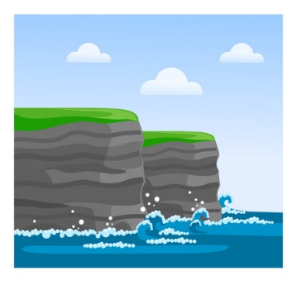

Key learning
Geography:
- Understand geographical similarities and differences through studying the human and physical geography of a small area
of the United Kingdom.
- Use basic geographical vocabulary to refer to:
*Key physical features, including beach, cliff, coast, forest, hill, mountain, sea, ocean, river, soil, valley, vegetation, season, and weather.
How to do it
Useful questions
- What part of the coastline would the child like to create in their artwork?
- What geographical features can they see e.g., cliffs, beaches, rocks etc?
This activity will test both the child’s art skills but also if they can identify features of the coastline around the United Kingdom.
Start with:
- Looking at photographs or pictures of the English coastline. Discuss what creatures could live under the sea and how these differ from other countries.
- Thinking about the types of art that are enjoyed and what materials could be used to make the artwork. Useful materials could be pencils, crayons, chalk, pens or paint.

Completing the activity:
- Find a base for the artwork. This could be light coloured card or paper.
- Use pictures or photographs to get some ideas.
- Draw the outline lightly showing the main features.
- Colour in the picture using either paints, pencil crayons or felt tipped pens. Make sure that the colours are accurate.
- Label the main features using sticky labels using the correct vocabulary.

HIAS Teaching and Learning Team

The HIAS Teaching and Learning Team give practical and supportive advice through coaching and mentoring teachers to improve outcomes for all pupils. They use a ‘plan, do, review’ approach to teaching and learning which broadly includes observation of teaching, personal target setting with areas given to improve, planning, demonstration of lessons and team teaching. The team focus their work on impact within the classroom.

They also work with Senior and Middle Leaders to develop the coaching model in their schools.

For further details referring to Primary Teaching and Learning support, please contact Sarah Sedgwick, Teaching and Learning Adviser: sarah.sedgwick@hants.gov.uk

For further details on the full range of services available please contact us using the following details:

Tel: 01962 874820 or email: hias.enquiries@hants.gov.uk.

