Look out for art!

Remote learning curriculum pack Upper Key Stage 2 (Years 5 and 6) Pack 1

HIAS REMOTE LEARNING CURRICULUM PACK

HIAS Teaching and Learning Team

Autumn 2020

Final version

© Hampshire County Council
HIAS Remote Learning Curriculum Pack
Using the Remote Learning Materials

Dear Parents and carers,
Your school is sending you this pack of remote learning activities to help you to support your child at home during the first few days of this isolation period. Your school may also have given you initial English and mathematics resources for the next few days, and this pack of activities can supplement and work alongside these. The school is finalising its plans to deliver your child’s current curriculum remotely to your child, with your support, during the remainder of the isolation period. These plans will be with you shortly and will maintain progress during this short interruption of education at school.
In the meantime, these activities are designed to help your child continue with learning across the wider curriculum, which is linked to the National Curriculum and will build on their existing skills and allow for suitable independence.

How to use the pack and support your child:
- Learning at home is distinctive and different to school but try to establish a routine with your child. These activities are practical and creative and can be used to work alongside the other remote learning activities.
- Encourage your child to choose the activities that most interest them. Some will build on knowledge that they already have, and some will be newer learning; but all are designed to be practical and fun.
- Activities may need reading with your child and explaining, and you may need to help them find resources. All the activities can be adapted where needed to make them work for you.
- The activities have been designed to enable a good amount of independence. Let your child work at their own pace, encourage them and celebrate their achievements frequently
- These activities could take approximately 2 to 3 hours to complete (approximately half a day) but can be spread across a few days if necessary. There is no time limit to the activities, they may take more or less than the suggested time.
Look out for art!
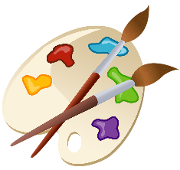

Key theme:

This theme is based on learning more about art, seeing it in everything around us and completing some artwork.

This project is related to the following National Curriculum art and design aims to ensure that all pupils:

- produce creative work, exploring their ideas and recording their experiences
- become proficient in drawing, painting, sculpture and other art, craft, and design techniques
- evaluate and analyse creative works using the language of art, craft, and design
- know about great artists, craft makers and designers, and understand the historical and cultural development of their art forms

Key Stage 2
The activities will link to the following subject content:

- to improve their mastery of art and design techniques, including drawing, painting, and sculpture with a range of materials (for example, pencil, charcoal, paint, clay)
- about great artists, architects, and designers in history

Upper Key Stage 2
The big idea
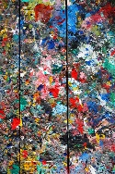
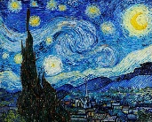
Compare two artists…combine their styles

Key learning
Art:
- To improve mastery of art and design techniques, including drawing, painting, and sculpture with a range of materials
- About great artists, architects, and designers in history

How to do it
Different artists across history have different styles and this activity is all about researching and comparing two artists and then recreating a piece of art by combining these styles. In order to complete this activity successfully, the style and medium of two different artists need to be studied and how they can be created into one piece of art that is similar but combines the two styles in a unique way.

Getting started:
- The artist could be from any time and have any style. The best effects might be to take two very different styles and combine them.
- Decide whether a painting will be created with colour, or a drawing using pencil or charcoal. This might depend on the type of art that is enjoyed and the materials that are available to complete the artwork.
- Study the style that is to be created and research some famous artists to give inspiration. Look at the style, use of colour, texture, and the art medium. This means whatever the artists have used to make their artwork and how they make marks on the surface.

Famous artists that could be combined:
Here are some famous artists that might give inspiration and that could be compared and combined, but there are many others!

- Van Gogh with Picasso
- Mondrian with Monet
- Matisse with Van Gogh
- Klimt with Kandinsky

Artistic terms to support the artwork:
Here are some of the main artistic terms to support the artwork:

Medium: the materials that the artists use to create their artwork

Portrait: a drawing or painting of a person or people

Perspective: a way of drawing or painting that makes some objects appear closer than others

Primary colours: red, yellow, and blue - all the other colours can be made from these

Self- portrait: a painting or drawing that the artists makes of themselves

Still life: a painting or drawing of inanimate objects that are often placed in an arrangement

Texture: the look and feel of the canvas in a painting. This can vary depending on how the paint is applied

Completing the activity:
- Gather the materials needed and have the work of the artists to act as a guide.
- Take two pictures of the artists and decide which parts could be combined. Could the focus be colour, texture, or shape?
- What will the artwork look like? Decide whether the picture will be a portrait (picture of a person), landscape or a still life of objects. Use the artists to find the inspiration.
- When the artwork is finished, share it with someone and ask them if they can see how the art has been combined.
- Evaluate the artwork and decide what has been successful what could be developed better next time.

Materials that may be needed:
- Pictures from the artists
- A canvas or paper to complete the drawing or painting
- Drawing pencils
- Coloured pencils, pastels, paints, or charcoal

Key questions:
- How will the styles of the two artists be combined?
- What part of their art will be used in the picture?
- What materials will create the best effects?
- What has gone well and why?
- What could be achieved better next time?

Useful websites and resources:
www.vam.ac.uk www.nationalgallery.org.uk www.npg.org/collections.php
www.britishmuseum.org www.bbc.co.uk/arts/yourpaintings/

Upper Key Stage 2
The big idea
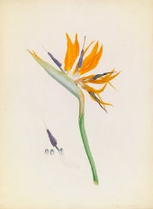
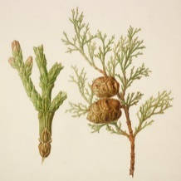
Make a colour wheel and use it to create
a picture in the style of the Bauer brothers
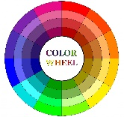

Key learning
Art:
- Produce creative work and explore ideas and record experiences
- Become proficient (really skilled) in drawing, painting and design techniques
- Learn more about great artists in history

How to do it
Franz and Ferdinand Bauer were two brothers, born in Austria, who became famous botanical artists. Their paintings have been used in many books, to inform people about plants and their different parts. Their paintings have helped scientists make sense of the life cycle of plants. When Ferdinand travelled to Australia the result was many pictures of unknown plants and species that were then studied by scientists. Many are now in the Natural History Museum in London.

This activity is all about studying their art and using the colour wheel to create artwork, based on their art.

A colour wheel is used in art to organise colours based on their colour values. The basis of the colour wheel are the three primary colours, spaced evenly apart. Directly between each primary colour is the secondary colour, spaced evenly between them.
Circles make good organisational tools and artists use them to organise colours to help them understand the relationship between colours.
There are many variations of the colour wheel but the traditional one has twelve distinct colour values.

Making a colour wheel:

Some materials to use:
- White paper or card
- Red, yellow, and blue paint
- A small mixing bowl to mix the paints
- A paintbrush
- Two small plates or saucers to make the wheel (one for the outer and one for the inner circle)

Primary colours:
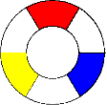
Primary colours are the colours that cannot be combined to make other colours. They are red, yellow, and blue. To start making the wheel, space out the red, yellow, and blue evenly on the circle (see picture).

Secondary colours:
The next set of colours are made by combining equal amounts of primary colours, called secondary colours. Red and blue make violet, blue and yellow make green, and yellow and red create orange. Now place these three colours on the wheel. Each one goes directly between the two primary colours used to create it.
Tertiary colours:
Now add six more colours to the wheel. These last six are all tertiary colours, created by adding more primary colour to a secondary colour. For example, green is a secondary colour. If more blue is added to it, it will go a bluish-green. If yellow is added it will go yellowish-green. On the colour wheel, tertiary colours fall in between the primary and secondary colours used to create them. Once these colours have been added, there will be all 12 colours on the wheel.
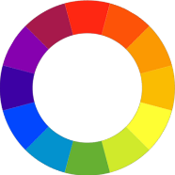

Creating a picture in the style of the Bauer brothers:
- Find a picture of a plant or flower that the Bauer brothers have drawn so it can be copied.
- Then gather the materials together.
- Draw the stem of the plant or flower, making sure it is big enough.
- Draw the first leaf, focusing on where the different lines go.
- Draw the next leaf, considering the different angles.
- When the leaves are finished, start drawing the flower or bud.
- Don’t forget to draw the anther and filament.
- Mix the paints carefully, keeping the colours soft to match the paintings (see below).
- Carefully fill in the detail with paint. Clean the brush between each colour so that it doesn’t smudge.

Using the wheel for the picture:
The colour wheel can be used to mix paints and create some soft colours for the picture. The colours that sit next to each other on the wheel are harmonious colours. These are known as analogous colours and Claude Monet used these colours in many of his watercolour paintings. The colours that sit opposite each other on the colour wheel are known as complementary colours and these can be used to create contrast e.g. yellow and purple.

Key questions:
- What colours can be mixed to make the Bauer picture?
- How will you use the colour wheel to make the picture effective?
Useful websites and resources:
www.nhm.ac.uk

Upper Key Stage 2
The big idea
Design an umbrella for a rainy day

Key learning
Art:
- Produce creative work and explore ideas and record experiences
- Become proficient (really skilled) in drawing and painting and design techniques
How to do it
As we go into autumn it is time to get out wet weather clothing and protection. This activity is all about designing an attractive umbrella design to protect people at this time of year.

Materials needed:
- Some paper for the plan
- A pencil
- A paper plate or some circular, plain card to draw the outline of the umbrella
- Some colouring pencils, or pens

Completing the activity:
- Decide on the theme of the design. Research some current umbrella designs to get inspiration.
- Plan out the design by drawing a circle on a piece of paper and drafting some ideas within it. This will ensure that the design achieves the correct effect. Remember that the umbrella design can be split into different pieces to represent how the spikes are fitted.
- Use a paper plate to draw the finished design. Remember to colour in the design carefully.

Different designs:
- A natural theme such as flowers, leaves etc.
- An abstract design (this means that it is not real but achieves its effect through shapes and colours)
- A repeating pattern using shapes or objects
Key questions:
- How will the design have impact and stand out?
- Will the design have a regular or abstract pattern and why?
Useful websites: www.accessart.org.uk

Upper Key Stage 2
The big idea
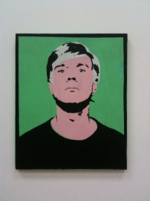
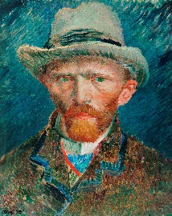
Complete a self-portrait

Key learning

Art:
- Produce creative work and explore ideas and record experiences
- Become proficient (really skilled) in drawing and painting and design techniques
- Learn more about great artists in history
How to do it
Self-portraits are where artists draw themselves and there are many famous self-portraits for us to get inspiration from. By drawing or painting themselves, artists can show their personality and improve their artistic skills all through studying their face and features.
This activity is all about studying some famous self-portraits and using their ideas to make a creation.

Getting started:
- Research some famous artists and their self-portraits. Art museum websites have some good images to study.
- Decide on the style of the art to model the image on. Will it be a modern style like Andy Warhol or a more traditional style like Van Gogh?

Materials to use:
Any of the following materials will help you achieve a good result:
- A well sharpened B, 2B or 3B pencil (if available)
- A solid graphite stick (these do cost more than pencils, but will last longer)
- Charcoal – a good drawing material for larger drawings as it can be smudged to create some interesting effects and is useful for shading
- Paper or a sketch pad
- Colouring pencils or paint if colour needs to be added

Holding the pencil:
It can be useful to hold a pencil like a brush, with a loose grip. This will mean that the grip is relaxed and there is no tension in the arm. This will also produce better marks on the paper.
Using the paper:
Fill the paper with as large an image as is possible as the larger the drawing is, the easier it will be to correct.

Completing the activity:
Gather the materials and get started:
- Sit in front of a mirror so the face can be studied. What is unique and what is special about the features?
- Draw the outline of the face carefully.
- Look at the way shadows are cast across the face.
- Once the outline is drawn, hold up the drawing and look at the face again. Notice which bits are correct and which bits need further work.
- Carefully redraw over the original drawing more correctly without rubbing out the incorrect lines first. Carry on re correcting until the drawing looks more like the person.
- The drawing can be re-started so that the self-portrait creates the correct effect.
Key questions:
- Which style of artist will be used in the self-portrait?
- How will the features be emphasised?
- How could the artwork be improved next time?
Useful websites and resources:
www.npg.org.uk www.tate.org.uk/kids

Upper Key Stage 2
The big idea
Be an architect…design a city building
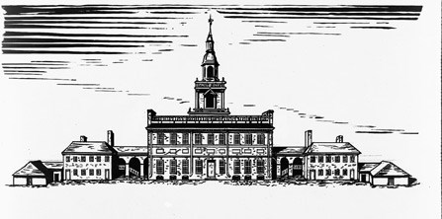

Key learning
Art:
- To improve your mastery of art and design techniques, including drawing
How to do it
Architects design and create plans and technical drawings of buildings which are used in the construction industry. They might also work on the restoration and renovation of existing buildings, for example designing a new extension for a house. Architects
train for many years to ensure that their designs work in real life and keep within the budget set.

This activity is all about designing a city building and reproducing it in detail. The drawing will have to be very neat and accurate to ensure that people can see how the design will work. Proper architectural drawings won’t be able to be recreated exactly, but children will be able to draw the outside of the building with accuracy.

Architects also use ‘scale’ in the pictures of their buildings. This means the building’s size in relationship to something else. This means that the parts of the building are designed so they are at human scale. Children could use 1cm in the drawing to mean 1m in real life.

Getting started:
- Decide what city building to design. This could involve some research of famous buildings (see below).
- Gather the materials for the activity. This may only need paper and drawing pencils. If scale is being used, then a ruler will be needed to measure accurately.
- Sketch out some ‘rough’ ideas before starting.

Think about:
- the main use of the building
- the outside’ look’ of the building
- what rooms it will have
- what the windows and doors will look like
- what materials it will be made out of
- the outside landscaping of the building

Famous buildings that may be useful for the research:
- The ‘Gherkin’ - offices and a restaurant in London
- ‘The Factory’ - arts centre in Manchester
- The Shard - skyscraper in London
- The Flatiron - skyscraper in New York
- The British Museum - museum in London
- Tianjin Binhai Library - library in China

Completing the activity:
Decide on the building, it’s use and the way it will look and then get started. It might take a little time and a few tries to get the correct results so perseverance might be needed!

Key questions:
- What building could be designed and why?
- How unusual could the building be? (get some ideas from the images of the buildings above)
- How can the drawing look realistic?
- Is the scale of the different parts correct? For example, is the tower in proportion to the body of the building?
Useful websites and resources: type in some famous buildings under ‘images’ to get some ideas

Upper Key Stage 2
The big idea
Draw a surreal landscape
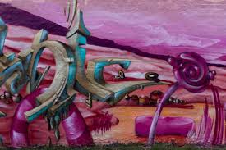

Key learning

Art:
- Produce creative work and explore ideas and record experiences
- Become proficient (really skilled) in drawing and painting and design techniques

How to do it
Surrealism was a 20th Century art movement that focused on using the imagination and the unconscious mind to create images. Many of these images were weird and wonderful! Surrealists focused on the fact that there are no right or wrong answers in art and their art often showed images that were bizarre and couldn’t happen in real life.

Famous surrealists:
Some of the most famous surrealists were:
- Salvador Dali (1904-1989)
- Pablo Picasso (1881-1973)
- Andre Breton (1896- 1966)
- Leonora Carrington (1917- 2011)
This activity is all about studying this art and then making a landscape of weird and wonderful things!
Completing the activity:
- Research different surrealist art and gather some ideas. Look at the way the artist has used colour and the objects in their drawings or paintings.
- Decide on the objects and the type of landscape that will be in the drawing. How could everyday objects be used in an unusual way? Salvador Dali used melting clocks and floating eyes!
- Gather the materials together. Paper and pencils will be needed for the outline with paints, or colouring pens/ pencils to complete the effect.
- Plan ideas on a piece of paper and draw some weird objects before they are placed on the final picture.
- Draw the outline of the art first and redraft if objects need to be moved around.
- Finally complete the surrealist art by adding colour. Try to use colour in an unusual way.
Key questions:
- What everyday objects could be changed or used in an unusual way?
- What artists could be used to base the ideas on?
- What has gone well what could be improved?
Useful websites and resources:
www.tate.org.uk/ kids

HIAS Teaching and Learning Team

The HIAS Teaching and Learning Team give practical and supportive advice through coaching and mentoring teachers to improve outcomes for all pupils. They use a ‘plan, do, review’ approach to teaching and learning which broadly includes observation of teaching, personal target setting with areas given to improve, planning, demonstration of lessons and team teaching. The team focus their work on impact within the classroom.

They also work with Senior and Middle Leaders to develop the coaching model in their schools.

For further details referring to Primary Teaching and Learning support, please contact Sarah Sedgwick, Teaching and Learning Adviser: sarah.sedgwick@hants.gov.uk

For further details on the full range of services available please contact us using the following details:

Tel: 01962 874820 or email: hias.enquiries@hants.gov.uk.

