Look out for art!

Remote learning curriculum pack Lower Key Stage 2 (Years 3 and 4) Pack 1

HIAS REMOTE LEARNING CURRICULUM PACK

HIAS Teaching and Learning Team

Autumn 2020

Final version

© Hampshire County Council
HIAS Remote Learning Curriculum Pack
Using the Remote Learning Materials
Dear Parents and carers,
Your school is sending you this pack of remote learning activities to help you to support your child at home during the first few days of this isolation period. Your school may also have given you initial English and mathematics resources for the next few days, and this pack of activities can supplement and work alongside these. The school is finalising its plans to deliver your child’s current curriculum remotely to your child, with your support, during the remainder of the isolation period. These plans will be with you shortly and will maintain progress during this short interruption of education at school.
In the meantime, these activities are designed to help your child continue with learning across the wider curriculum, which is linked to the National Curriculum and will build on their existing skills and allow for suitable independence.

How to use the pack and support your child:
- Learning at home is distinctive and different to school but try to establish a routine with your child. These activities are practical and creative and can be used to work alongside the other remote learning activities.
- Encourage your child to choose the activities that most interest them. Some will build on knowledge that they already have, and some will be newer learning; but all are designed to be practical and fun.
- Activities may need reading with your child and explaining, and you may need to help them find resources. All the activities can be adapted where needed to make them work for you.
- The activities have been designed to enable a good amount of independence. Let your child work at their own pace, encourage them and celebrate their achievements frequently
- These activities could take approximately 2 to 3 hours to complete (approximately half a day) but can be spread across a few days if necessary. There is no time limit to the activities, they may take more or less than the suggested time.
Look out for art!
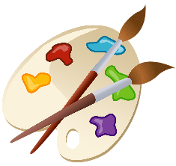

Key theme:

This theme is based on learning more about art, seeing it in everything around us and completing some artwork.

This project is related to the following National Curriculum art and design aims to ensure that all pupils:

- produce creative work, exploring their ideas and recording their experiences
- become proficient in drawing, painting, sculpture and other art, craft, and design techniques
- evaluate and analyse creative works using the language of art, craft, and design
- know about great artists, craft makers and designers, and understand the historical and cultural development of their art forms

Key Stage 2
The activities will link to the following subject content:

- to improve their mastery of art and design techniques, including drawing, painting, and sculpture with a range of materials (for example, pencil, charcoal, paint, clay)
- about great artists, architects, and designers in history

Lower Key Stage 2
The big idea
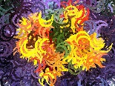
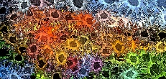
Make a mural design

Key learning
Art:

- To improve mastery of art and design techniques, including drawing, painting, and sculpture with a range of materials

How to do it
This activity will help express artistic talent in one amazing mural!

A mural is a piece of artwork that is usually drawn or painted directly on a wall, ceiling, or any other surface. The history of murals (of a sort) goes back to the Upper Palaeolithic times when people drew directly onto cave walls. Many ancient murals were also found in tombs in Egypt. Today, there are many famous artists that draw directly onto walls and surfaces and their art can be worth many thousands, or even millions, of pounds. Sometimes art on surfaces can be considered ‘graffiti’. This means that it is vandalism in a public place, whereas a mural has the consent of someone to be there.

One famous artist who paints this street art is called ‘Banksy’. They are an anonymous street artist with a very distinctive style and their work has fetched, in some cases, many millions of pounds.

This activity is all about completing a ‘Bansky’ on a large piece of paper, or on a wall or surface with permission!

Getting started:
- Research the work of some famous street artists and murals to see the different styles and decide on a suitable style.
- Find a large piece of paper to either complete the design or to plan it.
- Decide on the theme of the street art (see below).
- Find the materials needed to complete the art. A pencil, bright pens, or paints may be needed.

Different themes:
The art can have many different themes, but the following can be considered:

- Natural elements such as the repeating patterns that can be seen in nature
- A repeating, abstract pattern
- A human or animal form
- Art in the style of another famous artist
- A cityscape
- A beach scene
- A scene from outer space
- A forest scene

Completing the activity:
Think about the following when the artwork is completed:
- Drawing the outline first, remembering to make sure that the objects fill the paper or the wall.
- Filling in the detail and the features.
- Standing back when drawing is taking place to make sure that the objects look right and are in the correct proportion to each other.
- Filling in using colour and making sure that this is as near to the real colour of the objects.

Key questions:
- What theme will the mural have?
- What materials can be used to the best effect?
- How can proportion be used in the mural?

Lower Key Stage 2
The big idea
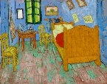
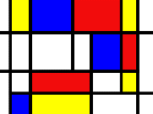
Take an artist and create in their style

Key learning
Art:
- To improve mastery of art and design techniques, including drawing, painting, and sculpture with a range of materials
- About great artists, architects, and designers in history

How to do it
Different artists have different styles and this activity is all about finding the style and then recreating a masterpiece in this style. In order to complete this activity successfully the style and medium of the artist needs to be studied before creating a similar piece.

Deciding on the artist:
- Decide whether a painting, drawing or a sculpture will be created. This might depend on the type of art that is enjoyed and the materials available to complete the artwork.
- Decide on the type of art to create and research some famous artists to give inspiration. Look at the style, use of colour, texture, and the art medium. This means whatever the artist has used to make the artwork and how they make a mark on the surface.

Famous painters:
Here are some famous artists that might give inspiration, but there are many others!

- Van Gogh
- Picasso
- Mondrian
- Monet
- Matisse
- Pollock

Famous sculptors:
Some artists work in 3D and they are called sculptors. They might cast metal or plaster or carve stone or wood to make their artwork. Here are some famous sculptors to research:
- Henry Moore
- Michelangelo
- Edward Degas
- Dame Barbara Hepworth
- Alexander Calder (mobile maker)
- Tony Cragg (sculpture out of scrap materials)

Artistic terms for support:
Here are some of the main artistic terms to support the artwork:

Sculpture: a 3D piece of art, often created by carving a piece of stone or wood or casting metal or plaster

Sculptor: an artist who creates a sculpture

Medium: the materials that the artist uses to create their artwork

Portrait: a drawing or painting of a person or people

Perspective: a way of drawing or painting that makes some objects appear closer than others

Primary colours: red, yellow, and blue - all the other colours can be made from these

Self- portrait: a painting or drawing that the artist makes of themselves

Still life: a painting or drawing of inanimate objects that are often placed in an arrangement

Texture: the look and feel of the canvas in a painting. This can vary depending on how the paint is applied

Completing the activity:
Before the activity starts, gather the materials needed and have the work of the artist to act as a guide.

Depending on the creation this might be:

- A canvas or paper to complete the drawing or painting
- Materials to complete a sculpture such as clay, boxes, recycled materials, plasticine
- A drawing pencil
- Coloured pencils, pastels, or paints

Key questions:
- How will the art be created in the style of a famous artist?
- What materials will create the best effects?
- What has worked well and why?
- What could be improved next time?

Useful websites and resources:
www.vam.ac.uk www.nationalgallery.org.uk www.npg.org/collections.php
www.britishmuseum.org www.bbc.co.uk/arts/yourpaintings/

Lower Key Stage 2
The big idea
Make a colour wheel and use it to create an autumn picture
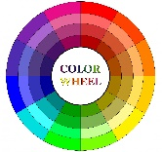
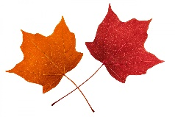

Key learning
Art:
- Produce creative work and explore ideas and record the experiences
- Become proficient (really skilled) in drawing, painting and design techniques
How to do it
A colour wheel is used in art to organise colours based on their colour values. The basis of the colour wheel are the three primary colours, spaced evenly apart. Directly between each primary colour is the secondary colour, spaced evenly between them.
Circles make good organisational tools and artists use them to organise colours to help them understand the relationship between colours.
There are many variations of the colour wheel but the traditional one has twelve distinct colour values. This activity is all about making a colour wheel and then creating an autumn picture, using the colours.

Making a colour wheel:

Some materials to use:
- White paper or card
- Red, yellow, and blue paint
- A small mixing bowl to mix the paints
- A paintbrush
- Two small plates or saucers to make the wheel (one for the outer and one for the inner circle)

Primary colours:
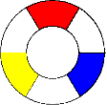
Primary colours are the colours that cannot be combined to make other colours. They are red, yellow, and blue. To start making the wheel, space out the red, yellow, and blue evenly on the circle (see picture).

Secondary colours:
The next set of colours are made by combining equal amounts of primary colours, called secondary colours. Red and blue make violet, blue and yellow make green, and yellow and red create orange. Now place these three colours on the wheel. Each one goes directly between the two primary colours used to create it.
Tertiary colours:
Now add six more colours to the wheel. These last six are all tertiary colours, created by adding more primary colour to a secondary colour. For example, green is a secondary colour. If more blue is added to it, it will go a bluish-green. If yellow is added it will go yellowish-green. On the colour wheel, tertiary colours fall in between the primary and secondary colours used to create them. Once these colours have been added, there will be all 12 colours on the wheel.
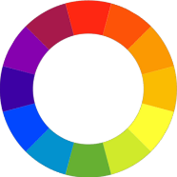

Creating an autumn picture:
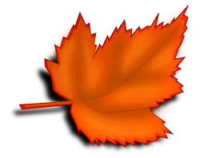
This is the time of year when there are changes in nature around us. The colours on the wheel can be used to create an autumn picture. This could be a landscape picture that shows a natural scene, or a more detailed picture could be created of some leaves, autumn flowers or berries.

Using the wheel for the picture:
The colour wheel can be used to mix paints and create some autumn colours. The colours that sit next to each other on the wheel are harmonious colours. These are known as analogous colours and Claude Monet used these colours in many of his watercolour paintings. The colours that sit opposite each other on the colour wheel are known as complementary colours and these can be used to create contrast e.g. yellow and purple.

Mix the paints and refer to the colour wheel to get the best out of the painting.
- Draw the outline of the painting - copy from a picture or look outside to get some ideas.
- Use a small bowl and paintbrush to carefully mix the colours. Start with one Primary colour such as yellow and add another colour to it. Use the colour wheel as the paint is being mixed.
- Keep the brush clean between each colour.
Key questions:
- What colours can be mixed to make the autumn picture?
- How can the colour wheel be used to make the autumn picture effective?
Useful websites and resources: www.drawpaintacademy.com www.bbc.co.uk/ homes www.accessart.org.uk

Lower Key Stage 2
The big idea
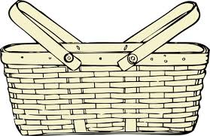
Design a plate for a picnic

Key learning
Art:
- Produce creative work and explore ideas and record experiences
- Become proficient (really skilled) in drawing and painting and design techniques
How to do it
September is a great time for a picnic as the weather is often still warm and sunny. This activity is all about designing an attractive paper plate design for a special picnic. Remember that this is just a design and the plate cannot be used once it has been coloured in!

Materials needed:
- Some paper for the plan
- A pencil
- A paper plate or some circular, plain card
- Some colouring pencils, or pens

Completing the activity:
- Decide on the theme of the design (see below).
- Plan out the design by drawing a circle on a piece of paper and drafting some ideas within it. This will ensure that the design achieves the correct effect when it is drawn onto the plate. Fill in most of the plate and give the design a border (this is the area around the edge of the plate).
- Use a paper plate to draw the finished deign. Remember to colour in the design carefully.

Different themes:
- A natural theme such as flowers, trees, or leaves
- A sporting theme such as objects used in sport
- An animal design
- An abstract design (this means that it is not real but achieves its effect through shapes and colours)
- A repeating pattern using shapes or objects
Key questions:
- How will the design have impact and stand out?
- Will the design have a regular or abstract pattern and why?
Useful websites and resources:
www.accessart.org.uk

Lower Key Stage 2
The big idea
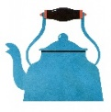
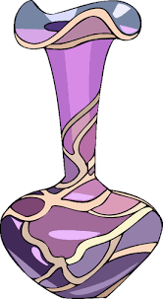
Take a household object and draw it in detail

Key learning

Art:
- Produce creative work and explore ideas and record experiences
- Become proficient (really skilled) in drawing and painting and design techniques

How to do it
Many artists take inspiration from the daily things around us, so this activity is all about drawing something familiar. These types of drawings are called a ‘still life’, meaning that they are of the ‘still’ objects around us. The drawing can be of anything in the home or garden that can be drawn in detail.

Getting started:
- Look around the home or garden and pick an object that can be easily drawn. A cup or a vase is an easy start. Make sure that it isn’t too complicated to begin with.
- Gather up the materials needed to complete the drawing (see below).

Materials to use:
Complicated drawing equipment does not need to be used to create a good effect with the picture. Any of the following materials will help achieve the result:
- A well sharpened B, 2B or 3B pencil (if available)
- A solid graphite stick (these do cost more than pencils, but will last longer)
- Charcoal – a good drawing material for larger drawings as it can be smudged to create some interesting effects and is useful for shading
- Paper or a sketch pad

Holding the pencil:
Although a pencil is often held like a pen, it can be useful to hold it like a brush, with a loose grip. This will mean that the grip is relaxed and there is no tension in the arm. This will also produce better marks on the paper.

Using the paper:
Work as large as is possible from the beginning to fill the paper. The larger the drawing is, the easier it will be to correct.

Completing the activity:
Once the materials and the object are ready, the art can be completed:
- Place the object on a table or flat surface and look at it carefully.
- Notice how high it is compared to its width (the area across the object). Notice the way that the light falls across it and its colour and texture.
- Draw the object by first drawing the outline carefully.
- Once the outline is drawn, the drawing can be held up to see the object and the drawing without moving the head. Notice which bits are correct and which bits need further work.
- Carefully redraw over the original drawing more correctly without rubbing out the incorrect lines first. Carry on re correcting until the drawing looks more like the object.
- Some similar objects could be drawn to improve the skills further.

Key questions:
- How will the object be selected for drawing and why?
- How will the texture of the object be shown? (the feel or appearance of an object or surface)
- How could the artwork be improved next time?
Useful websites and resources:
www.bbc/cbeebies.co.uk www.tate.org.uk/kids

Lower Key Stage 2
The big idea
Create a page for a colouring book

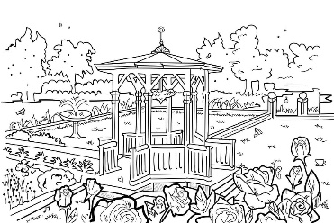

Key learning
Art:
- To improve mastery of art and design techniques, including drawing
How to do it
Colouring has lots of calming benefits. The act of colouring in an outline of something can relax the fear centre of the brain, and so generate mindfulness and quietness.

This activity is all about designing a page for a colouring book that can be given to someone else to colour in. The design will need to be very carefully drawn in outline, so that people can use their colouring skills to complete it.

Completing the activity:
- Decide on a theme for the page in the colouring book. This could be something that the child is already good at drawing or use books and magazines for inspiration.
- Use a piece of plain, white paper to draw the design.
- Ensure the outline is drawn carefully, using a drawing pencil to achieve a clear line (this is usually a 2B or 3B pencil for mid tones).
- Draw lines and areas so that the person can fill in the spaces between with colour.
- Give the design to a family member or a friend to colour in!

Key questions:
- What designs and shapes can be used to make it easier for the person colouring?
Useful websites and resources: Type ‘colouring in sheets’ on the internet to find different designs to use as inspiration.

HIAS Teaching and Learning Team

The HIAS Teaching and Learning Team give practical and supportive advice through coaching and mentoring teachers to improve outcomes for all pupils. They use a ‘plan, do, review’ approach to teaching and learning which broadly includes observation of teaching, personal target setting with areas given to improve, planning, demonstration of lessons and team teaching. The team focus their work on impact within the classroom.

They also work with Senior and Middle Leaders to develop the coaching model in their schools.

For further details referring to Primary Teaching and Learning support, please contact Sarah Sedgwick, Teaching and Learning Adviser: sarah.sedgwick@hants.gov.uk

For further details on the full range of services available please contact us using the following details:

Tel: 01962 874820 or email: hias.enquiries@hants.gov.uk.

