### Learning Zone

#### Getting Started

#### Guidance for Hampshire Academies & other external users

#### June 2022

# SERVICES FOR SCHOOLS

**Contents**

|  |  |
| --- | --- |
| **Accessing the Learning Zone** | **3** |
| **Logging in and Registering** | **4** |
| If you already have a user ID and password | 4 |
| **New User Registrations** | **4** |
| If you do not have a user ID and password | 4 |
| **My Learning Page** | **6** |
| **Searching for a Course** | **7** |
| **Booking a Course** | **12** |
| **Registering on Learning Items (User)** | **16** |
| **Withdrawing / Cancelling a Course Booking (User)** | **16** |
| **Help and Guidance** | **19** |
| **Moodle Sites** | **19** |

**Accessing the Learning Zone**

For your school, access to the Learning Zone is via the Hampshire County Council web page:

<https://www.hants.gov.uk/educationandlearning/learning-zone>

Click on the **green buttons** at the bottom of the pageto either **Register** or **Sign In** to the Learning Zone

Guidance on logging in is also provided on the front page of the Hampshire Teaching and Leadership website: [https://www.hants.gov.uk/htlc](https://www.hants.gov.uk/educationandlearning/htlc)

**Logging In and Registering**

**If you already have a user ID and password**

If you have already registered or have been registered on the site, log in using the below fields; use your allocated User ID and the password you set or the password you have been sent, then press the **Submit** button.

**New User Registrations**

**If you do not have a user ID and password**

If you are accessing the site for the first time and need to register, use the **Click here to register** link under the **New User** heading (shown below).

You will land on the screen below where you should enter the details requested.

Please note the information you’ll need to complete the three fields below can be obtained from your school’s Headteacher and Business Manager/Administrator. You will need to ask them for the following codes in order to create your Learning Zone account:

* **Registration Code**
* **Organisation ID**
* **Customer Number**

If your school has not been sent these codes, your Headteacher or Business Manager / Administrator can get them quickly by emailing [htlc.courses@hants.gov.uk](mailto:htlc.courses@hants.gov.uk) or telephone 01962 718600 and requesting access for your school.

Complete the other fields as directed, read our **Privacy Notice**, and **tick the box** to acknowledge you have done so, and then click the **Submit** button

If you make a mistake before submitting the form, click the **Reset** button to reset the form and have another go.

**Please make a note of the User ID beginning EXT which is automatically generated as you will need this each time you log in.**

If you experience any difficulty with this process, please contact [htlc.courses@hants.gov.uk](mailto:htlc.courses@hants.gov.uk)

**Searching for a Course**

Use the **Find Learning** box on the top right of the My Learning page. This is the easiest, fastest and most efficient way of searching, particularly when are looking for a specific offer and have some information about it.

* Search using two or three key words from the course title. Full details of our learning offer and keywords for all courses can be found on our upcoming training offers Moodle page:

<https://hias-moodle.mylearningapp.com/course/view.php?id=104>

* Type the key words and press enter or **Go.**
* You can view your returned search results in either List View or Card View. We recommend using List View as it displays more details. Click on the buttons on the top right of the screen to navigate between the two different views.

**Card View** **List View**

If you want to take a more general look at the learning items available and explore what is available in an area of interest, click on **Browse all courses.**

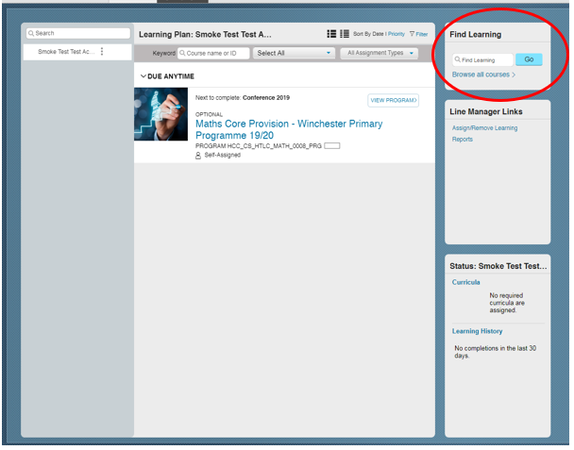

Here you can browse by topic (allowing you to view available learning by subject area).

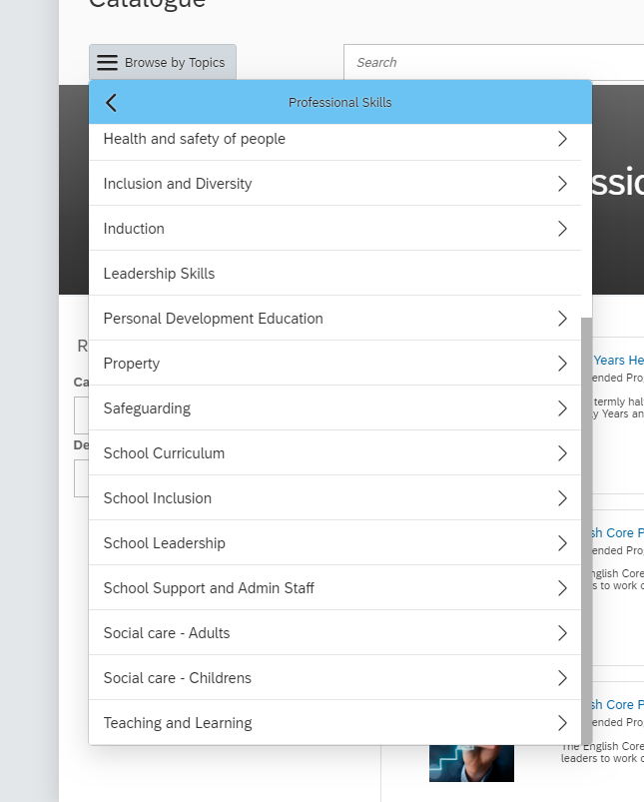

**All HTLC courses are listed in the ‘Professional Skills’ area**

Returned search from Browse all courses > Professional Learning > School Curriculum**.**

You will also see the current Featured courses. These are the courses that appear under the featured tab on your Learning Home page

**To see further information about the course content**

Click on the course title – this opens a new screen with further information. You may need to click on the ‘More’ button on this page to display full course details. From here, use the small back arrow to return to the results screen.

**To view available dates for the course**

Click on **See Classes**

*Full details of a multi session course – available by clicking on the date in see classes.*

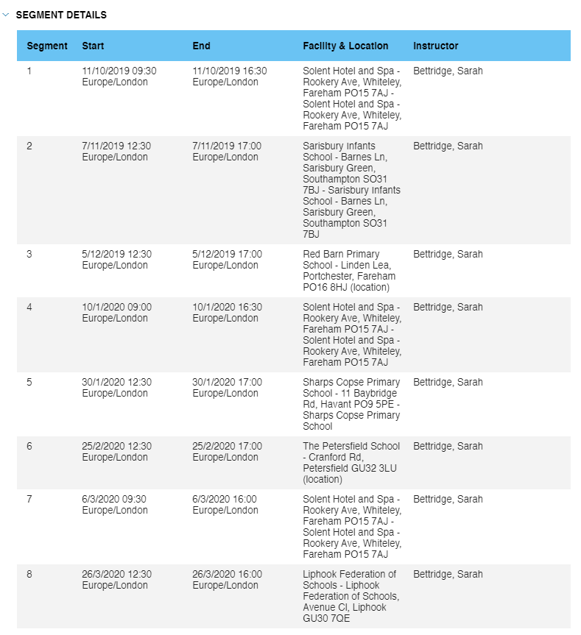

**Booking a Course**

**Process overview**

**Staff member logs in to the Learning Zone and locates the learning item/class in on the Learning Zone using the keywords in the ‘Find Learning’ search bar.**

**User reviews the learning item details (course date/time/location) and Add to Cart**

**User completes the process – Checkout, then Next**

**On the payment screen, user selects Place Order**

**Booking is now confirmed/complete – information will be displayed in the Order Information window.**

**Learning Items will then be visible in user’s learning plan and will display the status as ‘Enrolled’**

**An automated booking notification will be sent to the User**

**Registering on a Learning Item**

Find the course in the Find Learning search box on your Learning Home page – click enter or Go

Once you have added the item to your cart you will need to following the checkout process

Click **Next**

Click **Place Order.** The order information will then be displayed.

You should now be able to view the course in your Learning Assignments. The status will show as ‘Enrolled’ which means the booking is confirmed.

I**MPORTANT** – if the status is showing ‘Register Now’ the training has been assigned and not booked.

Select the training in your learning plan and ‘add to cart’ from there and complete the process through to place order. It should then show in your Learning Plan as ‘Enrolled’

**Withdrawing / Cancelling a Course Booking (User)**

**Withdrawals outside the cut off period**

Only a user can cancel a booking. A manager can only remove from a learning plan once assigned (not when booked)

Navigate to the **My Learning Assignments** page. Find the relevant learning item title in your learning assignments. Click on the arrow next to the title to expand the **Options** menu. Click **Withdraw**.

A Confirmation messagewill appear asking if you want to withdraw from the session**.** Click **Yes.**

A message will display to ask you if you wish to remove the item, click **Yes**

Select a cancellation reason from the drop down list.

If the course is chargeable and you are withdrawing in the cancellation period, the system will indicate the cancellation charge. You will need to confirm that you accept these charges.

**Withdrawals within the cut off period**

Navigate to the My Learning Assignments page. Find the relevant learning item title in your learning assignments. Click on the arrow next to the title to expand the Options menu. Click Withdraw.

An error message will be shown to inform you that you cannot withdraw from the course as the cut-off date has passed.

You will need to contact the HTLC Events Team to make an off-system withdrawal request.

**Reports**

Several reports can be run on your Learning. To access click on Reports under the Links tab on your Learning home page

A list of available reports will open in the next windonw. Click the expand icon > to see additional reports in each group

For each report you can use the drop downs and criteria fields to determine options

To run the report for your self, click the radio button under the user options

Some reports will state (CSV) in brackets, which mean they should be opened in Excel. Others have a option for report format – select Local File and PDF to save a copy

A screenshot of a cell phone

Description generated with very high confidence

**Useful reports**

**Registration Status**

* To see what courses you are enrolled on, run the Registration Status report
* Select date periods to review bookings for a specific period

**Learning Needs Report**

* This is useful for schools so that they can check the mandatory training is complete.
* By selecting requirements, the report will state the number of days the training has been outstanding or how may days they

**Help and Guidance**

**Talk to us**

If you need to speak to one of the Learning Support Team you should use the contact details below:

**Email:** [htlc.courses@hants.gov.uk](mailto:htlc.courses@hants.gov.uk)

**Telephone number:** 01962 718600

**Moodle Sites**

<https://hias-moodle.mylearningapp.com/>