IOW English and Maths Core Provision Programmes 2021-22
Booking Guidance

Our Isle of Wight Core English and Maths Programmes have been set up on the Learning Zone as Scheduled Programmes. This enables users to be automatically booked on all elements of the programme when they complete their registration, rather than having to register separately on all the different classes. Please note that the booking process for these programmes is slightly different, as detailed below.

If you have Manager functionality and want to assign the programme to a member of staff:

- Type Maths Core IOW or English Core IOW in to the Find Learning box, press enter

- Please ensure that you select the ‘Scheduled Program’
- Click on the blue programme title, do not click Enroll
- This will open up the programme with details of the meetings included (see below)
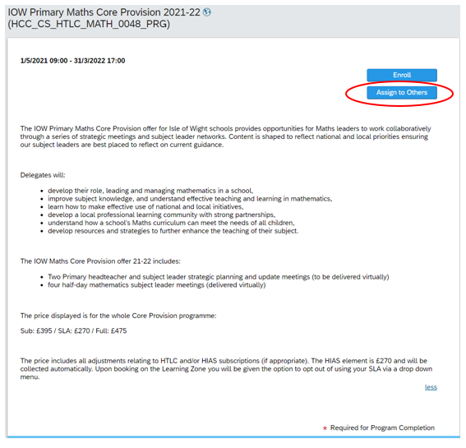

- Click Assign to Others
- You can then select the relevant member of staff from your Employee list
- Once selected, click Assign Learning
- The user will then need to log in to the Learning Zone and register on the programme that has been assigned to them (in the usual way)

- The user will automatically be registered on all elements of the programme and will receive booking confirmation notifications from the Learning Zone
- A confirmation will be generated for each element of the programme.

If you are a booking yourself on the programme (user self-booking)

- Type Maths Core IOW or English Core IOW in to the Find Learning box, press enter
- Please ensure that you select the ‘Scheduled Program’
- Click on Enroll
- Complete the self-service registration in the usual way
- You will automatically be registered on all elements of the programme and will receive booking notifications from the Learning Zone
- A confirmation will be generated for each element of the programme
- Your booking will be displayed in your ‘My Learning Assignments’ area on your ‘My Learning’ home page. You can click on ‘View Program’ to verify your enrolment on the programme elements.

