Organisations to support with mental health, self harm and suicide:

Organisation/group | Brief description | Weblink
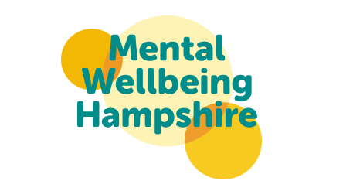 | Mental Wellbeing Hampshire is a partnership of organisations working to support good mental health and wellbeing in our communities. | Mental Wellbeing Hampshire - mental health and wellbeing support | Health and social care | Hampshire County Council
 | Taking the time to read and learn about mental health can help us find ways to cope, support others and move forward. Our library of resources provide you with a wealth of information, available for you to share at home, at work or in the classroom in a variety of languages. | Resources - Self-Harm Support Hub - Solent Mind
 | We recognise that professionals who work with children and young people might come across self-harming behaviour.  Our courses are designed to upskill staff and build a culture of understanding and proactive support. | Training for professionals - Self-Harm Support Hub - Solent Mind
 | This document presents practical advice and support that schools and colleges should consider after a student or staff member has died by suspected suicide. It is intended for use by schools (primary through to secondary) and colleges in Hampshire. | Hampshire Suicide Prevention & Postvention Protocol: Guidance for Schools & Colleges - Hampshire SCP
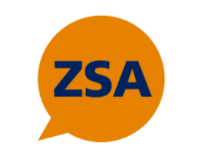 | The Zero Suicide Alliance (ZSA) is a UK based suicide awareness and prevention initiative hosted by Mersey Care NHS Foundation Trust and charitably funded via Mersey Cares NHS Charity. They offer free online suicide awareness training. | Zero Suicide Alliance (ZSA) - suicide prevention and awareness UK
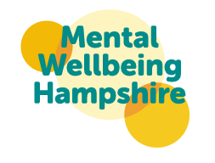 | Colleges only: Mental Health and Wellbeing Training Offer | HCC-Mental-Health-and-Wellbeing-Training-Offer.pdf
 | Samaritans supports schools, college communities and other youth settings across the UK and Republic of Ireland through our postvention services, lesson plans and school talks. | How Samaritans helps in schools

