Anaphylaxis: helpful webpages, resources and training:
Anaphylaxis UK :
Anaphylaxis UK | Supporting people with serious allergies | Anaphylaxis UK
Anaphylaxis UK have lots of useful resources that are free for you to download. You have to enter your email address to download and this will then sign you up for their newsletter. When you go to the home page, there is an ‘Education’ tab at the top – select that and your phase to access resources and guidance. They also do training – there is a cost attached to this.
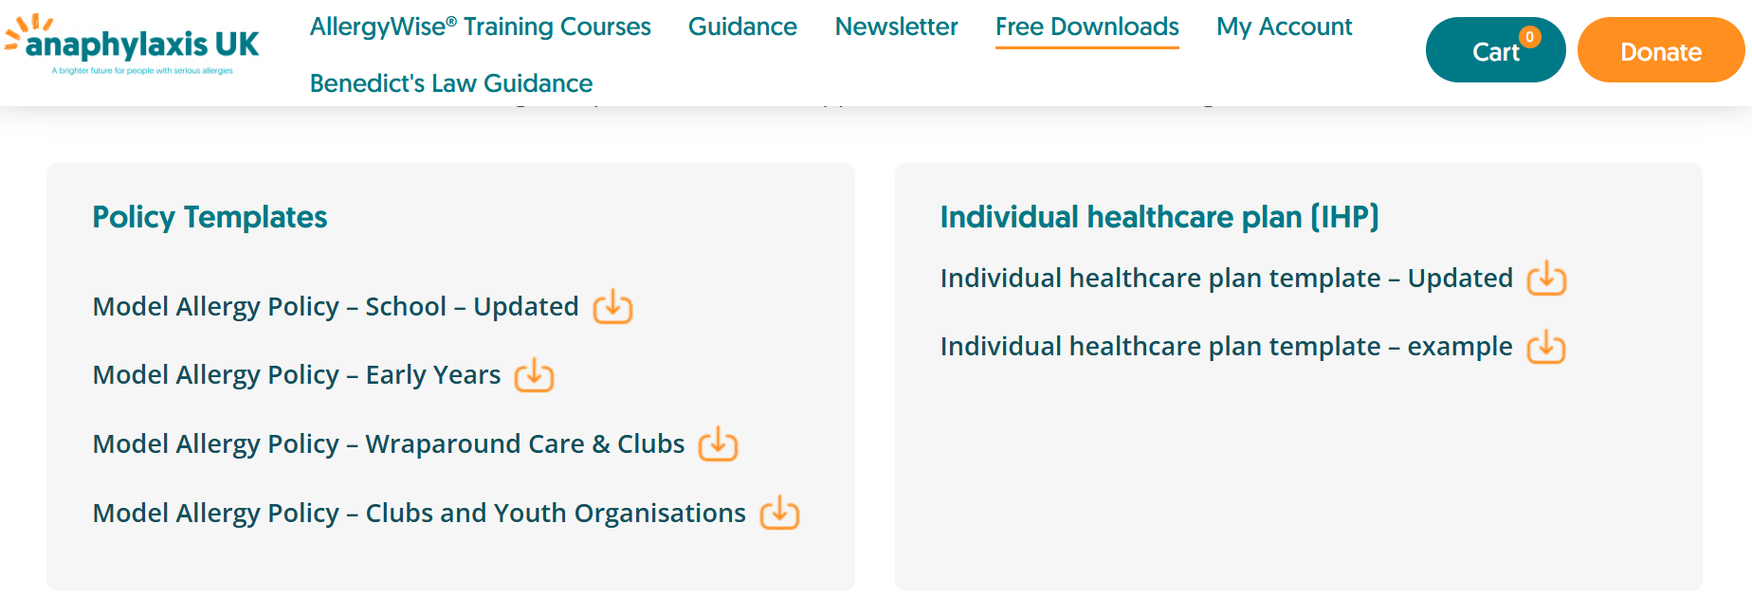
Natasha’s Foundation
Natasha's Foundation
Natasha’s Foundation provides free resources and anaphylaxis training that is compliant with the new government guidance. They have a free toolkit you can access as well and resources to use with children and young people. The foundation offers free, 1-hour online training specifically built for the September 2026 statutory requirements. It is City & Guilds accredited and covers all school staff (including lunchtime supervisors and support staff).
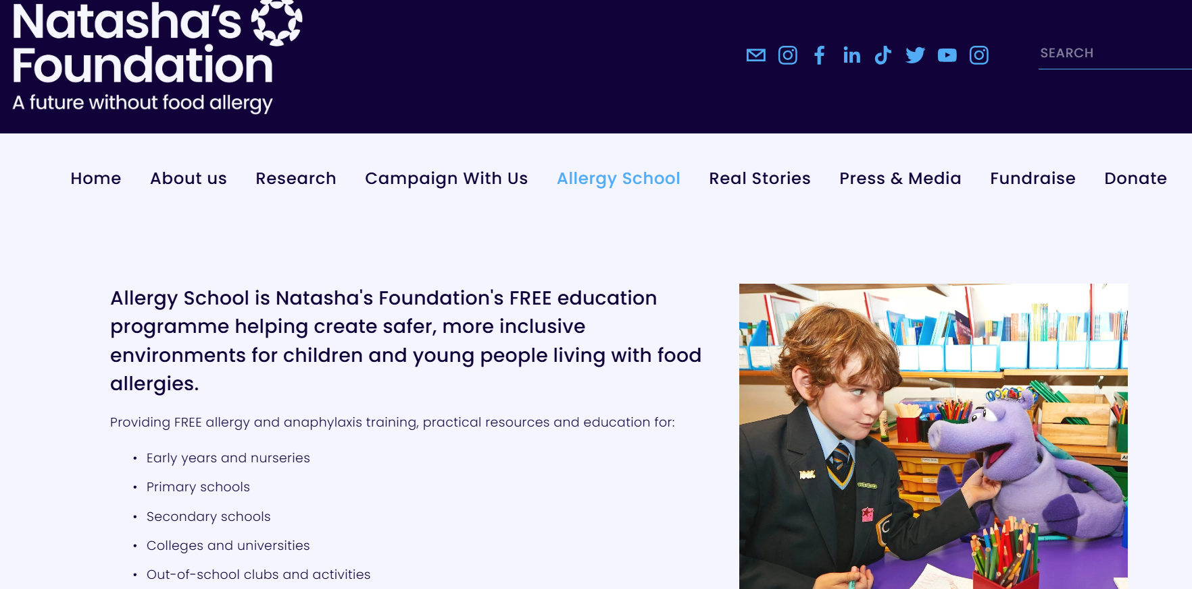
High Speed Training
Allergy & Anaphylaxis for Schools | Free Course Request
High Speed Training offers a 1 hour, online training course for staff. This training is free and compliant with the new guidance.
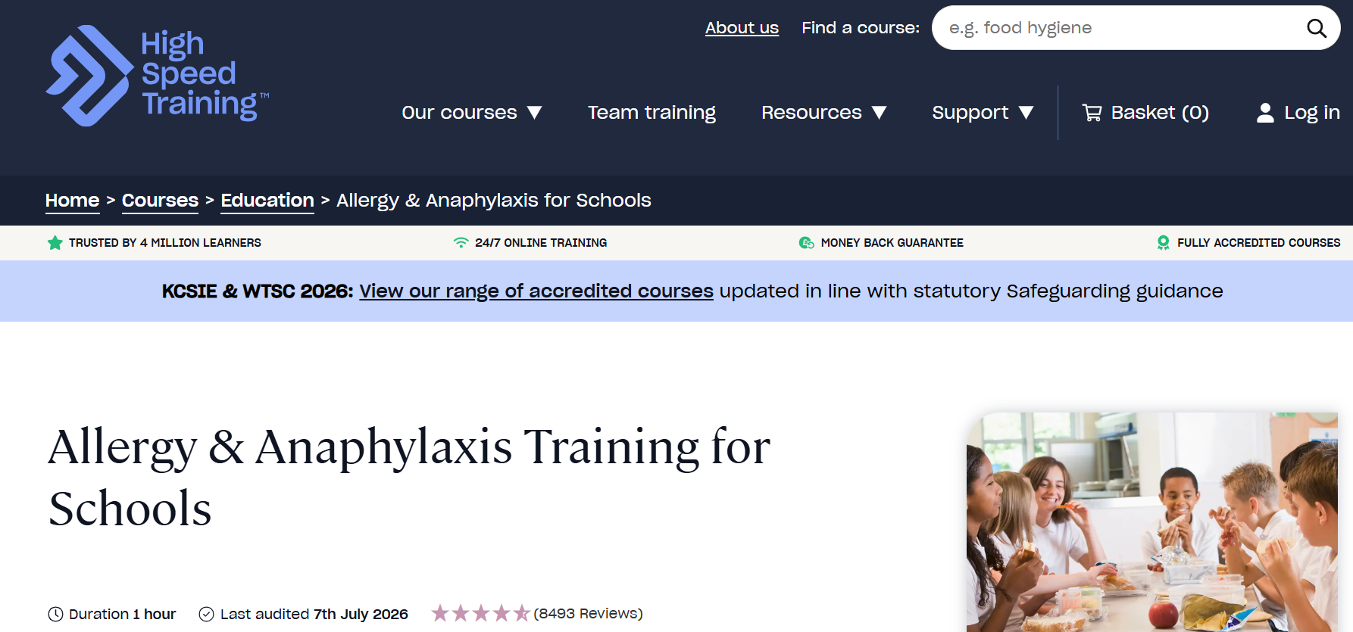
The National College
Allergy and Anaphylaxis
If you are signed up with the National College, they offer a training course on anaphylaxis and allergy awareness which is compliant with the new guidance.
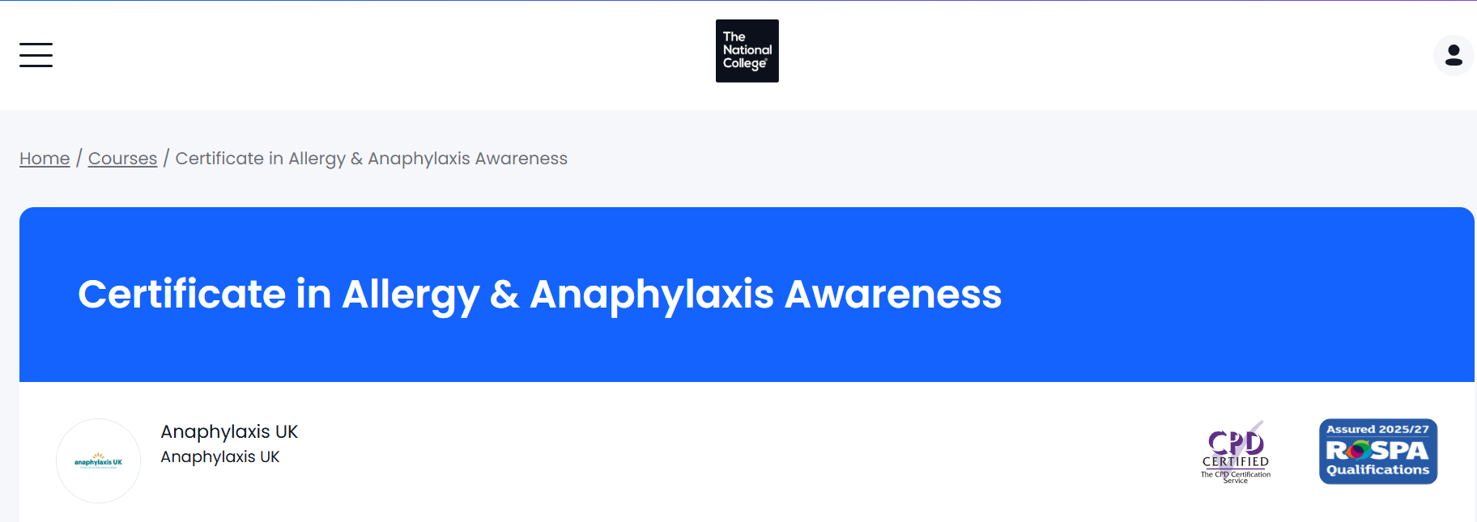

Allergy UK
Benedict's Law | Allergy UK | National Charity

Provides guidance and advice on allergy awareness and management.
