
Hampshire schools: guidance to support schools in managing lockdown procedures

Contents

Introduction 3
Case studies 4
Primary school 4
Incident 4
School’s action in line with its lockdown procedure 4
Secondary school 6
Incident 6
Supportive factors 6

Introduction

The health and safety of a school is a governing body/Trust responsibility. All schools are advised to have established lockdown procedures to ensure the safety of students and staff during emergencies.

The Local Authority advises the use of national guidance, copies of which are stored in the Hampshire Services for Schools portal:

- Emergency response planning: Health & Safety | Hampshire Services for Schools - for schools with an service level agreement (SLA).

In addition, the following national resources provide further guidance and templates:

- School and college security
- Protective security and preparedness for the education sector
- Lockdown template

These documents advise that schools should have security policies in place that complement their safeguarding policies so that health and safety policies are integrated, have an identified lead for health and safety, and that staff should be aware of the guidance, to ensure that pupils and staff remain safe.
Security policies should:

- identify the likelihood of a security related incident occurring
- assess the level of impact
- develop plans and procedures to manage and respond to any threats.

The Department of Education’s (DfE) lockdown template provides a clear plan to assist school leaders and the identified lead in preparing for and managing an incident, and professional associations and unions also stress the importance of training all staff and pupils on how to respond during a lockdown.

The relevant policies should be reviewed regularly by the governing body in line with their review schedule and shared with all staff.

In the case of any lockdown incident, schools are encouraged to communicate at the earliest opportunity with the Local Authority for advice on all matters including external communication following the incident and, following the event, ensure that learning can be shared and adjustments to policy and practice made.

Case studies

In the case of any lockdown incident, schools are encouraged to communicate at the earliest opportunity with the Local Authority for advice on all matters including external communication following the incident and, following the event, ensure that learning can be shared and adjustments to policy and practice made.

Primary school

Incident
- Parent came to school at the end of lunchtime with a younger child.
- Wanted to collect her child from school.
- Clearly distressed and in a very agitated state. School leaders unable to calm her.
- Parent forced way towards playground.
- Police were called by the school.
- Child saw parent, screamed and ran away. Child taken to safe space in school.
- All children brought off playground, inside to classrooms.
- Parent left but then returned.

School’s action in line with its lockdown procedure
- Lockdown procedure was implemented. Everyone advised to stay in classrooms with all of the outside doors locked. The corridor door was also locked to prevent access to the main body of the school. The office was instructed not to answer the buzzer to entrance door and not to open the main door to the parent.
- The parent buzzed for entry but was not allowed back into the school.
- The parent attempted to force her way in, with an implement then returned to her car and drove car down the slope towards the school doors, bumping the car at a low speed into the front door, causing the glass to crack.
- Staff monitored the situation from the safety of the raised reception area, away from the lobby, waiting for the arrival of the police.
- Children remained in classrooms; all doors remained closed.
- Parent apprehended by the Police outside the school.

In summary, the management of the incident aligns with the school’s Emergency Response Plan as follows:

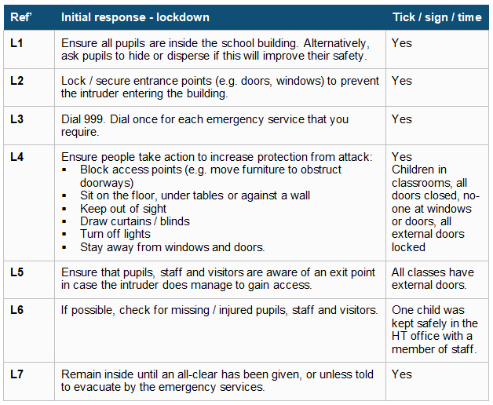

The headteacher sought Hampshire County Council communication team’s advice; an email sent out to parents before the end of the school day.

Shortly afterwards, the police reported the incident in the media. By Monday 10 March 2025, a number of parents had approached school sharing their concern about incident and the headteacher sought further communication advice; a second email was sent to parents.

Following the incident, the headteacher:

- Logged this as a 'Near Miss' with the health and safety team.
- Reported to the Police and they completed an inter-agency referral form (IARF)
- Reported to Children’s Services.
- Reported to School Improvement Manager.
- Reported to communications team.

Secondary school

The school was scheduled to close at 14:00 due to an open evening event, and a text message had already been sent to parents earlier in the day following reports of a white van behaving suspiciously, seen slowly driving past students. This incident had also been reported to the police, who confirmed they had received similar accounts, contributing to an already heightened sense of concern within the community.

Incident
- At 13:15 two students came to the pastoral support office saying there were some students along the cycle path and named one of the students.
- At the same time, two different students spoke to the member of senior team on lunch duty, appearing upset with information that the named student had made threats to another child on social media and that this student was coming to school, to cause an incident.
- Students were seen outside of school and the pastoral team rang 101 to report these.
- During this call, one of the reporting students was spoken to by the Police and it was revealed that he had previously had an altercation with student but felt it had all blown over.
- Across the school, this information was being shared, and students were alarmed.
- The reported student outside was a known knife carrier; and as a result, the headteacher then called 999.
- During the call, all known information was shared and the police responded as a priority as the student was known to them, and the headteacher was advised to make a safety decision, which was agreed to be invoking lockdown.
- As the day was close to the end, members of the leadership team were outside liaising with parents whilst lockdown was in process.
- At 14:50 the police confirmed that lockdown could be released before cancelling the lockdown as the pupil was spotted. Only one class had been released at this point and quickly returned to tutor base.
- Police stopped and searched the young people - nothing was found.
- At approximately 15:30, lockdown was released, and students went home.

Supportive factors
- New messaging system implemented at start of term was used to inform parents of lockdown.
- Updates given to parents – just informing them the Police were dealing with the matter.
- Staff communication channel on MS Teams was used to keep school up to date.

